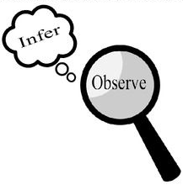
Observations and Inferences
Science 10 Name: BLK:

OBJECT | OBSERVATIONS  Words that describe the object | INFERENCES  Ie: Where might the object come from? Possible uses? Etc. | QUESTIONS YOU HAVE ABOUT THE OBJECT
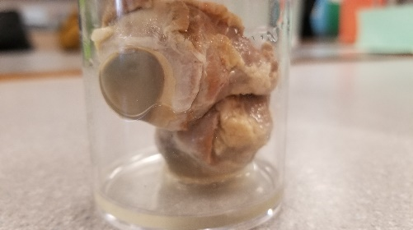 | Moist, Squishy, Slimy, nude colors, slippery, boring faded colors, chunky | This is an eyeball, it’s been preserved, not cut very well, still has fat all over it, from the same animal possibly? From a sheep (because of past knowledge) | How were these preserved? Why does cornea change to a solid color and what happens to the iris?
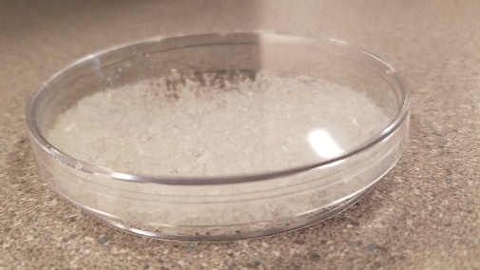 | Crystal-like, shiny, glass-like, shattered, white/translucent, | These could be a reaction from a mixture of something because of its rock/crystal like state and does not look like a natural crystal | How were these formed? Are they synthetic or natural?
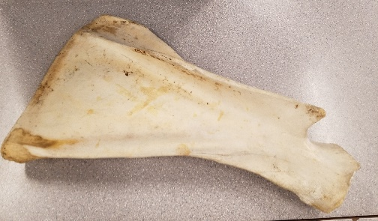 | Tough, smooth, dirty, pale, fibrous, strong, beige/off-white | This is a bone of a large animal. It is a singular once piece bone around 1 and a half feet, with one obvious ligament attachment area. Probable a hip bone or shoulder. Possibly from a goat or cow. | How was this made smooth, and taken from the animal?
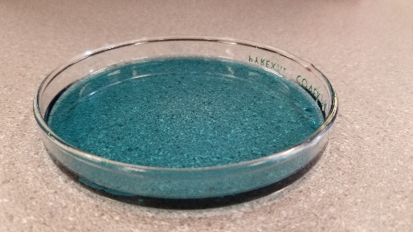 | High-viscosity, translucent, navy/green, dark, smells, like chemicals used to clean, | This could be laundry detergent, as it has a very similar smell, and is thick like detergent. | What brand, would it kill you if you ingested it, what chemicals give that smell?

Observations/Inferences Assignment Assessment
Name: Dylan Stevens
Ex: Excellent VG: Very Good G: Good S: Satisfactory IN: Improvement is needed
Criteria | IN | S | G | VG | Ex
The following is included
- All 4 Images included
Observations:
- A minimum of 5 detailed observations made
Inferences:
- Thoughtful and logical inferences made
Questions:
- 2 thoughtful and logical questions made
- Spelling/grammar
- Assignment was completed on time
/10

