Everything I know about exponents

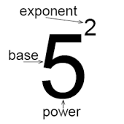
Before you begin reading, please scan over this for a better understanding of the content below. Firstly, a base is the main number, it can be positive or negative. Secondly, an exponent is the small number that is to the right of the base, it can also be positive or negative but in my class we stick to positives. The exponent tells you the amount of times have to multiply the base by itself. Together the base and exponent are called a power.
Credits to www.mathplanet.com
e.g. 3² As you can see the 3 is the base, the 2 is the exponent, and together they are a power.
e.g. 9³ As you can see the 9 is the base, the 3 is the exponent, and together they are a power.

Now that we have that clarified we can get to work. Below you will see the explanation to 18 Prescribed Learning Outcomes also known PLO’s. Each one will have an explanation of what it is and at least 1 example.
__________________________________________________________________________

- Represent repeated multiplication with exponents:
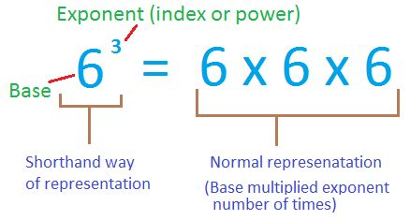
A repeated multiplication with exponent uses the base and the exponent. The base is the number that you will be repeating for the multiplication. The exponent will tell us how many times you must repeat it. A repeated multiplication is a way to show how many times the base has been multiplied using the exponent.
e.g. $3^{7}$ = 3 x 3 x 3 x 3 x 3 x 3 x 3
e.g. $4^{11}$ = 4 x 4 x 4 x 4 x 4 x 4 x 4 x 4 x 4 x 4 x 4
Credits to pinterest.com
- Describe how powers represent repeated multiplication.

A power is just the base and exponent together. The base tells you the number you will be multiplying and the exponent tells you how many times. Though there is an exception. If the base is negative and is in brackets as well as the exponent then you must change the repeated multiplication slightly. Because it is a negative and the exponent is with it you must add a -1 before writing anymore of the repeated multiplication. You have now used the negative symbol so you can remove that from the base, you are left with a positive number. After that you can follow the regular repeated multiplication rule using the positive base and exponent.
e.g. ${(-4)}^{3}$ = -4 x -4 x -4
e.g. ${23}^{5}$ = 23 x 23 x 23 x 23 x 23

- Demonstrate the difference between the exponent and the base by building models of a given power, such as 2³ and 3².

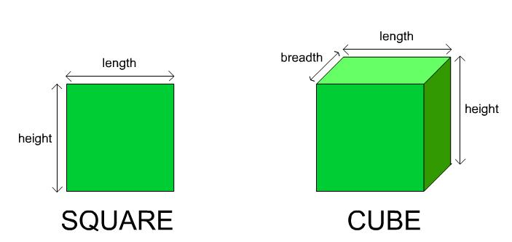
Firstly an exponent which is a 3 means cubed and an exponent with a 2 means squared. So you know that if the equation is 2³ and you have to draw a model, you are going to have to draw a cubed. If the equation is 3² you are going to have to draw a square model. When using the given power to make a model you look at the base, this will tell you how many units are on each side. The exponent will show you if it is going to be looking at the area or volume.
Credits to www.sourcecodeera.com

e.g. 2³ 2 x 2 x 2 = 8 If we made a model you would be looking for the volume of the cube.
e.g. 3² 3 x 3 = 9 If we were to make a model you would look for the area of the square.

- Demonstrate the difference between two given powers in which the exponent and the base are interchanged by using repeated multiplication, such as 2³ and 3².

Some people believe that because two powers in which the exponent and the base are interchanged by using repeated multiplication that the product will be the same. Yet they won’t be. To figure this out you can use repeated multiplication to visualize this. If we used 2³ and 3² as an example of two powers that have interchanged base and exponents, we can use repeated multiplication to prove that they are not equal. For 2³ you would do 2 x 2 x 2 and get the answer 8. If you do 3² you will do 3 x 3 which gives you 9. As you can see by using repeated multiplication that these two powers may look like they are equal but are not.

e.g. $9^{3} and 3^{9}$ = 9 x 9 x 9 = 729 3 x 3 x 3 x 3 x 3 x 3 x 3 x 3 x 3 = 19 683
e.g. $4^{7} and 7^{4}$ = 4 x 4 x 4 x 4 x 4 x 4 x 4 = 16 384 7 x 7 x 7 x 7 = 2401
As you can see just because the bases and exponents are interchanged doesn’t mean they will give the same answer.

- Evaluate powers with integral bases (excluding base 0) and whole number exponents.

To evaluate powers with integral bases and whole number exponents you can use repeated multiplication to visualize and show your work.

e.g. $6^{7}$ = 6 x 6 x 6 x 6 x 6 x 6 x 6 = 279 936
e.g. ${(-2)}^{4}$ = (-2) x (-2) x (-2) x (-2) = 16

- Explain the role of parentheses in powers by evaluating a given set of powers such as (-2)^4, (-2^4) and -2^4.

Brackets or parentheses in powers are very important. If they are in any equation you must do them first. For example the question ${(-2)}^{4}$ this shows you that you have to do the brackets first. Though there is no equation inside we move to the exponent. So ${(-2)}^{4}$ = 16. But if the equation was ${(-2}^{4})$ the answer is going to be different. It is a negative number and the exponent is in the brackets as well. So to do this you do brackets first, which is -1 x 2 x 2 x 2 x 2 = -16. One more, ${-2}^{4}$ there is no brackets on this equation which makes it a bit trickier. There is no brackets so we have to move on to exponents. -1 x 2 x 2 x 2 x 2 = -16. See just by moving the brackets to different areas or taking it out completely, we will see different answers. Brackets are important, they help you get the correct answer.

e.g. ${(-8)}^{2} and {(-8}^{2})$ ${(-8)}^{2}$ = -8 x -8 = 64 ${(-8}^{2})$ = -1 x 8 x 8 = -64
You can see here that just by moving the brackets it can change the answer to the question. They may look the same yet they give completely opposite answers.

Explain the exponent laws for multiplying powers with the same base.
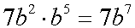
- The law for multiplying powers with the same base is called the product law. The rule is you must keep the base, the base numbers have to be the same! Next step is you must add the exponents together from each power. The next step is not always necessary, it depends on the equation. If there is coefficients you can then multiply them together. After that you can get your single power for the equation and evaluate the question.
Credits to www.regentsprep.org
e.g. $7^{2} x 7^{3}$ = $7^{ 2+3}$ = $7^{5}$
e.g. $3 {(3)}^{3 } x 8 {(3)}^{9}$ = ${(3)}^{ 3+9}$ = $3^{12}$ = 3 x 8 = 24 = 24 x $3^{12}$ = 12 754 584

- Explain the exponent laws for dividing powers with the same base.

The law for dividing powers with the same base is named the quotient law. The rule is you must keep the base, it must be the same. The following step is to subtract the exponents. The next step depends on the equation, if there is coefficients then you must divide them. After that you will get your single power and can evaluate the equation.

e.g. ${(-4)}^{6} ÷ {(-4)}^{3}$ = ${(-4)}^{6-3}$ = ${(-4)}^{3}$
e.g. $y^{43} ÷ y^{21}$ = $y^{43-21}$ = $y^{22}$

- Explain the exponent laws for raising a product and quotient to an exponent.
The law for raising a product and quotient to an exponent is called the power law. The rule is you must keep the base, and they must both be the same! Then you have to multiply the exponents together. This should give you the single power and from there you can evaluate the equation.

e.g. ${(11}^{3})²$ = ${(11)}^{3 x 2}$ = ${11}^{6}$ = 11³ x 11³= 1 771 561
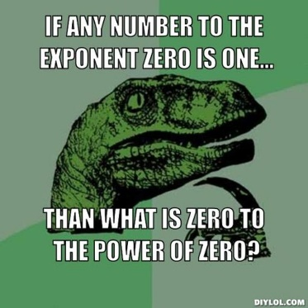
e.g. ${(-4}^{3})³$ = ${(-4)}^{3 x 3}$ = ${(-4)}^{9}$ = -4³ x -4³ x -4³= -262 144

- Explain the law for powers with an exponent of zero.

Any base that has the exponent as zero the answer will always be 1. The only exception is if the base is also a zero.

e.g. ${(-59)}^{0}$ = 1
e.g. ${(333)}^{0}$ = 1
Credits to beta.diylol.com

- Use patterns to show that a power with an exponent of zero is equal to one.

$2^{5}$ = 32 | ${(-3)}^{5}$ = (-243) | $4^{5}$ = 1024
$2^{4}$ = 16 | ${(-3)}^{4}$ =81 | $4^{4}$ = 256
$2^{3}$ = 8 | ${(-3)}^{3}$ = (-27) | $4^{3}$ = 64
$2^{2}$ = 4 | ${(-3)}^{2}$ = 9 | $4^{2}$ = 16
$2^{1}$ = 2 | ${(-3)}^{1}$ = (-3) | $4^{1}$ = 4
$2^{0}$ = 1 | ${(-3)}^{0}$ = 1 | $4^{0}$ = 1

As you can see in all these examples they have something in common. From the start of each one they decrease by one the result is divided by the base.

- I can apply the laws of exponents.

To apply the laws of exponents all you must do is follow the laws. For the product law you must keep the base, add the exponents and if there are coefficients multiply them together. For the quotient law you must keep the base, subtract the exponents, and if there are coefficients divide them. For the power law you must keep the base and multiply the exponents together. For the zero law you must look to see if the exponent is a zero, if so then the answer will always be 1.

e.g. ${(-12)}^{2} x {(-12)}^{1}$ = ${(-12)}^{3}$ = -1728
e.g. $8^{19} ÷ 8^{12}$ = $8^{7}$ = 2 097 152
e.g.${(4}^{2})³$ = $4^{6}$ = 4096
e.g. $9^{0}$ = 1

- I can identify the error in a simplification of an expression involving powers.

Errors are common to see in expressions involving powers. But if you use the laws of exponents these errors will minimize themselves.

e.g. A student was asked to evaluate this question, ${(-3)}^{4} x {(-3)}^{6}$. They told us that the answer should be${(-3)}^{24}$. This is wrong, this student did the power law instead of using the product law. He should have answered the question as so, ${(-3)}^{4+6}={(-3)}^{10}$ which would give him the total of 59049.

- Use the order of operations on expressions with powers.

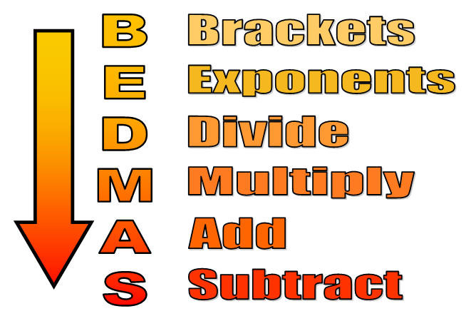
The order of operation also referred to as BEDMAS. To evaluate expressions with powers in which you have to use BEDMAS you must follow the rules. First you look in the expression and see if there are any brackets. If so look to see if you can do the equation inside the brackets. Next you must do exponents, if there are exponents in the question, evaluate them and get the answer. The following step is to do division or multiplication, if they are both in the expression start from the left and move to the right. The next step is to do subtraction and addition, if they are both in the expression, start from the left and make your way to the right. After that you just need to put it all together to get the answer.
Credits to maths.nayland.school.nz

e.g. $4^{2} ×3+({-78)}^{0}$ = $16 x 3+1=$ $48+1=49$
e.g. $40 x 2-\left(3^{4}+ 4^{2}\right)$= $40 x 2-(81+16)$= $40 x 2-65$= $80-65=15$

- Determine the sum and difference of two powers.

Note there is no law that applies to the law of exponents. You must just do the work to figure it out.

e.g. (Sum) $3^{2}+ 3^{3}= 9+27=36$
e.g. (Difference) $3^{3}- 3^{2}= 27-9=18$

- Identify the error in applying the order of operations in an incorrect solution.
Many people tend to make errors when applying the order of operation to equations. But if you pay attention to what the equation is and use BEDMAS (brackets, exponents, division, multiplication, addition and subtraction) you can minimize the errors you make.

e.g. Incorrect way: Correct way:
$3+{(-3)}^{4} x 2=$ $3+{(-3)}^{4} x 2=$
$3+81 x 2=$ $3+81 x 2=$
$84 x 2=168$ $3+162=165$

As you see a student made the mistake in step 3 (last step). They added 3 + 81 instead of doing it the correct way which should have been 81 x 2 = 162 + 3 = 165.

- Use powers to solve problems (measurement problems).

Word questions can be a bit more difficult than just regular equations. One common word question is a measurement problem. It is where you are usually given the surface area and must find the volume of the cube.
e.g. What is the volume of a cube if the side is 3 cm?
You would do $3^{3}$ because an exponent that is the number 3 means cubed. So $3^{3}$ = 27 units³.
The volume of a cube with the side of 3 cm is 27 units³.

- Use powers to solve problems (growth problems).
Word questions can be a bit more difficult than just regular equations. One common word question is a growth problem. It is where you start with one number and it grows over time, you must find out how much it grows every so often.
e.g. You start out with 2$ and every year it doubles for 12 years. How much money do you have at the end of the 5 years?
Year | Amount of $
1 | 2$
2 | 4$
3 | 8$
4 | 16$
5 | 32$
$$Type equation here.$$

