The Daily Queen rough draft

Guardians kill another
Teen Royal found dead

Police were called to the scene of a murder last night in an alleyway at around midnight, after receiving a phone call about a young man gone missing. He was later found dead with a lethal stab wound.

The boy, Andy Brokwell, a 16 year old Royal was found dead at the scene. He had a severe wound to the abdominal area and was lying dead in the alley.

Laura Vamsi, Andy’s girlfriend, called police shortly after 11:30 pm yesterday, reporting her missing boyfriend. He had gone to get cigarettes from a nearby store and was supposed to be back shortly, she knew once he had been gone for more than 15 minutes something had gone wrong.

Police officer Mike Howell went out searching for the missing teen. Shortly after he found the boy dead in the alley with his Royal jacket placed on the ground. It is still unclear how the dying boy managed to get his jacket off.

Patrick Patridge, a drinker, told police he came across Andy in the alley but he had drank too much and was not clearly thinking.

“I thought the boy had been drinking like me, he was lying on the ground practically unconscious, I didn’t even realize his wound. Had I not been drinking I may have been able to help.” He told us.

Two other witnesses came forward after hearing the news of the death of Andy. Freddie Harrison and Angela McGruder had been coming through the alley after their date. They thought about helping Andy but decided that they didn’t want to get involved.

“I regret every moment afterwards.” Freddie told us tears forming in his eyes. “I should have helped him, he was only a boy.” His girlfriend Angela however did not say a word when we tried to interview her, instead she kept her head down.

Martha Erosa, the town’s flower shop owner told police she had been in the alley last night but did not see the young Royal. “I was out searching through the trash, I heard some rustles but I thought they were the neighbourly cats. Had I known the boy was there I would have helped. My dearest regards to his family and friends.”

Head Gang Violence Unit Chief, Detective Joseph Fernandez, has recently seen an increase in these gangs attack. “This is the 12th gang attack this year, and I’m sure there is still more to come.” He tells us.

Police do have a few suspects in custody, one of them being Angela McGruder. Her partner Freddie Harrison, a witness, told police that she wanted to leave Andy to die. Freddie told police that during their date she disappeared right before they left the restaurant. As for as we now she is cooperating with police.

If you have any other information about the murder please Crime Stoppers.

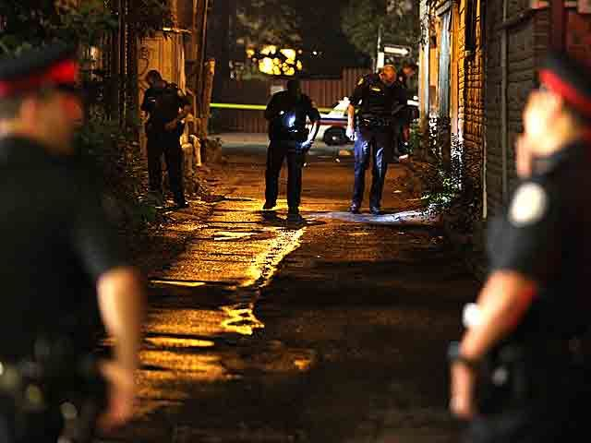
Figure 1 Local Police investigating the homicide. (Photo by John Hanley)

