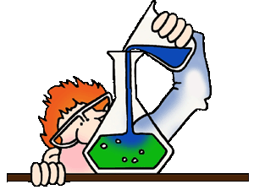
Virtual Chemistry Lab App Review
Nicholson Reviews 101
Chemistry (Photo credits to Clipart Panda)
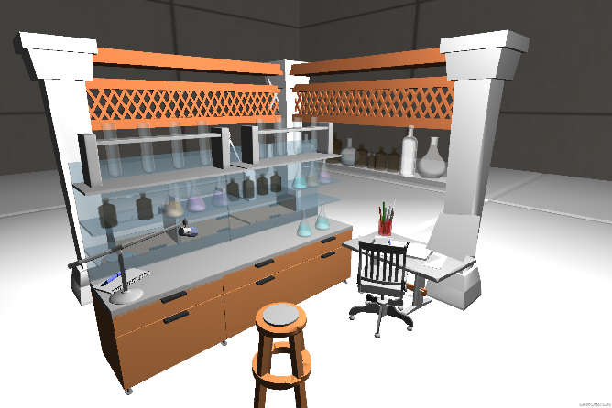
The app virtual chemistry lab is a free app in the windows app store. It was published by Creative Tech, categories as educational. It is a virtual game in which you can learn how to and do chemistry labs. It is somewhat interactive game best suited for students in a Science 9 classroom. Try the games out and test the experiments, magnesium ribbon burning, preparation of oxygen gas, preparation of hydrogen gas and preparation carbon dioxide.
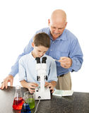
Virtual Chemistry Lab App being used
How would this help students and teachers in the classroom or at home?
This app will help teachers by demonstrating different chemistry experiments. The app will be able to demonstrate to the student what they will have to do during the experiment. This app can help students not only by showing them what they have to do but also if they missed the lab, what they would have had to do. If the student is unable to do the lab but still must complete the work they can look on this app. This app also works well for students who feel they may have not done the experiment correctly, they can look it up and see if the product was the same
Figure 1 Teacher helping student (Photo credits to Lisa Young)

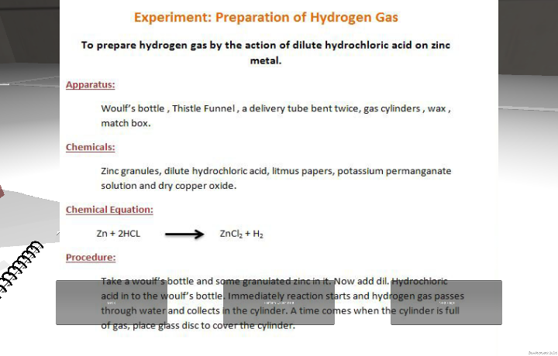
Did I learn anything from this app?
I learned many different information in this app. I learned how to do different labs that I hadn’t had the chance to do yet. I saw how to do them and what the product should look like. I learned some chemical equations that they used to do the lab. I also learned different equipment and chemical names, I can now identify a few new ones.
Experiment in app: Preparing Hydrogen Gas

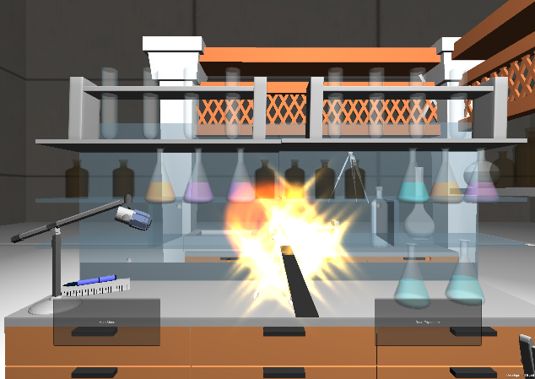
Was this app easy to use and understand? Was the app a fun way to learn the content?
This app was quite easy to use. I was able to start the app immediately without any problems. It is pretty straight forward as all you must do is click on a few buttons and follow along. The app does a lot of the work for you. I found this app was a great way to learn content. It was a somewhat interactive app that taught you different labs. It was fun to do the labs while learning procedures, equipment, equations and more.
With a simple click of a button you can learn experiments with ease. It is fun and educational at the same time!

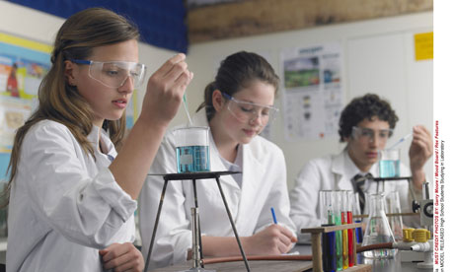
What subject of science would this app be most useful in? What age group would this app best suit?
This app is ideal for a science class as it is a science app. It is a chemistry app so it would be great for a class that is currently or will be learning chemistry. I think this app would best suit high school science classes, more specifically science 9 classes. I believe anyone could use it in high school but it may be too simple for older high school students. It would be best for 9th graders because the content isn’t too hard nor too easy and the experiments are generally what you would do in this course.
Students doing chemistry in science (Photo credits to Gary Moore)
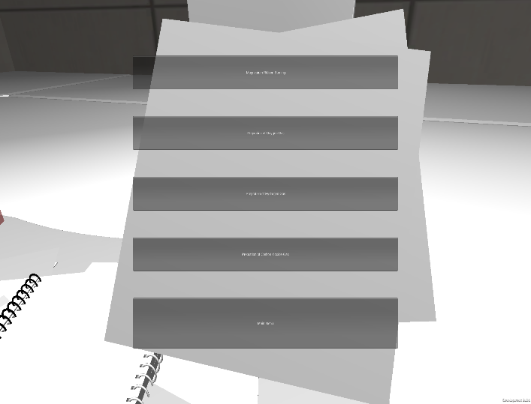
What are some issues in the app that would help improve overall experience?
This app was a pretty good educational app. Though it did have some issues that I think could be fixed to make the app more enjoyable. I find that the print of the letters in the game or much too small. I truly have trouble reading them at times. Also I believe there should be more lab experiments to try. There are only four and I believe it would be much more useful if they added more so students had the opportunity to try new ones. I believe if the developers of the app fixed these issues it would make it much more useful to students and teachers.
As you can see the boxes with words in them are much too small

I found that this app was quite educational. I learned some information from it in a fun and interesting way. It would definitely be best for students in science 9 who are in chemistry. It can help demonstrate and teach a certain experiment. With a few tweaks to the app I am certain that our school would benefit from having it on our devices.
Recap of all my questions:
- How would this help students and/ or teachers in the classroom?
- Did I learn anything from this app?
- Was this app easy to use and understand?
- What subject of science would this app be most useful in?
- Was the app a fun way to learn the content?
- What age group would this app best suit?
- What are some issues in the app that would help improve overall experience?

Fun Factor: 3/ 5

Easy to use: 4/ 5

Usefulness: 3.5/ 5

Information taught/ learned: 4/ 5

Overall Experience: 3.5/ 5

