The Daily Queen
Reported by: Devon Nicholson Date: October 5th 2015
Guardians strike once again
Teen Royal found dead

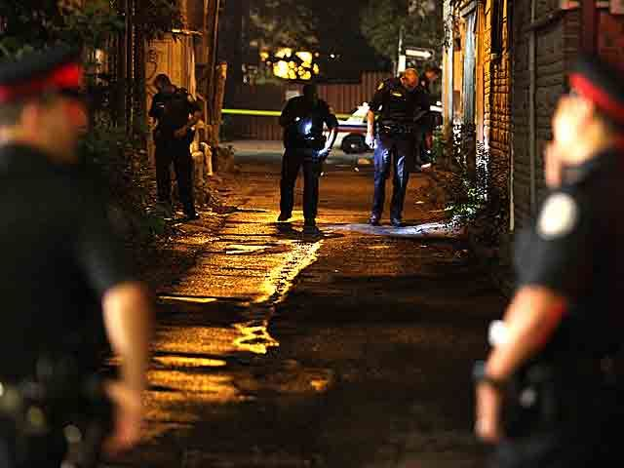
Guardians strike again, a teen royal was found dead. Police were called to the scene of a murder last night in an alleyway at around midnight, after receiving a phone call about a young man gone missing. He was later found dead with a lethal stab wound.
Police investigating the homicide (Picture taken by John Hanley
The boy, Andy Brokwell, a 16 year old Royal was found dead at the scene. He had a severe wound to the abdominal area and was lying dead in the alley.
Laura Vamsi, Andy’s girlfriend, called police shortly after 11:30 pm yesterday, reporting her missing boyfriend. He had gone to get cigarettes from a nearby store and was supposed to be back shortly, she knew once he had been gone for more than 30 minutes something had gone wrong.
Police officer Mike Howell went out searching for the missing teen. Shortly after he found the boy dead in the alley.
Patrick Patridge, a drinker, told police he came across in the alley. “I thought the boy had been drinking like me, he was lying on the ground practically unconscious, I didn’t even notice his wound. Had I not been drinking I may have been able to help,” he told us.
Two other witnesses came forward after hearing the news of the death of Andy. Freddie Harrison and Angela McGruder had been coming through the alley after their date.
“I regret every moment afterwards,” Freddie told us tears forming in his eyes, “I should have helped him, he was only a boy.” He has agreed to be the expert witness for this crime.
Head Gang Violence Unit Chief, Detective Joseph Fernandez, has recently seen an increase in these gangs attack. “This is the 12th gang attack this year, and I’m sure there is still more to come,” he tells us.

