Filipino-Chinese Specialties and Tropical Desserts
Pinpin is a Filipino-Chinese restaurant, located in Vancouver. It is one of my favorite restaurant, my happy place and it’s close to my heart. Even today, while I’m writing this essay I would still picture how joyful I am when being in the restaurant with my loving family. This restaurant is one of the best on town, let’s talk about their service. These men and women in their tidy uniform, hairs are covered with hairnets, nails are properly clipped and I will never forget those sweet smiles form them, it makes me feel that I am in a 5 Star hotel. From ceiling down to the polished floor, shining so brightly. Tables and chairs were wiped out smoothly and the food, just looking at the menu makes me drool, from appetizer to main dishes and don’t forget the dessert. These mouthwatering meals makes me hungry now, what caught my attention is the kare-kare, this is a traditional Filipino stew complimented with a thick savory peanut sauce. While waiting for our orders, I could smell from seat the sweet aroma of the food being cook in the spacious kitchen. When food is served on our well-organized table, I couldn’t help myself but to be amazed on the speed service of the staff, we didn’t wait that long. Remember that kare-kare that I mentioned you a while ago, it tastes like my grandma’s recipe, I would die now. While enjoying our meals and having a good talk with my parents, the atmosphere is perfect for this family date, the peaceful music playing in the background is truly entertaining, as I looked around I saw other people laughing, I could tell they’re also having a good time. The lightings are perfect, it’s not dim nor too bright just rijat for us to enjoy our meals. Cleanliness, checked, in other words it has a pleasant soothing ambiance.

Decors plays an important role in the restaurant, having said that, Pinpin has the most stunning paintings hanged in their wall, and maybe your curious about the prices on their menu, worry no more because all the meals are reasonable and it’s worth it.

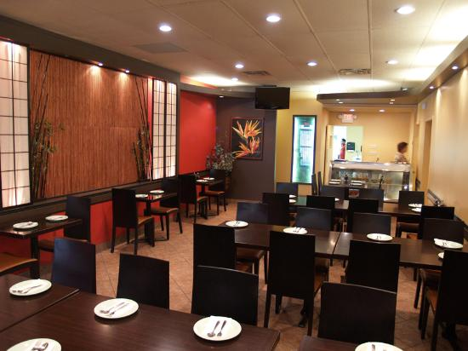
It is one of the unforgettable chapter in my life, dining out with my family rarely happens, and in moments like this makes my heart felt so good. Eating Filipino foods gives me a glimpse of home. It’s like a home savory from home.

Every table was a filled even though it was a holiday and they were all occupied by Filipino families, the meals are delicious and worth it

