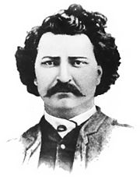
The Northwest Uprising 1885

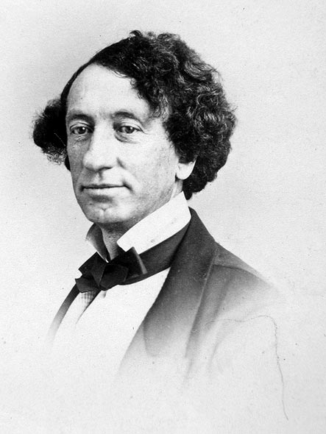

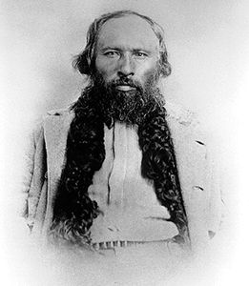
VS

Name: Block:

Events in the Northwest 1870-1884

- Metis are pushed westward
- Sold land scrips to land speculators
- Encroaching European settlers and immigrants

- Northwest Territories are governed by Ottawa (purchased Rupert’s Land in 1869)
- Any laws have to be approved by Ottawa (a territory has less independence/autonomy)

- North West Territories Act 1875: establishes a government in the region = Lieutenant Governor with an appointed 5 member council; gradual implementation of an elected, representative, and responsible government

- Numbered Treaties 1871-1877
- Government of Canada gains title to lands in the Northwest
- Only First Nations that sign treaties are given status and benefits of treaties
- First Nations promised land, health care and education, farming seeds, equipment, and training
- Macdonald refuses to help “difficult” First Nations communities

- Indian Act 1876
- First Nations become wards of the state; must register with the government to receive “status”; placed on reserves and not allowed to leave reserves without permission of the Indian Agent; children must attend residential school; traditional ceremonies and forms of governance are abolished

- Building of the CPR
- Signed treaties with First Nations to acquire land for the railway
- Terms of treaties were not fulfilled as money was diverted to pay for the CPR = starvation of the First Nations

- 1881 – Metis and European settlers of the Northwest send petitions to Ottawa asking for land grants
- This land is worth $71 million –this money would fund the building of the CPR
- Macdonald sends commissioners to the NW to settle the land issue; Metis are disappointed more issues aren’t addressed

- Gabriel Dumont convinces Louis Riel to return to the Northwest in 1884 to fight for the rights of the Metis
- Bill of Rights 1884: demand responsible government, control over resources, provincial status as Saskatchewan, representation in the federal government, rights for Metis and settlers

- Northwest government officials, NWMP, and church missionaries write letters to Ottawa stating the government needs to respond to the Metis and European settlers otherwise there will be trouble

- Amendments are made to the Indian Act in 1884 banning the sale of ammunition to First Nations

- Metis are told by HBC Chief Factor Lawrence Clarke that their call for responsible government would be denied and answered with bullets and 500 NWMP on their way to arrest Louis Riel
- 1st part of this statement was true – the Canadian government had no intention of granting responsible government to the region (this could allow Metis to gain control of the gov’t)
- 2nd part was false – there were no NWMP on their way to the region to arrest Riel = this only escalates tension in the region which is what Clarke wanted!
Causes of the Northwest Uprising

Cause #1: Land Grants in the Northwest
- The Canadian government was slow in handing out land grants to the Metis
- Land surveying conflicted with current land settlement patterns: sometimes the surveyors honoured the seigneurial system of land division, while other times they imposed the grid system on land that was already settled
- Land was devoted to the building of the CPR
- Land was devoted to the settlement of European immigrants
  - However, not all settlers received their land grant papers in a timely manner

Cause #2: Uncertainty for the Metis
- Concerned their rights would not be heard or recognized by the Canadian government, just like in Red River
- Metis were not guaranteed land in the Northwest because they were not able to negotiate and sign treaties with the Canadian government
- Increasing settlement in the Northwest disrupted the bison hunt; Metis were forced to become farmers and wanted support from the government like the First Nations received
  - However, since they did not sign treaties with the government there was no way to get this support

Cause #3: Actions by the Government of Canada
- Government of Canada did not fulfill the promises of Numbered Treaties – instead it focused money and efforts on the building of the CPR
  - First Nations begin to suffer starvation
  - Metis have to feed and support First Nations, putting a strain on their own food resources
- Government is slow to respond to petitions, letters, and Bill of Rights
- Regional government under the North West Territories Act 1875 = Ottawa appoints Lieutenant Governor and council; gradual implementation of an elected, representative, and responsible government

Key Leaders of the Northwest Uprising
Use Canada Revisited p. 253, Horizons 2nd edition p. 186 to match the key leaders with their descriptions. Draw a line from the picture to the description.
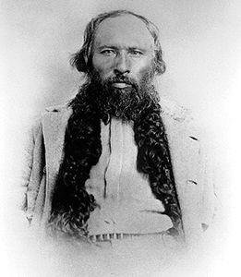
He was a Chief of the Cree who fought against the Canadian government at Frog Lake and Frenchman’s Butte. He surrendered and was convicted of treason with a sentence of 3 years in jail. He died shortly after his release in 1888.

He was the military leader of the Metis. He believed in using a guerilla war tactic of hit-and-run against the Canadian Militia. He fought with the Metis at Duck Lake, Fish Creek, and Batoche. He fled to American and was later pardoned for his actions by the Canadian government.

He is a Chief of the Blackfoot (Siksika) who refused to join Riel, the Metis, and other First Nations groups in fighting the Canadian government. He peacefully negotiated solutions to issues affecting his people.

He is a Chief of the Cree who fought against the Canadian government at Battleford and Cut Knife Hill. He wanted more food and supplies from the government. He stops his men from unnecessarily killing Canadian Militia. He surrendered, was charged with treason, and sent to prison for 3 years. He died shortly after his release.

He was in charge of the Canadian Militia. He and his men were attacked by the Metis at Fish Creek and retaliated by attacking them at Batoche. He received a medal and $20,000.
Gabriel Dumont

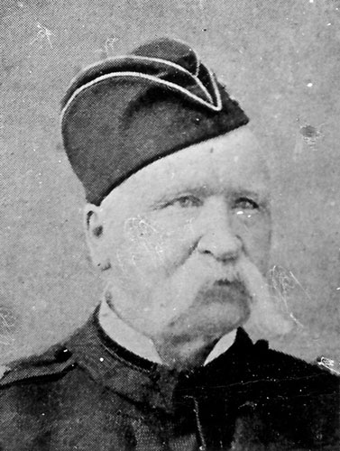
Major Frederick Middleton

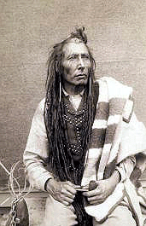

Poundmaker

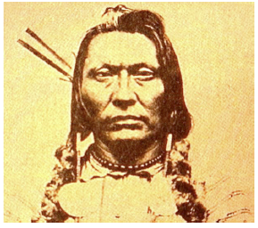

Big Bear

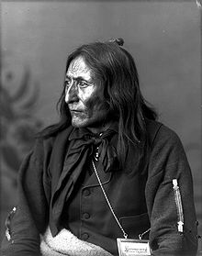

Crowfoot

Timeline of Events of the Northwest Uprising 1885
Use Canada Revisited pp. 250-251

March 19
- Louis Riel sets up a ____________________ government, with ____________________ as military leader
- European settlers _________________ join the Metis
- Most First Nations in the Northwest _______________ join the Metis

March 26 – Battle at __________________________
- Dumont and Metis attack ________________________ and the NWMP on the way to rescue arms and ammunition stored in Duck Lake
- Metis destroy Fort __________________

End of March – Raid on __________________________
- Cree Chief ________________________ travels to Battleford to talk with government agents about receiving more ______________ for his people
- Government refuses to negotiate; Cree raid the fort for supplies

April 2 – Battle at __________________________
- Cree Chief _______________ and his men attack the fort killing 9 men, including a government agent
Riel and Dumont disagree over how to proceed. _____________ wants to attack the army using guerilla tactics, while __________ says visions from God have told him not to attack unless provoked.
When Prime Minister Macdonald receives word of these events, he sends __________ soldiers under the command of Major General __________________ to the NW using the ________.

April 24 – Battle at ______________________
- Dumont and his men attack Middleton using ___________________ tactics
- This slows down the advancement of the Militia, but they aren’t defeated

May 2 – Battle at Cut Knife Hill
- _______________________ and his people are attacked by the Canadian Militia
- They are successful in defending themselves, but Poundmaker will not allow his men to _______________
May 9 – Battle at ______________________
- Metis and First Nations are waiting for the militia in dug out rifle pits; they soon run out of ammunition and have to resort to firing ______________________ and ______________________
- __________________ wins; __________ escapes and later surrenders; _______________ flees to the US

May 26 – ___________________________ surrenders

May 28 – Battle at _______________________________________
- __________________ and his men clash with the Canadian Militia; are able to escape

July 2 – ___________________ surrenders

This uprising lasted 99 days, resulted in the deaths of 53 Canadian Militia and 35 Metis and First Nations, and cost the Canadian government $5 million.

Outcomes and Consequences of the Northwest Uprising
Use Canada Revisited pp. 252-253 and Horizons 2nd edition pp. 187-189

What happens to the First Nations?
What happens to the Metis?
What happens to Louis Riel?

What happens to the CPR?
What happens to French-English relations?

