Ms. Ross Name: _____________
Socials 11 Date: _____________
KEY POLITICAL FIGURES IN CANADA
DURING THE POST WORLD WAR II ERA

Provincial Politicians in Post-WWII Canada (Chapters 6, 7, 8)

POLITICAL FIGURE | WHAT IS HE KNOWN FOR?
A. Tommy Douglas (CCF/NDP)  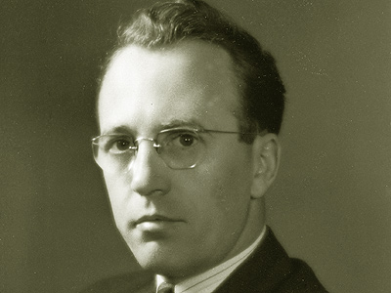 | - Premier of Quebec from 1936-39; 1944-59  - Strong Quebec nationalist; “distinct society”  - Introduced the ‘fleur de lis’ provincial flag  - Allowed RCC to heavily influence province  - Encouraged foreign investment in the province, with ‘kick backs’ going to his party  - Time in office had bribery, corruption, known as ‘The Great Darkness’
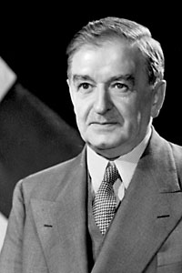  B. Maurice Duplessis  (Union Nationale) | - Quebec Premier from 1960-66  - Won campaigns with slogans “Time for a Change” and “Maitres chez nous” (masters in our own house)  - Got rid of corruption in provincial politics; reduced power and influence of the RCC  - Brought change known as the “Quiet Revolution” = modernize economy, education, and culture
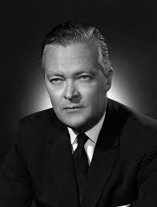  C. Jean Lesage  (Liberal) | - Quebec Premier from 1970-1976; 1985-1994  - In power during the October Crisis  - Created Bill 22 in response to Official Languages Act: made French the sole official language of the province
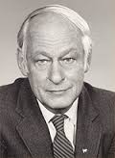  D. Rene Levesque  (Parti Quebecois) | - Premier of Quebec from 1976-85  - Created the Parti Quebecois – a provincial party that would focus on Quebec interests and separation  - Passed Bill 101: strengthened French language laws in government, business, and education  - Held referendum on Quebec sovereignty 1980 based on ‘sovereignty association’ (40% Yes, 60% No)
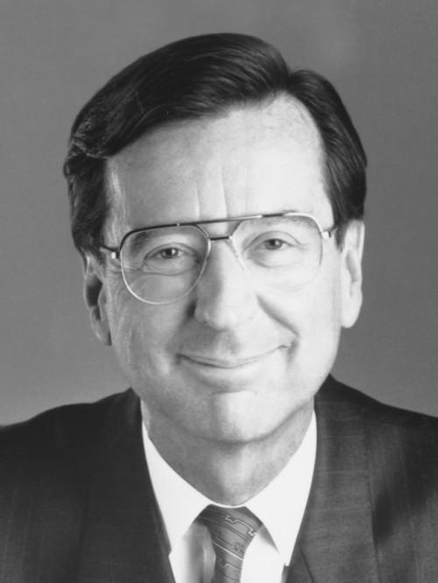  E. Robert Bourassa  (Liberal) | - Saskatchewan Premier, then became leader of NDP  - Introduced a provincial medicare program in 1962  - Helped to influence another federal party (Liberal) to adopt universal health care  - In 2004, was nominated the ‘Greatest Canadian’

Federal Politicians in Post-WWII Canada (Chapters 6, 7, 8)

POLITICAL FIGURE | WHAT IS HE KNOWN FOR?
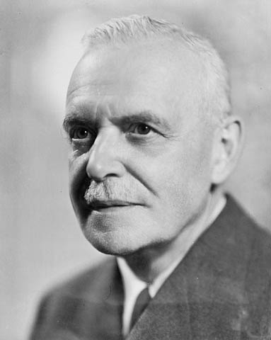  A. Louis St. Laurent  (Liberal) | - PM from 1963-68  - Earned the Nobel Peace Prize in 1957 for defusing the Suez Canal Crisis  - Created the 1963 Royal Commission on Bilingualism and Biculturalism  - Introduced Canada’s flag in 1965  - Introduced social welfare programs: Canada Pension Plan (CPP), Canada Assistance Plan, universal health care (Medical Care Act)
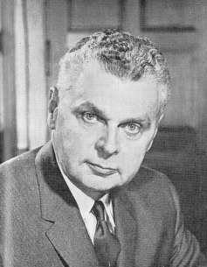  B. John Diefenbaker (Conservative) | - PM from 1948-1957  - Took over from Mackenzie King  - First PM to govern in front of media  - Added Newfoundland to Canada  - Expanded social welfare programs such as pensions, family allowance, hospital insurance  - Protected Canadian culture  - Increased political autonomy from Britain  - Defined Canada as a “middle power”  Supported NATO, UN, Korean War
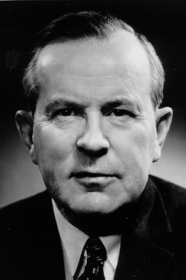  C. Lester “Mike” Pearson (Liberal) | - PM from 1968-1979; 1980-84  - Was very popular with the youth; relaxed, hip, like a celebrity; it was “mania” at public appearances  - Believed in a “just society”: 1969 Omnibus Bill, extending personal rights such as access to contraception, abortion, homosexual relationships; end to death penalty 1976  - Created the Official Languages Act 1969 – made Canada officially bilingual  - Issued the ‘White Paper’ 1969 (end to Indian status and Indian Act)  - Envoked the War Measures Act to deal with October Crisis  - Introduced an official policy of multiculturalism 1971  - Created the National Energy Program (NEP): reduce use of oil, protect oil prices, be self-sufficient in oil; was not popular in the West  - Introduced the idea of foreign aid to help developing nations (“trade and aid”)  - Fought against Quebec separatism in 1980 referendum  - 1982 repatriation of the Constitution and entrenching CCR&F in law
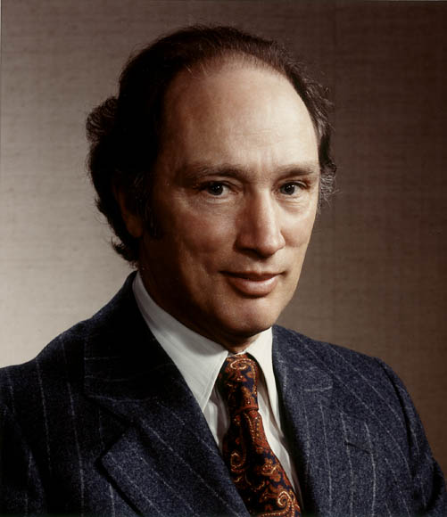  D. Pierre Elliott Trudeau (Liberal) | - Prime Minister from 1984-93  - Passed the Multiculturalism Act 1985 to recognize multiculturalism as part of Canada’s heritage and identity  - Tried to address Quebec separatism and Confederation in the Meech Lake Accord 1987 – give Quebec ‘distinct society’ status = FAILED  - Negotiated Free Trade Agreement (FTA 1989) with USA  - Attempted to settle Confederation issues with  - Introduced GST in 1991  - Signed the 1992 North American Free Trade Agreement (NAFTA) with USA and Mexico  Charlottetown Accord 1992 – distinct society status, Aboriginal self-government, reform the Senate = FAILED
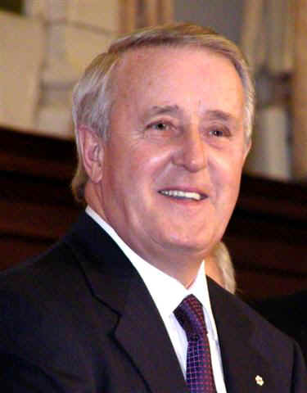  E. Brian Mulroney (Progressive Conservative) | - PM from 1993-2003  - Created the Clarity Act for future referendums on separation = clear question, clear majority  - Signed free trade agreements with Chile, Israel; joined Asia-Pacific Economic Cooperation (APEC)  - Sent Canadian troops to the crisis in Yugoslavia 1999  - Passed Youth Criminal Justice Act (YCJA) 2003 – updated the Young Offenders Act  - Refused to send Canadian troops to war in Iraq 2003
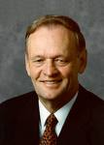  K. Jean Chretien  (Liberal) | - PM from 1957-63; first PM from Western Canada  - Won the largest majority government in Cdn history  - German origin; first PM to not be British or French  - Signed NORAD – linked Canada/US air defense  - Cancelled Avro Arrow project  - Believed in the “unhyphenated Canadian” = all equal  - Created 1960 Bill of Rights (precursor to CCR&F)  - Gave Aboriginals the right to vote federally in 1960

