Ms. Ross Name: _______________
Socials 11 Date: _______________
CANADA’S ROLE IN THE NEW WORLD ORDER
Use Counterpoints 2nd edition e-text pp. 271-279 to complete the following activity. Word bank is included.

In the first half of the 20th century, Canada was strongly influenced by ____________; but in the second half of the century our country saw a lessening of this influence and a new world power emerged that influenced Canada socially, economically, and politically – the ______________________________. PM Pierre Trudeau said it best with this quote: “Living next you is in some ways like sleeping with an elephant. No matter how friendly or even-tempered is the beast…one is affected by every twitch and grunt.” Conservative PM ____________________ created a close alliance with the US during his terms in office, yet Liberal PMs Trudeau and ____________________ did not always take direction from the US when deciding national and foreign policy.
Cold War tensions were still present in the 1980s. The US developed the idea of a __________________ that would protect against Communist nuclear weapons – this was the Strategic Defence Initiative (SDI) more commonly known by its nickname ___________. Canada chose not to participate in this initiative.
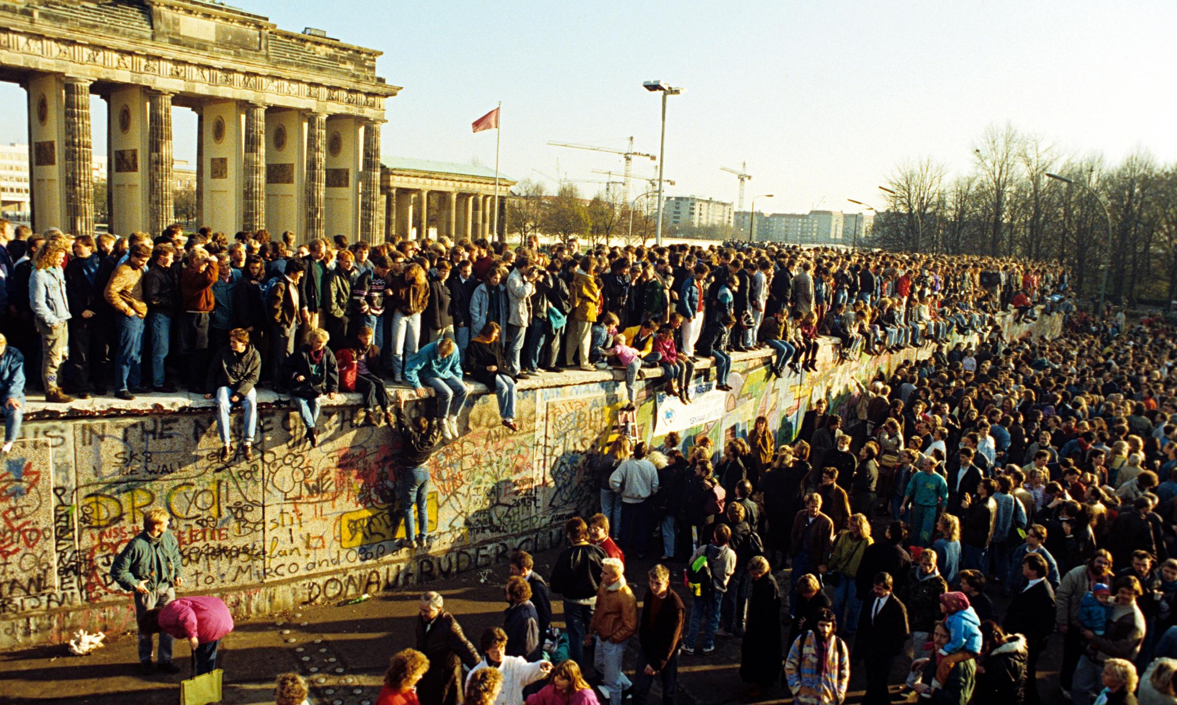
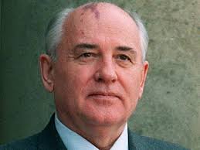
The high cost of designing and building nuclear weapons was starting to take its toll on national budgets. The Soviet Union, under _______________________, decided to cut the military budget and place this money in modernizing the country. His policy of ______________ (reconstruction) would focus on reforms to politics, the economy, and society. ___________ (openness) allowed for more freedom of speech and less censorship. These ideas were also implemented in other European communist states. By 1991, the Soviet Union collapsed and the Cold War came to an end. The most famous symbol of this was the fall of the Berlin Wall.

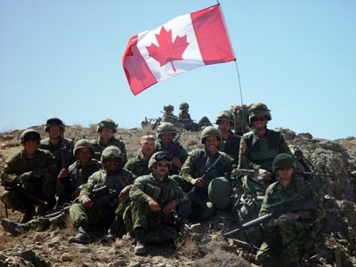
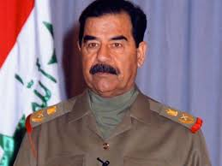
The end of the Cold War did not signal a time of world peace. Since 1990, the world has seen as escalation of ____________ conflicts and _________ rivalries. The ____ has a mandate to ensure collective security, but will its traditional methods of keeping world peace work? The first post Cold War conflict was the __________________________ in 1990. ____________________ and Iraqi forces invaded _____________; the UN responded with demands that Iraq withdraw or suffer _________________ sanctions. Ignoring UN demands, a multinational military force, known as Operation Desert Storm, was put together led by the ____. Canada participated in this war by sending 2 naval destroyers, a supply ship, fighter jets, a hospital unit, and soldiers. Some believed Canada should enter the war since we are a member of the UN; others believed not enough time was given to see if economic sanctions would influence Iraq to withdraw before resorting to war. The ‘_________’ technology used in this war was unlike anything ever seen and changed the nature of warfare forever. UN attacks decimated the Iraqi military and the country’s infrastructure leading to victory. No Canadians were killed or injured in the war. Moving forward, the UN’s mandate would include not only _____________________ but also ___________________; if necessary, military force would be used to obtain collective security.

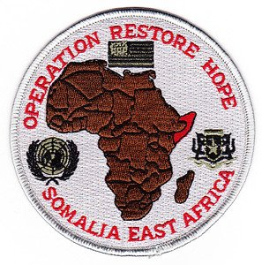
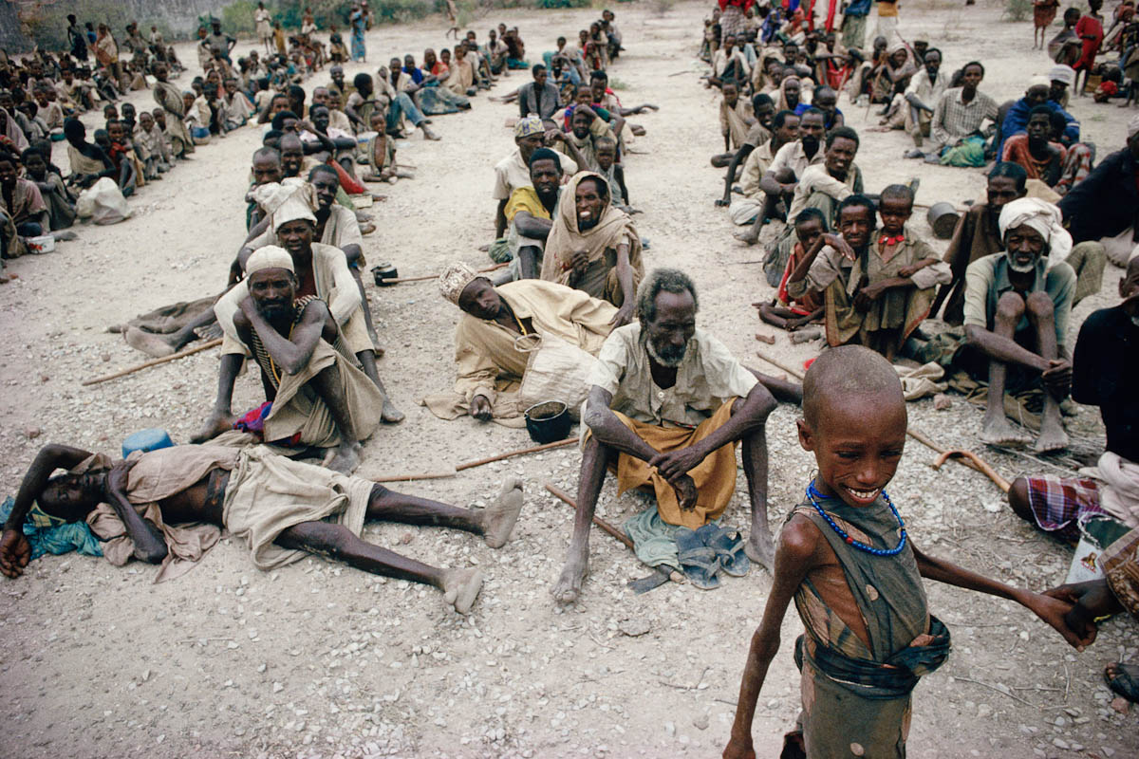
Regional conflict in Ethiopia resulted in a ____-led UN intervention. In 1992, “______________________________” was launched to bring an end to civil war and famine. Canada was given the role of distributing ________ and ___________, but shipments were hijacked by war lords. One night, Canadian soldiers beat and tortured a Somali teen to death. Initially it looked as though a few low ranking officers had committed a racist crime; but further investigation discovered high ranking officials had been involved in a ___________. The conduct and subsequent attempt to hide it damaged Canada’s international _______________.
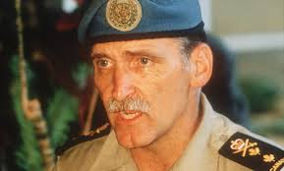
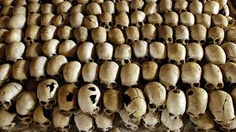
The UN’s next big test was stopping genocide in ____________ in 1994. This was a conflict where ________ began murdering _________. The UN sent a small peacekeeping contingent, led by Canadian Lieutenant General _____________________. Dallaire called on the UN and the US to provide more troops and equipment to stop the killings; neither group was interested in committing troops or resources to the conflict. After 10 Belgium soldiers were killed they withdrew all their troops. Dallaire was left with a small peacekeeping unit to defend the country. 800,000 - 1 million Rwandans died in 100 days of conflict.

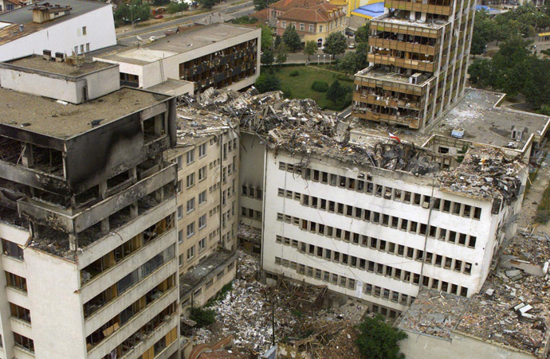
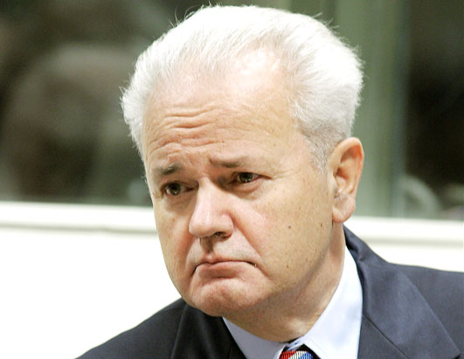
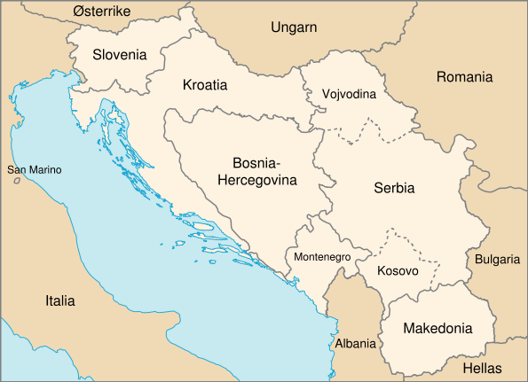
While this conflict was occurring in Africa, there was another conflict in Europe that required UN support. Yugoslavia was engulfed in ethnic wars amongst Serbians, Albanians, Croatians, and Bosnians. The President of Serbia, _________________________, wanted to unite all Serbians. Fighting began in Bosnia-Herzegovina and Croatia amongst Serbians, Croats, and Bosnians. UN _________________ were sent to the region but were unsuccessful in de-escalating the situation. _______ forces took over and launched air strikes against Serbian forces in 1995. A ceasefire agreement was made and UN peacekeeping forces were kept in the region. In 1998, Serbian forces began committing acts of genocide against _____________________ to cleanse the region for Serbian occupation. US dominated NATO forces launched a military operation; as part of NATO, Canada participated in the air strikes. There were conflicting opinions about our country’s involvement: a) should we act to stop the atrocities? b) is it our place to interfere in the problems of an independent country? c) isn’t it the UN’s role to address threats to collective security?
WORD BANK

Albanian Muslims
Brian Mulroney
Britain
cover up
defence shield
economic
ethnic
food
glasnost
Hutus
Jean Chretien
Kuwait
Mikhail Gorbachev
NATO
Operation Restore Hope
peacekeepers
peacekeeping
peacemaking

perestroika
Persian Gulf War
regional
reputation
Romeo Dallaire
Rwanda
Saddam Hussein
Slobodan Milosevic
smart
Star Wars
supplies
Tutsis
United States of America
US x2

