Name: _Connor____________

Date: __Feb 19, 2018___________

Science 10

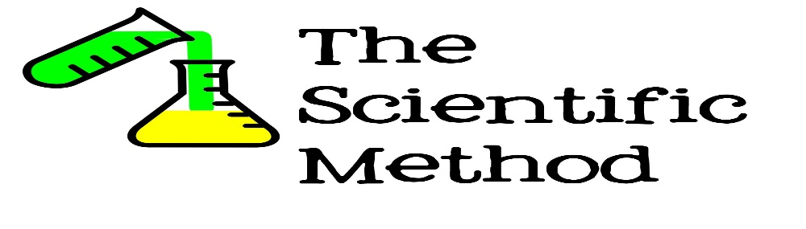

Science is…

A study of natural ___phenomenon______________________.

A systematic study and method.

Knowledge through __Experience_____________________.

A good Scientist is….

* + Is safe!
  + Is accurate, precise and methodical.
  + Is unbiased, a seeker of the truth.
  + Can observe and question.
  + Can find solutions, reasons, and research.
  + Works in all weather conditions if safe.
  + Can overcome obstacles.
  + Collaborates (talks) with others.

Science is a systematic attempt to get around human limitations.

* + Science tries to remove personal experience from the scientific process.

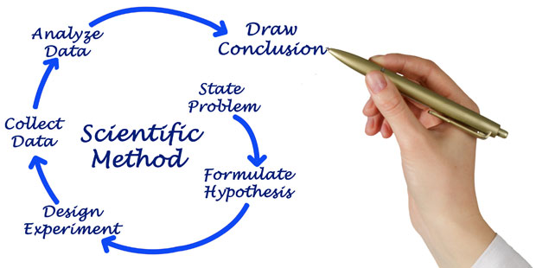Try and write without personal pronouns.

* + AVOID USE OF…I, me, you, he, she, we, you, they, them, theirs, names, etc

The experience was ok and the items had a hard texture after passing it around 3 times.

**Scientific Method:**

**(A) ASKING A QUESTION**

Science starts with an observation about the world around us. An interesting question is to ask why something works in a particular way or how it works.

Examples: - Why do leaves turn red in the fall?

- What will happen if I give my cow steroids?

What was the question we asked in our “Float Your Boat” activity?

What design would hold the most pennies without sinking in the water with limited designs?



_____________________________________________________________________

**(B) HYPOTHESIS**

Scientists make a hypothesis regarding the observations and questions that they make.

A hypothesis is _____________If the boat is equally shaped, then the boat will hold more pennies._________________________________________________________

______________________________________________________________________

To be **valid**, a hypothesis must be **testable.**

Example: To say “the moon is made of cheese” is not a valid hypothesis if we can’t travel to the moon to test this.

Hypothesis should be written in the form – “______...___________...___________________”

Example: **If** I feed my cow steroids…**then** they will produce milk…**because**…

“Float Your Boat” Hypothesis – ______________________________________________________________________________

______________________________________________________________________________

**(C) VARIABLES**

Scientists design ____________________ experiments to test hypothesis. This means that all variables (conditions) must be kept the same, **except for one** which is the condition/variable that is being tested for.

**Control Group** - The control group allows the experimenter to compare his test results with a **group that has not been affected by the experimental variable, but all other conditions remain the same**. This is so we can feel confident that those results are not due to chance.

**Experimental Group** – This group **gets the variable being tested for** while all other conditions remain the same as the control group.

**Independent Variable** - The variable that is **controlled and manipulated** by the experimenter.

**Dependent Variable** – The variable that is **measured for change** as a result of the independent variable being manipulated.

The only difference between these two groups is that the experimental group gets the variable being tested and the control group does not.

**Experiment #1: Does fertilizer help a plant grow?**

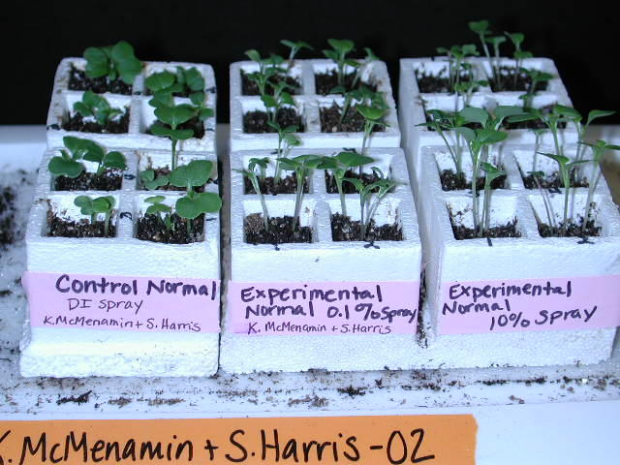

|  |  |  |  |
| --- | --- | --- | --- |
| **Problem** | **Independent Variable (change)** | **Dependent**  **Variable**  **(observe)** | **Control**  **Variable**  **(same)** |
| **Does fertilizer help a plant grow?** | **Amount of fertilizer** | **Height/size**  **Colour**  **Number of leaves**  **flowers** | **How much water**  **Same type of plant**  **Location**  **Type of soil**  **Light**  **Water**  **Space** |

**Experiment #2: Do Pillbugs prefer a light or dark environment?**

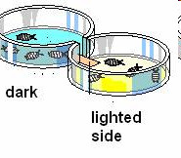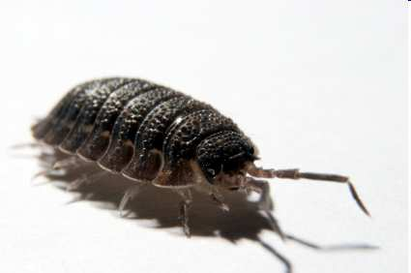

|  |  |  |  |
| --- | --- | --- | --- |
| **Problem** | **Independent Variable (change)** | **Dependent**  **Variable**  **(observe)** | **Control**  **Variable**  **(same)** |
| **Do Pillbugs prefer a dark or light environment** | **One is dark, one is light** | **How many pillbugs that enter dark number** | **Amount of pillbugs**  **Size of the container**  **Moisture**  **Food**  **Size of the pillbug** |

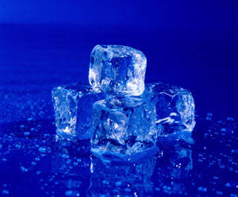**Experiment #3: Minerals and Ice?**

|  |  |  |  |
| --- | --- | --- | --- |
| **Problem** | **Independent Variable (change)** | **Dependent**  **Variable**  **(observe)** | **Control**  **Variable**  **(same)** |
| **What mineral will melt the ice the fastest?** | **The type of mineral** | **The melting time** | **Location**  **Size of ice** |

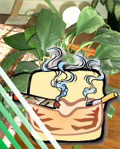

**Experiment #4: Cigarette smoke and plants**

|  |  |  |  |
| --- | --- | --- | --- |
| **Problem** | **Independent Variable (change)** | **Dependent**  **Variable**  **(observe)** | **Control**  **Variable**  **(same)** |
| **Does cigarettes affect plant growth?** | **Smoke amount** | **Which plant will live**  **Height of the plant**  **Amount of leaves** | **Container**  **Soil**  **water** |

**EXTRA PRACTICE:**

Ashley receives 10 potted flowers for Valentine’s Day. She keeps her potted plants outside her bedroom window. Over the next week she notices that her flowers open during the day and close again at night. She thinks that flowers sense the warmer temperatures during the day and open up when the temperature increases. She also thinks that colder temperatures at night cause the flowers to close. She wants to test her idea. Ashley brings her 10 plants inside her bedroom and places them next to her window. The temperature inside her room is always . Each day Ashley looks at her plants and discovers that her plants still open during the daytime and still close during the night time hours. She decides that a warm temperature is not the signal that tells the plants when to open, and cold temperature is not the signal that tells the plants when to close. Something else must be telling the plants when to open and close.

Initial Observation:

Hypothesis (If…then…because):

Control Group:

Independent Variable:

Dependent Variable:

**(D) DATA AND DATA ANALYSIS**

Data can be recorded in many ways, but it must be recorded for both groups **in the same way**.

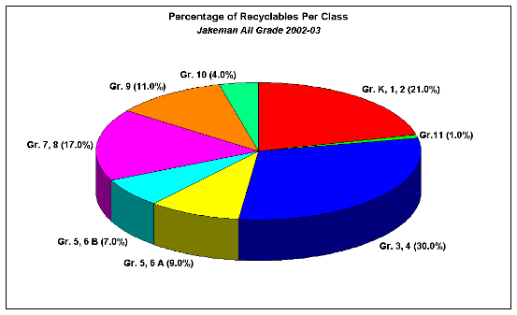Examples: tables, graphs, equations, etc.

Data is both **qualitative** and **qualitative.**

Qualitative – quality

Quantitative – quantity

Once the data is recorded in one of these formats, it is analyzed to see if it supports your hypothesis or does not support your hypothesis.

**(E) CONCLUSION**

This is the final reflection on the experiment that brings everything together.



1. State your results (what you found out).

2. State whether your hypothesis was **supported** or **refuted**.



3. State how the results lead you to decide whether your hypothesis was correct or not.

4. Any errors that could have been made that would have affected the results.

5. Suggestions for improvement in experimental design.

Practice:

**The Strange Case of BeriBeri**

In 1887 a strange nerve disease attacked the people in the Dutch East Indies. The disease was beriberi. Symptoms of the disease included weakness and loss of appetite, victims often died of heart failure. Scientists thought the disease might be caused by bacteria. They injected chickens with bacteria from the blood of patients with beriberi. The injected chickens became sick. However, so did a group of chickens that were not injected with bacteria.

http://www.biologycorner.com/resources/bird_chicken.gifOne of the scientists, Dr. Eijkman, noticed something. Before the experiment, all the chickens had eaten whole-grain rice, but during the experiment, the chickens were fed polished rice. Dr. Eijkman researched this interesting case. He found that polished rice lacked thiamine, a vitamin necessary for good health.

1. State the Problem

Nerve disease was attacking people in the west indies

2. What was the hypothesis?

The disease was caused by bacteria If we inject the bacteria then the chickens will get sick because bacteria causes the disease

3. How was the hypothesis tested?

Injecting bacteria into the chickens

4. Should the hypothesis be supported or refuted based on the experiment?

Rejected

5. What should be the new hypothesis

If people/chickens are fed polished rice, then beri beri will come because the rice lacks thiamine.

**How Penicillin Was Discovered**

In 1928, Sir Alexander Fleming was studying Staphylococcus bacteria growing in culture dishes. He noticed that a mold called Penicillium was also growing in some of the dishes. A clear area existed around the mold because all the bacteria that had grown in this area had died. In the culture dishes without the mold, no clear areas were present.

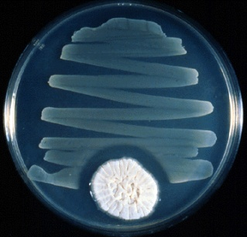Fleming hypothesized that the mold must be producing a chemical that killed the bacteria. He decided to isolate this substance and test it to see if it would kill bacteria. Fleming transferred the mold to a nutrient broth solution. This solution contained all the materials the mold needed to grow. After the mold grew, he removed it from the nutruient broth. Fleming then added the nutrient broth in which the mold had grown to a culture of bacteria. He observed that the bacteria died.

1. Identify the problem.

Penicillum was growing

2. What was Fleming's hypothesis?

If the bacteria is added to the broth, then it will die off

3. How was the hypothesis tested?

Putting the bacteria in the broth

4. Should the hypothesis be supported or refuted based on the experiment?

Supported

5. This experiment led to the development of what major medical advancement?

Nutrient broth