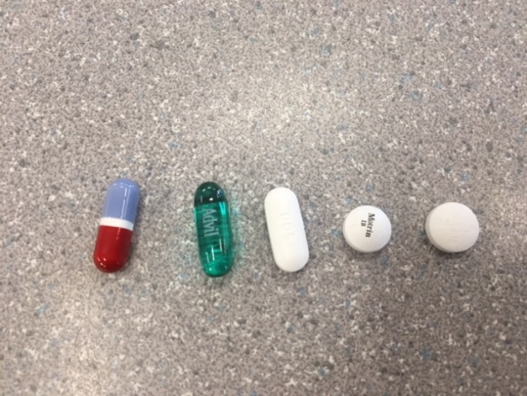**Pill dissolving experiment**

Partners; Madeline, April, Nolan

**purpose**

to see which pill dissolves the fastest

**prediction**

the aspirin tablet will dissolve the fastest.

**Hypothesis**

If we create a stomach like environment, then the aspirin tablet will dissolve first.

**Materials**

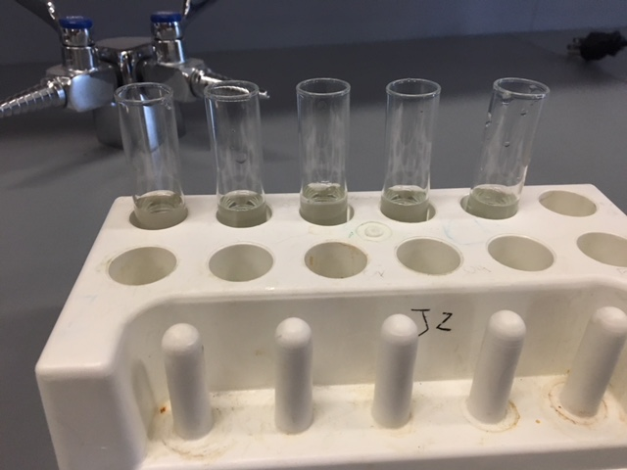test tubes, beaker, safety googles, test tube tray, heating pad, vinegar 5ml, water 12ml, medications; Motrin, aspirin, Tylenol, Advil liquid gels, no name Life Brand.

**Procedure**

Heat vinegar and water in beaker on heating pad till reaches 38 degrees. Pour liquid into test tubes, place each different pill’s in each test tube and wait and watch to see results.

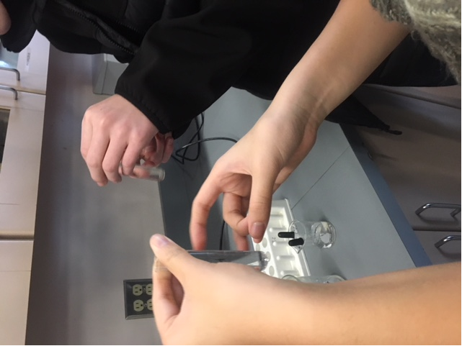

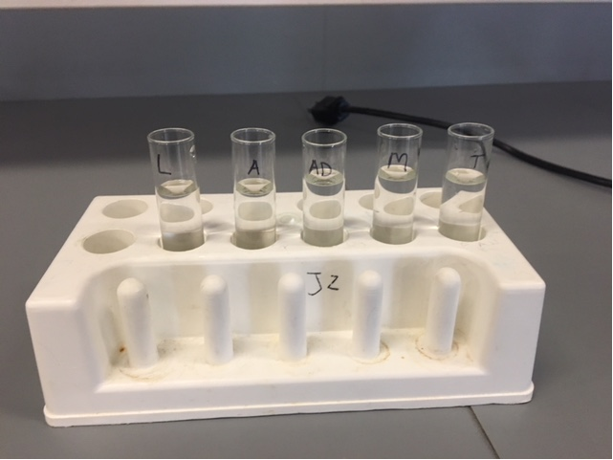**Observations**

•31 minutes > Tylenol looks like white fuzz

·Advil looks same, looks like expanding the letters peeled off

Asprin looks like a small gathered fuzz at bottom of test tube

·Motrin A flattening pancake…starting to get fuzzy

·Life Brand…exploding like the capsule broke open 'fluff' is coming

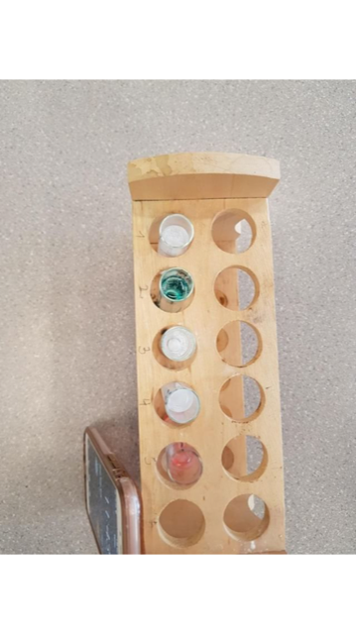

* + 26 minutes > Advil still looks the same
    - Tylenol still like a thick layer of fuzz
    - Asprin like a small amount of fuzz
    - Motrin looks like its rising pancake, still sorta fuzzy
    - Life Brand capsule breaking apart almost as if exploding from the inside out.
  + 24 minutes > Advil looks like the top is evaporating? Turning invisible…the gel layer getting thinner.
  + 20 minutes > Tylenol Fuzz expanding
    - There's now a line split down the advil, it's white on the edges
    - Aspirin still the same
    - Motrin deflated and now fuzz is like rising upwards
    - Life brand still the same, a pile of grossness with a mix of red and white fuzz everywhere in the bottom
  + 15 minutes > Tylenol Still same amount of fuzz
    - Advil looks like a bean…top is narrower the bottom is fat
    - Asprin looks like weak amount of snow
    - Motrin looks like it's climbing the sides of the test tube
    - Life Pill looks like blood in snow
    - They all got little bubbles in the test tube…Tylenol has the most bubbles
    - 5minutes> Tylenol is still fuzz
    - Advil is still looking bean like, small crack in the lower portion; milky liquid is releasing
    - Aspirin looks the same
    - Motrin looks the same
    - Life brand has continued the blood and snow appearance
    - Bubbles have continued.

**Was your hypothesis supported?**

Yes, my hypothesis **was** supported

**Conclusion**

In conclusion, we were successful with our hypothesis. We Learned that after our medications have spent 30 mins submerged in our stomach like concoction, our Advil liquid gel still failed to react as some had hopped even though we improved our experiment from the past year of testing. In our next experiments with these medications we could add a more acid like material to make the concoction more stomach like. Testing could be done more accurately by having more samples with different variations. To wrap things up, the Advil liquid gel still hasn’t succeeded in our experiment even though we gave stomach like components. In future studies more, variations should be implemented.