Pitch Organizer
Part 1:
- Complete the chart below (Horizons – Chapter 4 – pages 126-128):
 | Hudson’s Bay Company | Northwest Company
How did it start? | British wanted to be more competitive and involved in the fur trade with Aboriginals. | Small fur traders were not able to compete with HBC so they all came together to make one trade group.
Where does it operate? | Managed out of Britain. Hudson’s Bay area of the Canadian Shield | Managed from Montreal. Operated throughout mainly through Fort William. From there goods would be moved inland. Rupert’s land.
What was it like working for the company? | Boring especially during the winter because not a lot of people travel in the cold weather. | A long and slow process transporting goods around. Travelling took long because may portages were made, caused by rapid water, poor conditions.
What are the advantages this company had over the other?  Explain why these are advantages | Workers received a salary. No matter how well or poor the company did workers would get the same salary all year around. | The more profit the company received, the more you would get in salary. Worked closer to FN, better quality.

Find a quote/image that confirms any of the above
Source:  (author, title, year written/published, URL) | Joseph James Hargrave  Red River  1871  http://www.furtradestories.ca/details.cfm?content_id=66&cat_id=2&sub_cat_id=1
Quote/Image: | “In winter, after the first snow has fallen, and before the tracks have been beaten, the roads are bad, but the inconvenience undergone by passengers at that season is as nothing to that caused by the melting snow in spring, when the ground is usually, for nearly a month, so saturated with water as to render locomotion, except on horseback, almost impracticable.”
Interpretation: | The tough and gross conditions are common and not favorable. But you get used to many portages after a while.
How might this affect a character or a plot? | Making the process of travelling longer and more tiring. Having to unpack the boats and bring goods on land and re-loading to set out again.

- What do Voyageurs do and what was their life like (Horizons – Chapter 4 – page 120)?
-Voyageurs row canoes that are holding goods ready to be traded. Their lives were very tiring and long. It takes many hours just to get to one place with many stops in between. At the end, they would drop off their goods and pick new stuff up to return. They are also rowing for most of the day so by the end they would be exhausted. Voyageurs also wouldn’t get to see their family a lot as they are always moving. They also did not have much food with them except for water and the unfavorable pemmican. It was not the best but they ate it to get the energy.

Find a quote/image that confirms any of the above
Source:  (author, title, year written/published, URL) | Ballantyne, Robert Michael  Hudson Bay, or, Everyday life in the wilds of North America  Published 1879  https://archive.org/details/cihm_26409
Quote/Image: | “When there was not much probability of being interrupted by portages, I used to spread out my blanket in the stern of the boat and snooze till breakfast time.”
Interpretation: | Without portages the more energy you are losing and you are not gaining enough rest.
How might this affect a character or a plot? | Would not be healthy for a character, could become ill, dehydrated.

- Complete the chart (Horizons – Chapter 4 – page 132):
How did Aboriginals contribute to the fur trade? | They were the ones trapping and skinning the beavers. Taught Europeans how to build canoes and snowshoeing to travel. They also showed them how to survive off the food of the land instead if bringing everything you need.
How did the fur trade affect Aboriginals? | -Created competition among each other  -European diseases were brought over (many fell ill)  -Way of life changed  -Before, every day they gathered what they needed  -After, gaining profit was the focus  -1800, Fur demand went down  -Aboriginal economy suffers  -Introduced alcohol to the FN (gave gifts after finished trading)

Find a quote/image that confirms any of the above
Source:  (author, title, year written/published, URL) | Thomas McCliesh  Letters from Hudson Bay  1703-1740  http://www.furtradestories.ca/details.cfm?content_id=94&cat_id=2&sub_cat_id=1
Quote/Image: | "I hope the trade will increase and not diminish, provided your honours send a yearly supply of such goods as is most taking with the Indians, which I shall indent for.”
Interpretation: | I hope the demand for fur goes up and not down and the British will always continue to supply goods from their land as it helps the Aboriginals out a lot.
How might this affect a character or a plot? | This could affect the character’s everyday life. Without demand for fur Aboriginals would have to put their knowledge towards harvesting a different goods.

- In what ways were Aboriginal women vital to the fur trade? (Horizons – Chapter 4 – page 134)?
-They acted as guides (women know how to get around the land)
-Married to NWC fur traders create ties
-Most fur traders had wives in different areas
-Traders learned how to build traps, snow shoes, moccasins, pemmican bags (buffalo hide), pemmican and learned how to gather food.
- ‘Relationship of business’
A lot of travelers would not have survived without the help from a wife.

Find a quote/image that confirms any of the above
Source:  (author, title, year written/published, URL) | A. Gottfred  Women of the Fur Trade  1774-1821  http://www.northwestjournal.ca/XIII2.htm
Quote/Image: | “These relationships had a firm, practical foundation. By marrying a Native or Mixed-blood woman, fur traders strengthened trade ties with her Native relatives. The marriage also could help to improve relations with the rest of her nation, as the fur trader now had ready access to inside information on their language and culture.”
Interpretation: | Marring a First Nations women was more of a business strategy. The fur traders were looking for more of a business relationship.
How might this affect a character or a plot? | This would help a character more than be negative. The male trader would need his wife to help guide, cook, set up shelter etc.

- Describe the Metis and their society. How did they contribute to the fur trade? (Horizons – Chapter 4 – pages 138-140)?
-French Canadian traders married Aboriginals
-Children become metis (mixed)
-Spoke French and Cree
-Not always fully accepted by the fur trader
-Developed in southern Manitoba
-Hunting buffalo was central to their way of life
-Provided meat hides
-Sold to voyageurs and traders
-Used muskets to hunt
-Followed the buffalo herds
-Women and children drove carts to drive the herds
-Men hunted them

Find a quote/image that confirms any of the above
Source:  (author, title, year written/published, URL) | Horizons Chp. 4 Pg. 139  Metis
Quote/Image: | “Belonging completely to neither parent’s culture, they were, in effect, the children of the fur trade.”
Interpretation: | Metis aren’t fully one culture so it may be hard for them to be respected in the business.
How might this affect a character or a plot? | Mixed children might not feel fully accepted by either side. They would want to fight to prove their worth to their parents.

- Use the space below to start brainstorming a sequence of events that incorporates all the above into a story. Think about how one character may encounter or interact with all the above.
-Fight between two companies
-Portages
-Travelling (land and water)

- Create a sketch or find images that illustrates at least one aspect in #6:
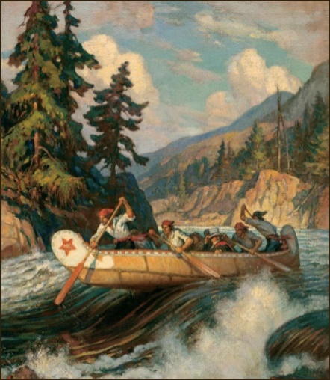
Part 2:
- Describe the push and pull factors of Irish immigration to Canada in the 1800s:
Push Factors (In Ireland) | Pull Factors (Canada)
-Absentee landlords  Landlords left the farms while others worked  -Potato Famine  -Blight (fungi) started growing on the potatoes which made it not safe to eat  -Lost a lot of potatoes  -Sold all the good food to the British  -Not enough food to feed everyone in  Ireland  -Discrimination  -British thought the Irish were lower than them | -Landlords pay for the trip  -Vision of freedom  -Lots of food and land

Find a quote/image that confirms any of the above
Source:  (author, title, year written/published, URL) | Robert Seymour  The Absentee  1830  https://s-media-cache-ak0.pinimg.com/736x/88/67/3c/88673cb6c9ee2716d0b5f9a17403a6e1.jpg
Quote/Image: | 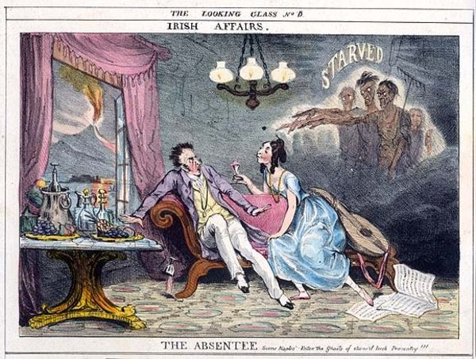
Interpretation: | This shows how unfair the farm business was. The landlords would have all the nice things, go on vacation while the Irish farmers are starved and worked long hours just to support one person.
How might this affect a character or a plot? | The character could be worked very long and could start effecting their health and mental state. This would happen if they did not receive enough food, sleep, or proper care (hygiene).

- Describe the conditions on board coffin ships (Horizons – Chapter 2 – pages 57-58):
-Crowded
-Poor conditions
-Rocky (sea sick)
-Stuffy, humid, smelly
-Low quality food
-Fighting for food
-No privacy

Find a quote/image that confirms any of the above
Source:  (author, title, year written/published, URL) | Immigration vessels- between docks  http://www.mayolibrary.ie/en/media/Media,11151,en.jpg
Quote/Image: | 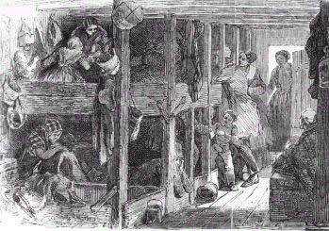
Interpretation: | This picture shows how crammed the coffin ships were. It also shows how much of your privacy is taken away.
How might this affect a character or a plot? | The diseases could affect the character’s health.

- In what ways were the Irish accepted or not accepted in Canada?
Accepted | Not Accepted
-Catholics Irish  -Had more money  -Higher class  -French accepted them  -Both didn’t like the British  -Same religion  -French were willing to let them in even with the language barrier | -Protestants were not treated equally  -Canadians still saw them as the Irish stereotype  -Thought they were all diseased from the ships  -People thought they had poor education

Find a quote/image that confirms any of the above
Source:  (author, title, year written/published, URL) | The Ignorant Vote-Honours are easy  Harper’s Weekly  Dec. 9 1876  http://cartoonsmix.com/cartoons/irish-discrimination-cartoon.html
Quote/Image: | 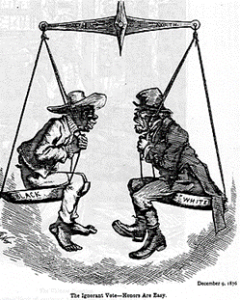
Interpretation: | At the time, the black was seen as a race that was not fully developed and as knowledgeable as the British. By putting the Irish and black on an equal scale shows how they were viewed in the same class. Showing neither the Irish or black had the technology or smarts to keep up with the British and other higher class races. The higher races viewed them as useless and unworthy. The painter also shows them looking like monkeys which gives them the reputation of undeveloped, unmodern not hard workers.
How might this affect a character or a plot? | The character might feel they are not appreciated and they could never live up to the British. Would want to show they are as smart as the British. They might go onto a coffin ship.

- Use the space below to start brainstorming a sequence of events that incorporates all the above into a story. Think about how one character may encounter or interact with all the above.
One male worker and his family gets evicted
-He then goes to workhouses
-Can’t support everyone
-Wants to go to Canada
-Doesn’t have enough to pay to board the coffin ships
-Sneaks him and his family on the ship

- Create a sketch or find images that illustrates at least one aspect in #4:
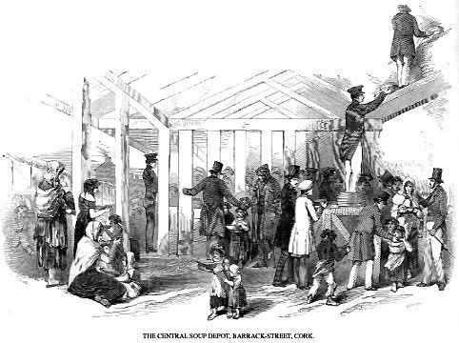

Part 3:
- Describe the push and pull factors of American slaves immigrating to Canada in the 1800s (Horizons – Chapter 2 – pages 60):
Push Factors (In America) | Pull Factors (Canada)
-Treated unfairly  -Everybody looks at them as less  -Worked very long hours  -Beaten, whipped | -Freedom  -No more slavery  -Food  -Acceptance  -Equality  -Education  -Windsor has multi coloured schools  -Government helps you  -Find a job  -Supports you for the first few days  -Gives you land (5 acres)

Find a quote/image that confirms any of the above
Source:  (author, title, year written/published, URL) | Fountain Hughes  1949, June 11  http://memory.loc.gov/cgi-bin/query/r?ammem/afcesn:@field(DOCID+afc9999001t9990a)
Quote/Image: | “It didn’t matter about your tired, being tired. You’re afraid to say you’re tired.
Interpretation: | The slave masters didn’t care if you were tired because you are still producing. If the slaves said they were tired they could get beaten and whipped to be ‘woken up’.
How might this affect a character or a plot? | Being whipped and worked long hours would affect the character’s mental state which would then lead to the quality and quantity of their work production. Being talked down to and not getting enough rest would affect them mentally.

- Describe how slaves made it to Canada/free states (Horizons – Chapter 2 – pages 60-61):
-Slaves that have escaped from their masters would take the underground railroad
-Underground railroad was a code word for escaping, there were no tunnels dug or specific paths
-People found out about it strictly from word of mouth because if it was recorded the information of about escaping and workhouses got in the wrong hands ‘security’ would be a lot more strict
-Workhouses were run by people that wanted to help slaves
-They had small hidden rooms to hide and keep slaves safe if slave hunters searched their house
-These were used for a resting point for slaves on the path of their journey
-Slaves could stop for rest, sometimes food or to lose their master if they are being followed
-Along the way slaves would have to be very careful about who they speak to or where they walk
-Rewards could be given out by masters so people always had their eyes open for dark skin
-Masters also had slave hunters go out and re-capture their slaves
-Slaves would have to travel during dark for a smaller chance of being spotted
-Travel though rough weather conditions

Find a quote/image that confirms any of the above
Source:  (author, title, year written/published, URL) | https://s-media-cache-ak0.pinimg.com/originals/64/07/e4/6407e40913c57508b61ce18f1de46f41.jpg
Quote/Image: | 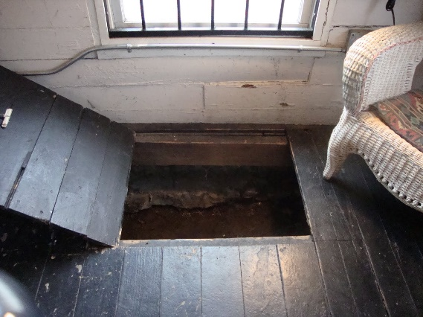
Interpretation: | Shows how people wanted to help slaves escape. They hosted safe houses for slaves so if a slave needed to rest they would have to know of one and then they could take the risk to approach. Most safe houses had hidden rooms for slaves to hide in if a slave hunter or master searched the house.
How might this affect a character or a plot? | A slave would be nervous taking the risk of seeing if it is a safe house. If it wasn’t a true safe house the slave might be turned in for a $ reward.

- What was the Fugitive Slave Act and how did that affect the Underground Railroad?
The Fugitive Act
-Slaves could be captured by slave hunters and/or masters in all states
-Doesn’t matter if you were in a free state or not you could be brought back to a slave state
-This made free black people scared to because they could also be captured
-This made the underground railway even more dangerous because you weren’t safe in the free states anymore. So much tried to make it to Canada which is an even longer journey.

Find a quote/image that confirms any of the above
Source:  (author, title, year written/published, URL) | Operation of the Fugitive Slave Law  https://padresteve.files.wordpress.com/2014/12/fugitive-slave-act-1850-granger-1.jpg
Quote/Image: | 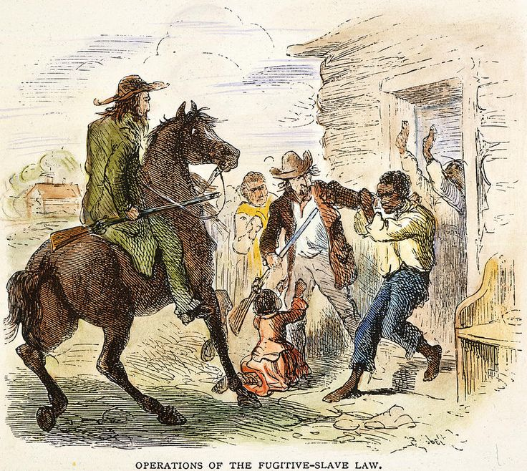
Interpretation: | Here it shows a slave being taken away by a slave hunter back to the master. It looks like the slave and a few others found a house to live in but they were still found.
How might this affect a character or a plot? | The main character could have finally made a successful escape to a free state but when the Fugitive Law is placed they get taken away back to the master.

- In what ways were the Black immigrants accepted or not accepted in Canada?
Accepted | Not Accepted
-Committees we formed to raise to help the black immigrants  -The government would give them some support (money, food) during the first few days of arrival | -Some thought they should not be given free land and food because they did not work for it

Find a quote/image that confirms any of the above
Source:  (author, title, year written/published, URL) | Drew Benjamin  1856  http://www.inmotionaame.org/texts/viewer.cfm
Quote/Image: | “The object of the society is declared to be to assist he refugees from American slavery to obtain permanent homes, and promote their social, moral, physical and intellectual elevation.”
Interpretation: | The society was mainly made to help slave immigrates feel welcomed and to support them. This shows how accepting most Canadians were with a sudden jump of population.
How might this affect a character or a plot? | The character might have just arrived in Canada. They could feel a little lost and not sure where to get started.

- Use the space below to start brainstorming a sequence of events that incorporates all the above into a story. Think about how one character may encounter or interact with all the above.
-Slave would escape, make it to a safe house but when they arrive they are turned in for a reward
-While slave hunter brings the slave back to the master, master sells slave to a master closer to the free state border.
-Slave escapes a second time and then makes it to a free state
-Days after, word gets around it is now legal for slave hunters to bring slaves from free states back into the slave states.
-Now free slave, makes their way to Canada safely and consciously.
-Is given land from the Canadian government but they must prep the land before they can build a house.

- Create a sketch or find images that illustrates at least one aspect in #4:

Part 4: Video Discussion
- What modern day events share some parallels with the fur trade? Explain the similarities.
-To this day Canada trades with countries around the world.

- How vital were Aboriginals to the fur trade? Who is more significant to the creation of our Canada today, the Aboriginals or the European fur traders?
-The Aboriginals were very important to the fur trade because they were the ones hunting and gathering the resources.
-I think the Europeans were the ones that were most important to the creation because without them the Aboriginals would have no one to trade with. The Europeans were the ones that came over to set up trading posts.
]
- Are push (from anywhere) and pull factors (to Canada) generally the same today as it was in the 1800s? Explain why or why not regarding the Great Migration and the Underground Railroad.
-The pull factors are mostly the same. When people think of Canada today they still think of freedom, acceptance, multi-cultural. They might not think of food and land as they did back then but overall I think they are similar. Push factors could also be the same like, no freedom, not being accepted.

- Is Canada more accepting of immigrants today than it was in the 1800s? Explain how you know regarding the Great Migration and the Underground Railroad.
-I think Canada is more accepting today because we let anyone come in. We don’t give them free land but we do still give them support, housing etc.

- How did the fur trade and immigration in the 1800s contribute to our identity today?

Part 5 – getting the story for your pitch
Discuss the following with your partner:
- Create an overall goal (theme) for your main character that drives the movie/game idea.
eg: revenge, love, freedom, learning a valuable lesson, finding the truth, proving yourself, etc.
- How could the goal of your character end up with her/him interacting with all 3 settings (fur trade, slave states, Ireland)? What would be the sequence? Where will the story start and end?
- What conflicts will get in the way of your character achieving her/his goal? Where will these happen? Could the historical research you’ve done provide any conflicts?
- How does your character achieve his/her goal?
- How can you make the ending exciting and impactful?
- How can you incorporate all the checklist items into the story to make it plausible or realistic?

Part 6 – what to present:
- Hook your audience with the concept of the film/game – what makes it special?
- Give the general plot:
  - Intro - How does the film/game start? How is your character’s goal set up?
  - Rising Action – What conflicts get in the way of your character achieving his/her goal?
  - Climax – How does the goal get achieved (or not)?
  - Falling Action/ Conclusion – How will you wrap up the film/game?
- Explain how each checklist term will be incorporated into your film/game.
  - Provide images to help clarify your description
  - Explain why you’ve incorporated the term the way you did (reference your primary evidence)
- Conclude with reminding the audience what is special about your idea.
*Remember, SELL your idea to the audience.

