Stretch the Kitchen Reflection
The recipe that my group and I decided to do is Cinnamon Rolls since nobody has ever made them before and we felt as though it would be a good one to do since we had to swap two ingredients.
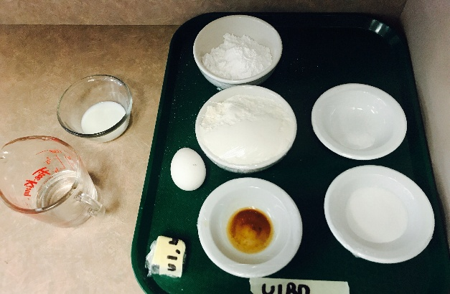
The process of us making the cinnamon rolls overall went pretty good. We knew that we were going to be in a bit of a time crunch from the start, so we made sure we measured out some of the ingredients ahead of time so that way we could work quickly and efficiently to get everything done. This took a lot of team work and communication between everyone so we could make sure we were doing everything properly and following all the directions. Since this was a lab that none of us have done before we were all doing our best to follow the directions and we would help each other out wherever we could, but for our first time doing this I believe it went pretty well and our final product was good as well.
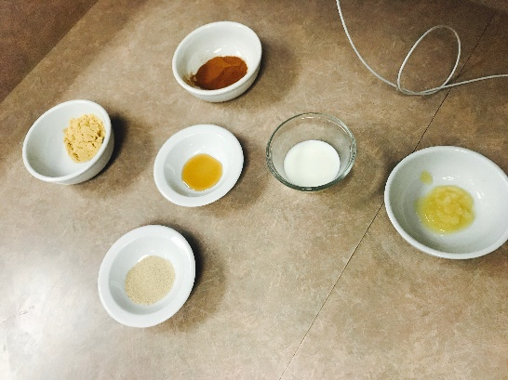
I was very happy with how open-minded everyone was for this assignment. At the beginning we had a bit of trouble picking something to cook since everything we wanted to make took over an hour to do. When we thought of the idea cinnamon rolls everyone was happy with it but the problem once again was the time, but this time we were determined to make it work. After looking for a little while we found one that had a 45 minute cook time and we all agreed on it. We knew our time was going to be close but all agreed that we were going to work very efficiently to get it done on time. If it wasn’t for everyone’s positive and determined thinking we would have never baked what we did and would have never got to try out something new that none of us have done before.
There wasn’t that much that my group would change with how we completed this assignment but something we would change is if we were to make these again, instead of heating up the oven then turning it off we would leave it on so they can cook faster and we wouldn’t have to waste as much time. The other thing that we would change is that we would pick a food that doesn’t take as long to cook as we were still finishing up a few minutes after the bell. But other than those small things this assignment went pretty smoothly and was a really fun one to do.
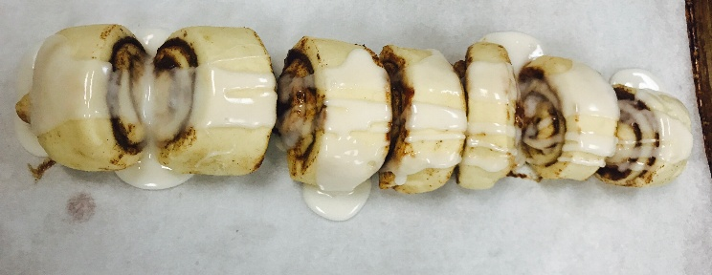
Whenever there was a decision that had to be made we made sure that it was a group based decision so that way everyone got a say, this made sure that everyone’s voice was heard and nobody felt left out. Our group works fairly well together and this really helped when it came time to make group decisions because there were no arguments or huge disagreements, since everyone got along quite nicely which helps tremendously when cooking so we can make quick choices.
Overall this was a very fun assignment to do and my group’s final product turned out quite good. With only the few things that I would change if I were to do this again, I would say that our process for making the cinnamon rolls went quite smoothly and we all had a fun time doing it. We were all happy with our final product and would love to do an assignment like this in years to come.

