**Answer Key**

**Negotiables:**

1. 104.5 J
2. 30.1 J
3. 50.16 J

**Answer Key**

**Imperatives:**

1. 23324.4 J

1. 23665.3 °C
2. 4012.8 J

1. 387.1 J/kg•K

**Negotiables (You *must* do at least 1 of each these… a or b or c…)**

1. How many joules are required to heat 250 g of water from 0°C to 100°C, if the specific heat capacity of water is 4.18 J/kgK?
2. A can of soda is 450g, how many joules are released when it is cooled from room temperature 20°C to refrigerator temperature 4°C assuming the same specific heat capacity as water?
3. How many joules of heat are given off when 200 g of water is cooled from 80°C to 20°C?

**Imperatives (You *must* do each of these…)**

1. How much heat is required to raise the temperature od 90.0 kg of water from 18 °C to 80°C if the specific heat capacity of water is 4.18 J/kgK?
2. If 1 million joules of heat is transferred to 10.0 kg of water initially at 15°C, what will the water’s final temperature be if the specific heat capacity of water is 4.18 J/kgK? $∆T= \frac{Q}{mc}$ $T\left(f\right)=T\left(i\right)-∆T$
3. If 12 kg of water cools frim 100°C to room temperature, 20°C how much heat does it lose to its surroundings?
4. If it takes 1200 J to raise the temperature of 0.500 kg of brass from 20.0°C to 26.2°C, what is the specific heat capacity of brass? $c= \frac{Q}{m∆T}$

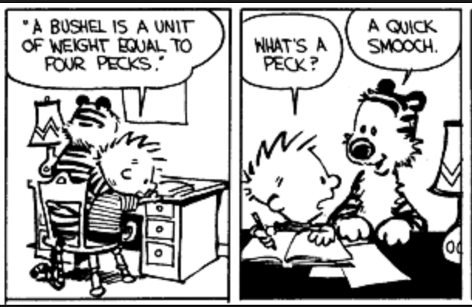

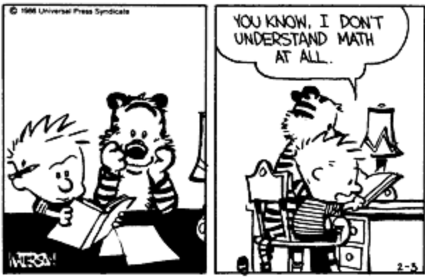

**Optionals (These are if you feel you need more practice)**

1. What amount of heat is released with the temperature of a 150g substance changes by 4°C? Assume a specific heat capacity is 400 J/kgK.
2. What amount of heat is released with the temperature of a 50kg substance changes by 10°C? Assume a specific heat capacity is 126 J/kgK.
3. What amount of heat is released with the temperature of a 5000g substance changes by 25°C? Assume a specific heat capacity is 1500 J/kgK.

**Negotiables (You *must* do at least 1 of each these… a or b or c…)**

1. What amount of heat is released with the temperature of a 450g substance changes by 7°C? Assume a specific heat capacity is 126.4 J/kgK.
2. If 2.508 kg of a substance changes in temperature by 4°C when it absorbs 3420 J of energy what is its specific heat capacity? $c= \frac{Q}{m∆T}$
3. If 1 kg of a substance changes in temperature by 10°C when it absorbs 1000 J of energy what is its specific heat capacity? $c= \frac{Q}{m∆T}$
4. By how many degrees C would the temperature of 3 kg of a substance change if the substance absorbed 4328 J of energy? Assume its specific heat capacity is 0.630 J/kgK. $∆T= \frac{Q}{mc}$

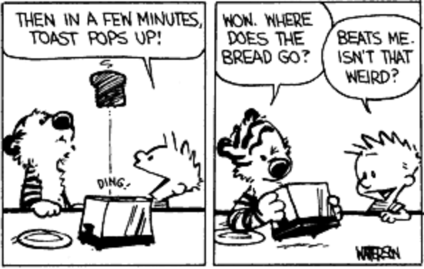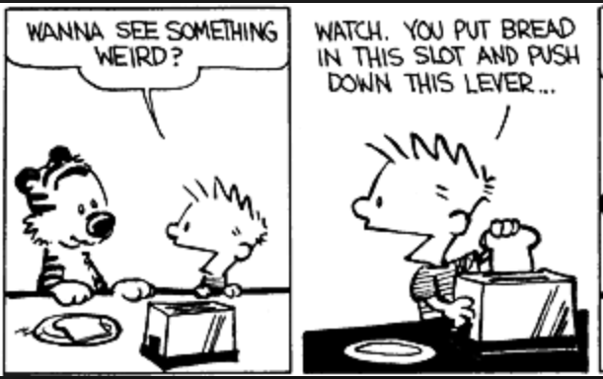

**Answer Key**

**Negotiables:**

1. 398.16 J
2. 4.92 J/kg•K
3. 3.53 J/kg•K
4. 2016.8 °C

**Answer Key**

**Optionals:**

1. 240 J
2. 63 000 J
3. 187 500 J