Group Evaluation Form
*This evaluation form is to be done individually and is confidential. Do not share what you put with anyone else, and your teacher will also not show this information to the other students.*

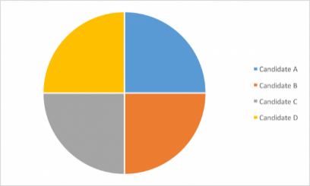
- Using the pie chart below, colour in how much of the project each person did.
If all 4 group members did a perfectly equal amount of work, it would look like this ------------------------------------------------------------------------

Put group members’ names on the piece that
represents them.

- Fill in this information about yourself.
My Name: ________________ | Always | Sometimes | Rarely
Contributed ideas and worked on the project.
Listened to and respected others in the group.
Came to class prepared to work.
Found appropriate materials for the project.
Cooperated with all group members.

Give yourself a score out of 5 for the quality of work you produced. ____ /5
Justify that score. (example: 3/5 -> explain why you earned 3 points AND explain why you lost 2 points)
____________________________________________________________________________________________________________________________________________________________________________________________________________________________________________________________________________________________________________________________________________________
- Fill in this information about your group members.
Name: ________________ | Always | Sometimes | Rarely
Contributed ideas and worked on the project.
Listened to and respected others in the group.
Came to class prepared to work.
Found appropriate materials for the project.
Cooperated with all group members.

Give them a score out of 5 for the quality of work they produced. ____ /5
Justify that score. Example: 3/5 -> explain why they earned 3 points AND explain why they lost 2 points.
____________________________________________________________________________________________________________________________________________________________________________________________________________________________________________________________________________________________________________________________________________________

Name: ________________ | Always | Sometimes | Rarely
Contributed ideas and worked on the project.
Listened to and respected others in the group.
Came to class prepared to work.
Found appropriate materials for the project.
Cooperated with all group members.

Give them a score out of 5 for the quality of work they produced. ____ /5
Justify that score. Example: 3/5 -> explain why they earned 3 points AND explain why they lost 2 points.
____________________________________________________________________________________________________________________________________________________________________________________________________________________________________________________________________________________________________________________________________________________

Name: ________________ | Always | Sometimes | Rarely
Contributed ideas and worked on the project.
Listened to and respected others in the group.
Came to class prepared to work.
Found appropriate materials for the project.
Cooperated with all group members.

Give them a score out of 5 for the quality of work they produced. ____ /5
Justify that score. Example: 3/5 -> explain why they earned 3 points AND explain why they lost 2 points.
____________________________________________________________________________________________________________________________________________________________________________________________________________________________________________________________________________________________________________________________________________________

Name: ________________ | Always | Sometimes | Rarely
Contributed ideas and worked on the project.
Listened to and respected others in the group.
Came to class prepared to work.
Found appropriate materials for the project.
Cooperated with all group members.

Give them a score out of 5 for the quality of work they produced. ____ /5
Justify that score. Example: 3/5 -> explain why they earned 3 points AND explain why they lost 2 points.
____________________________________________________________________________________________________________________________________________________________________________________________________________________________________________________________________________________________________________________________________________________

