1. Simplify using order of operations. (BEDMAS)

a) 8 + 10 ÷ 2 b) (12 – 3) • (24 ÷ 8) c) 30 ÷ 5 + 2 • 12

d) 

2. Evaluate each expression.

a) 2x – 3y x = 5 and y = 2 b) 19 – 2y y = 5

c) 3 (x + 2y) x = 9 and y = 4 d) y – 10x x = 2 and y = 30

3. Arrange from smallest to largest.

1.7, 1.6, 1.05, 0.7, 1.57, 1.75, 1.007

4. Replace the blank with a “>” , “<” or “=” to make the statement true.

a) 7.89 ____ 7.98 b) 0.008 _____ 0.01 c) 5.92 _____0.592

d) $0.5 _____ 50 ¢ e) -31 _____ 0 f) -8 ____ -9

5. Name each part of the power term:

6. Evaluate each power.

a) 23 b) 15 c) 52 d) 63 e)104

f) 24 – 33 g) 92 +53 h) 2(4)2

7. simplify using the exponent laws.

1. b) c) d) e)



8. Write the fraction indicated using the data provided. In a class of 30 students,

|  |  |
| --- | --- |
|  |  |
|  |  |

18 have blue eyes and 12 have brown eyes.

What fraction of the class has brown eyes? _______

What PERCENT of the class has blue eyes? ______

9. Simplify each fraction.

a)  b)  c)  d) 

10. Solve each proportion.

a)  b)  c)  d) 

PART 2

1. Ron made 9 out of 15 free throws and Jeff made 8 out of 12. Who made the

greatest fraction of free throws? What was his shooting percentage?

2. On a numberline, show where each of the fractions is located.

1. ½
2. 4/5
3. 7/3
4. 10/4
5. 3/7

3. Perform the operation indicated.

a)  b)  c)  d) 

e)  f)  g)  h) 

i)  j) 

4. Place the integers on the numberline.

-6, 2, 4, -2, 0, 10, -7

5. Compare the numbers using > <

6 12 9 0 -3 1 -4 -2

6. Arrange from smallest to largest.

9, -12, 3, -5, 0, -9, 8, 24, -25

7. Perform the indicated operation.

a) 8 + (-6) b) -11 + (-5) c) -14 + 9 d) –3 + 12 + (-5)

e) -8 – 9 f) 10 – 14 g) -6 – (-4) h) –12 – 8 – (-3)

Part 3

1. Calculate:
2. -6 + 10 b) 5 – ( -3) c) (-2 )( - 3) d) -1 x 5 + 10

e) -20 (-6 - 4) f) [4 + 2 – 8 – 12 + 9] • -2 g) [-5 – 3 + 4 - 2] • 0

1. The temperature at 8 am was -4° C, at 2 pm the temperature was 5° C. What was the difference?

3. Evaluate each expression.

a) 4c + a b) x2 c) 2x – x2 d) 

if a = (-3) if x = -6 if x = -3 if a = -5

c = (-5)

1. Model the following expressions using algebra tiles.
2. -2 + 5

1. -x + 2 – 4 + 3x
2. x2 – 4x + 3 +2x -1
3. Simplify by collecting the like terms.

a) 10n + 5n b) 2n + 7m – 4n – 9m c) 7y2 – 12y – y + y2 – 9y

d) (5x – 6x2) + (3x + 4x2) e) 4(3x – 2) f) 5(2x + 4) – 3(x – 9)

1. Fill in a number that makes a true statement.
2. + 3 = 10 b) 6 - = 4 c) 3 ( ) = 12

6. Solve each equation below. Show all of your work!

a) x – 9 = 12 b) x + 14 = 27 c) x + 3 = -10 d) x – 4 = -8

e) 5x = 15 f) -2x = 22 g) 3x = 18 h) -2x = 12

i) 2x – 4 = 12 j) 7x + 2 = 30 k) 5x – 8 = -23 l) -3x – 2 = 43

m) 4(x + 3) = 20 n) 10 = 2(x – 7) o) 5x + 2 = 4x – 10

Part 4

1. Extend the linear pattern

1. 6, 9, 12, ____ , ____ , ____ , ____
2. 22, 17, 12, ____ , ____ , ____ , ____
3. -16, -10, -4, ____ , ____ , ____ , ____
4. 15, 7, -1, ____ , ____ , ____ , ____



2. What are the coordinates?

M

O

A

T

R

C

H

K

M

A

T

H

R

O

C

K

3. Plot the following points on the grid.



A (3, 9)

B (-4, 2)

C (0.5)

\ D (-3, -6)

4. Fill in the table of values for each equation

Y= x + 1 y = 2x – 6 y = -3x

|  |  |  |  |  |  |  |  |
| --- | --- | --- | --- | --- | --- | --- | --- |
| x | y |  | x | y |  | x | y |
| 0 |  |  | 4 |  |  | 2 |  |
| 1 |  |  | 3 |  |  | -2 |  |
| 2 |  |  | 2 |  |  | 1 |  |
| 3 |  |  | 1 |  |  | -3 |  |

5. Given the scale factor, determine if it is an enlargement or a reduction.

SF = 9 enlargement or reduction

SF =0.2 enlargement or reduction

SF = ¾ enlargement or reduction

SF = 6 enlargement or reduction

6. Fill in the scale factor chart

|  |  |  |
| --- | --- | --- |
| Original length | Scale factor | Image length |
| 12 cm | 2 |  |
| 8 m | 3 |  |
| 4.5 mm | 0.5 |  |
|  | 4 | 28 m |
|  | 2 | 17 cm |
|  | 0.5 | 3 mm |

1. Draw the enlargement or reduction

Scale factor of ½

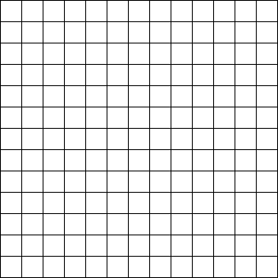

Scale factor of 2



Part 5

1. Determine the missing side lengths in the similar shapes.

1. b)

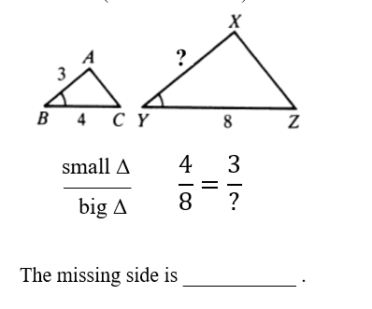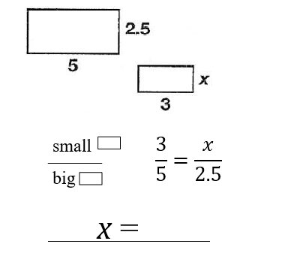

c). d)

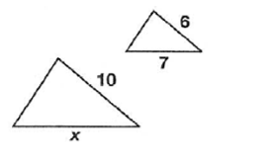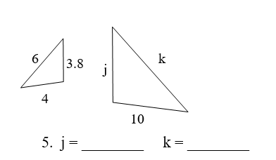

2. Determine the perimeter for each shape

7.5 cm

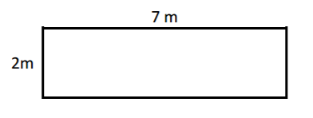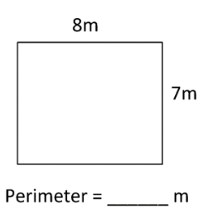

3. Determine the area for each shape

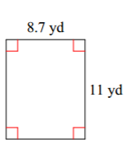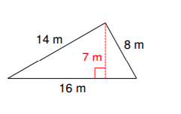

1. Calculate the surface area

