Classifying reactions comic

1. Synthesis (combination) reactions

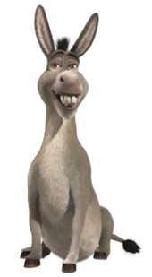
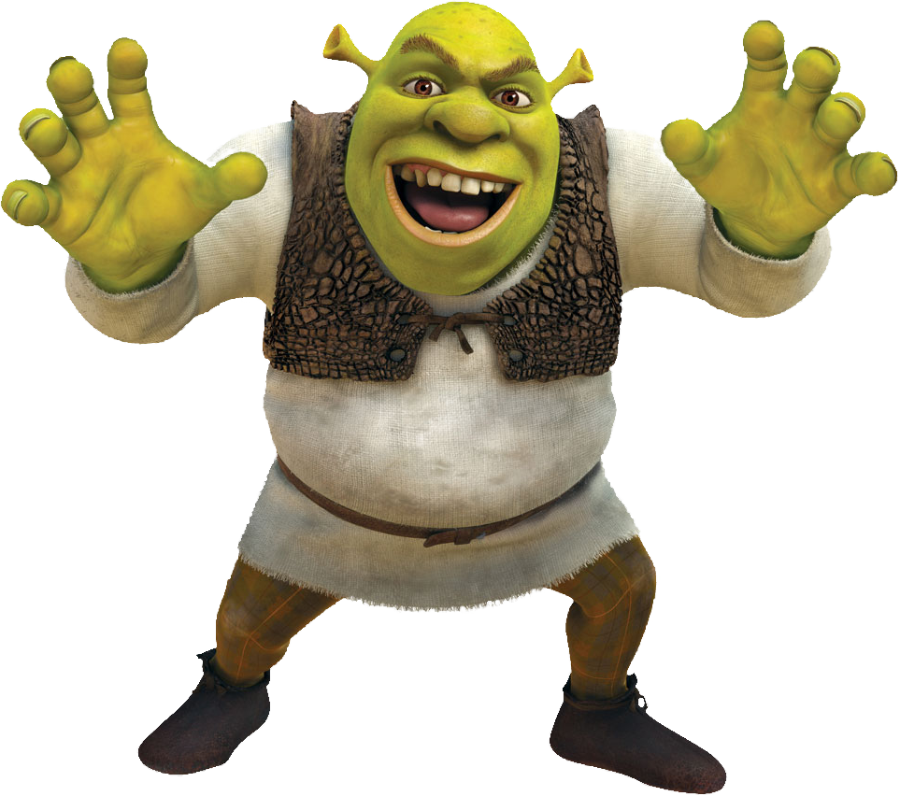
- Two or more reactants (A and B) combine to produce a single product (AB).

2. Decomposition reactions

- The breaking down of a compound (AB) into smaller compounds or separate elements (A and B).

Single replacement reactions

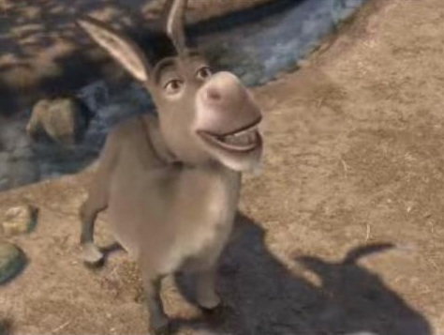
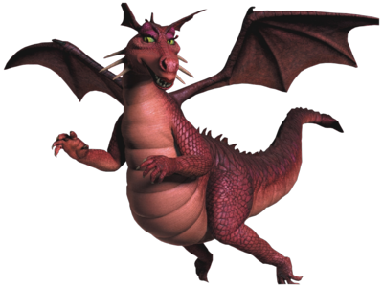
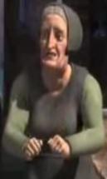
- A reactive element (metal or non-metal by itself) and a compound react to produce another element and compound. One of the elements is “replaced” by another element.

Double replacement reactions

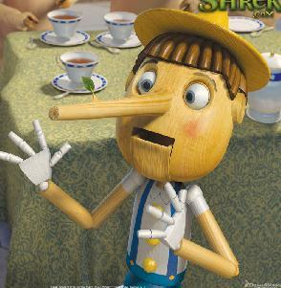
- Involves two ionic solutions that react to produce two other ionic compounds. One of the compounds often forms a precipitate (solid that forms from solutions mixed together)

