Static electricity
Lab
My predictions: my predictions are that the spoon and the fur are the most corporative and it will work the best.

List of materials:
- Plastic spoon
- Straw
- Wood stir stick
- Aluminum
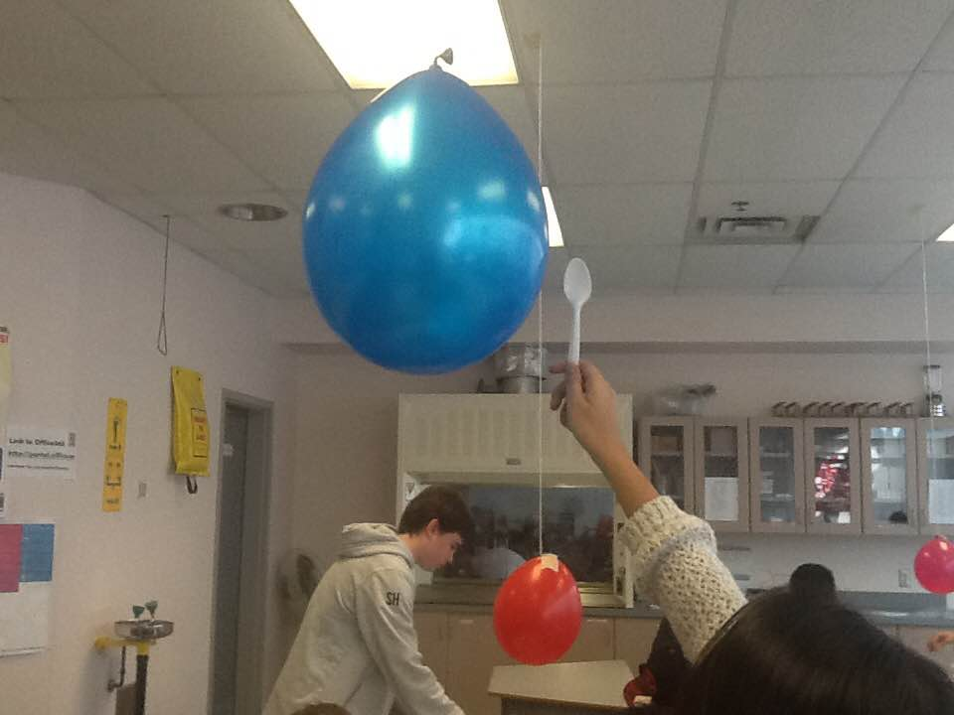
- Glass
- Lucite
- Ebonite
- Copper
- Polyester
- Fur
- Silk
- Plastic

Tests:
- Lucite & plastic = nothing didn’t happen to both
- Lucite & silk = pulled back the balloon and the confetti stuck to the object
- Lucite & polyester = nothing didn’t happen to both
- Lucite & fur = pulled back and the confetti stuck to the object
- Ebonite & polyester = it pulls the balloon only slightly and the confetti stuck
- Ebonite & fur = it slightly pulls towards the balloon and stuck to the confetti
- Ebonite & polyester = slightly pulls towards the balloon and didn’t attach to the confetti
- Ebonite & silk = it pulls towards and confetti didn’t do anything
- Spoon & plastic – did nothing to both objects
- Spoon & polyester = it a little pulled towards but didn’t do anything to the confetti
- Spoon & silk = nothing happened and only a couple of the confetti stuck
- Spoon & fur =
- Copper & plastic – did nothing to both
- Copper & polyester – did nothing to both
- Copper & silk = did nothing to both
- Aluminum & plastic = did nothing to both
- Aluminum & silk = pulls towards
18. Aluminum & fur = pulls the balloon but did nothing to the confetti
*We didn’t have time to finish the rest of the project with the glass rod and plastic straw and wood stick*
weakest: Spoon
strongest: Lucite and silk

