TITLE
The Effect of Bridge Design on Weight
HYPOTHESIS
If a bridge design with more support carries the same amount of weight as a bridge with less support then it should be able to withstand more weight than those with less support because the weight is more evenly balanced throughout the bridge
INDEPENDENT VARIABLE
how much weight is being placed on each bridge
LEVELS OF INDEPENDENT VARIABLE AND NUMBERS OF REPEATED TRIALS
A bridge with no weight | 15 pounds | 30 pounds | 45 pounds
3 (1 per bridge) | 3 (1 per bridge) | 3 (1 per bridge) | 3 (1 per bridge)
DEPENDENT VARIABLE AND HOW MEASURED
How long each bridge can withstand more weight being placed on it
CONSTANT VARIBLES
1. all the bridges have around the same amount of sticks
2. they all use around the same amount of glue
3. the same materials are used for all three bridges
4. the surface these bridges were tested on are all the same
5. the same items were used as weights
PROCEDURE:

Materials:
500 popsicles (maximum)
8-13 hot glue sticks
A ruler
Marker
Hot glue gun
Utility tool (pliers, file, saw, etc...)
Scale
Weights (filled bottles, dumbbells, etc...)

Procedure
Starting the foundations
- Mark of 1 inch from the end of the popsicle stick
- Add glue from the marked line to the end of the stick then attach a popsicle to the glued area
- Repeat step one with the new stick and add glue to said stick then attach a new stick

- Repeat this process until the stick is 8 sticks long
- Attach popsicle sticks to the other side of the larger stick

Make 8 of these sticks (4 for the deck bridge, 2 for the Waddell bridge, and 2 for the warren bridge)

The middle foundation stick

  - Measure the stick then mark the middle
  - Add glue to half the stick
  - Attach a new stick to the glued stick from the end to the middle of the stick

  - Add glue to the opposite side of the stick

- Continue these steps until approximate length of first foundation stick. This stick will most likely be longer than the others so using the utility tool (ei. Saw, file, and pliers) make this stick the same length to the best of your ability.

Make 3 of these sticks (1 for each bridge)

Building the bridge
  - Mark off 6 inches on 3 of the foundation sticks on both sides of the sticks
  - Measure a popsicle stick and place a line in the middle of the stick glue

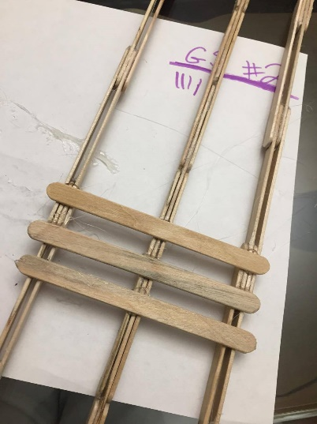
  - Glue the single popsicle evenly to the 3 foundation sticks

  - Glue sticks from one marked side of the stick to the other
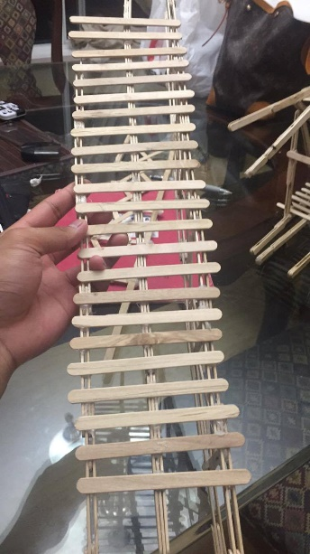
Make 3 of these (1 for each bridge)

Making the Deck Truss Bridge

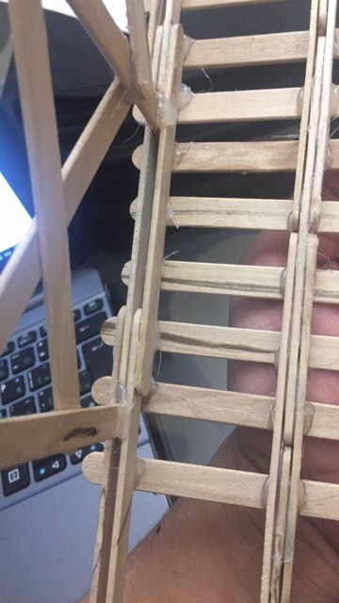
- Glue sticks in between the space of the support beams on both sides

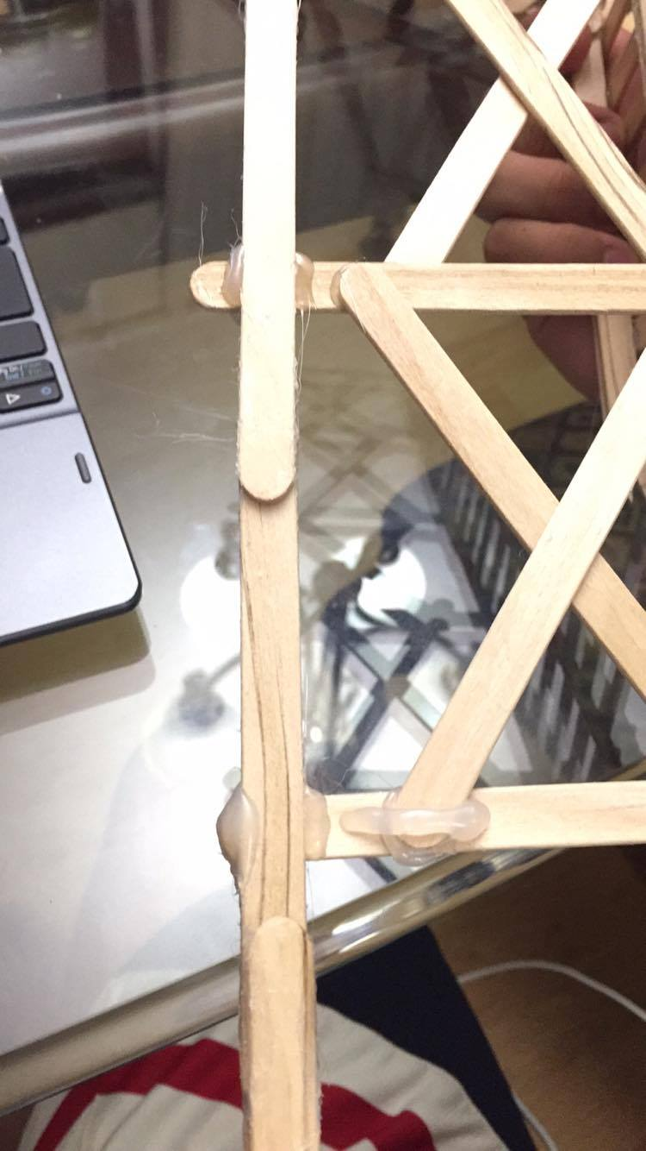
- Glue the sticks to the other support beams from the end of the sticks

- Make a “x” pattern from one end to the other
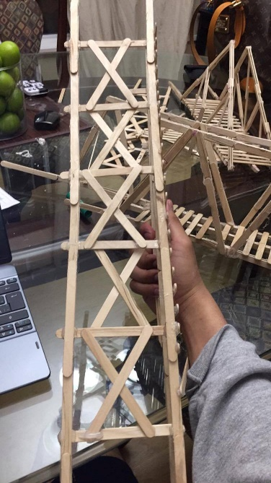
Final Product

Making The Warren Truss Bridge

- Glue 4 sticks together like the diagram below. Make 4.

- Glue them on an angle attached to the bottom support beam
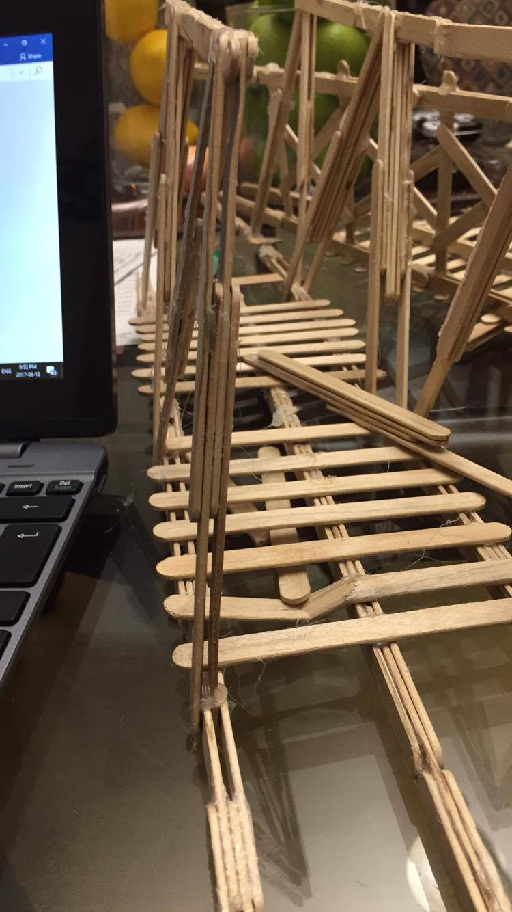
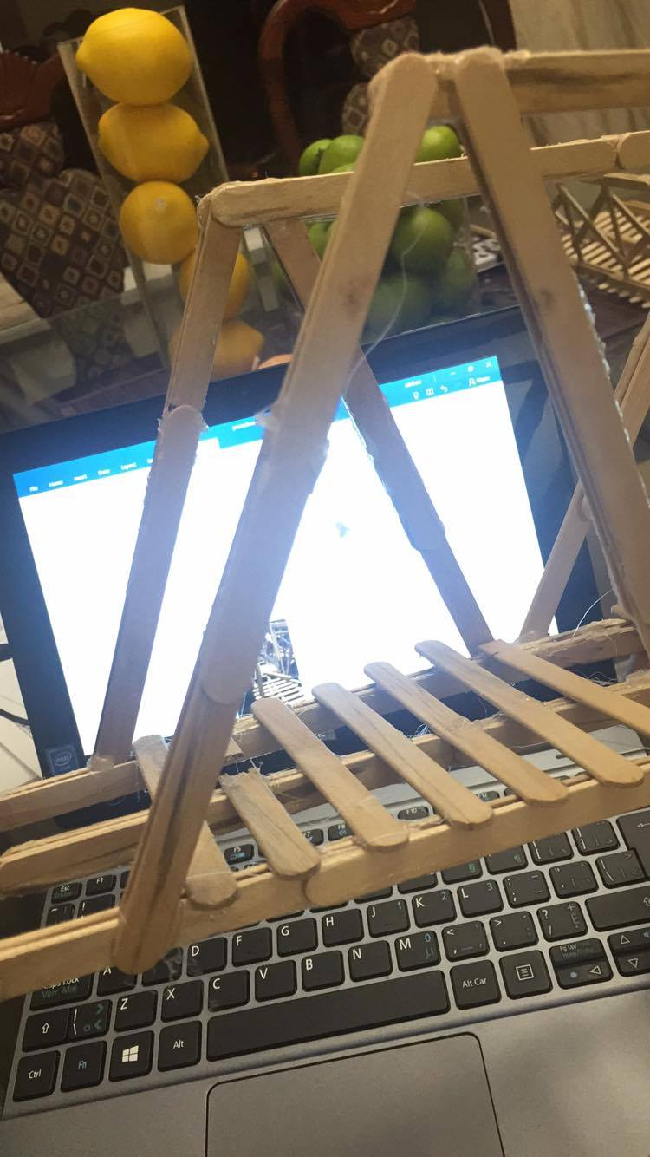

- Make 2 longer sticks horizontally attaching the sticks

- Make 4 sticks like in the diagram below using 3 sticks each

- Glue the end of the stick with one end to the bottom support beam and the end of the stick with 2 ends to the top of the bridge like so in the image below

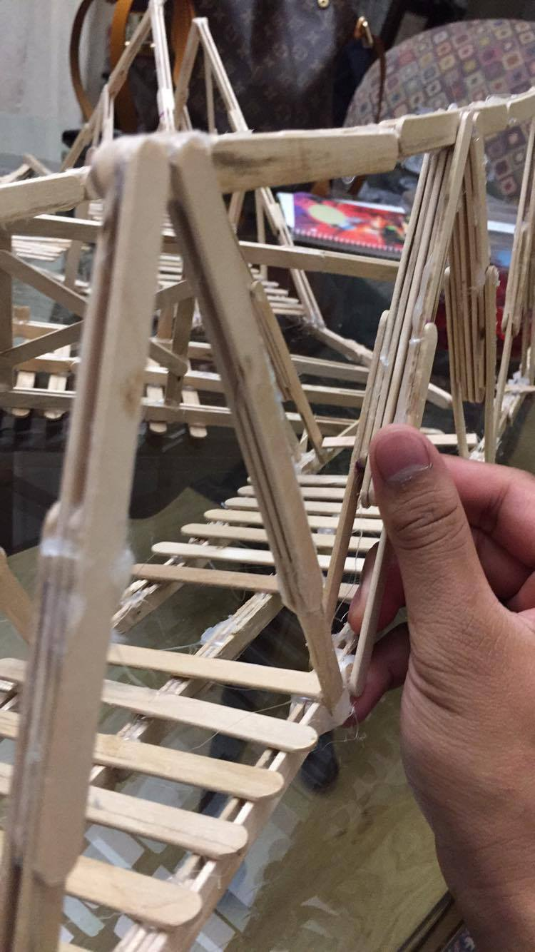

- Glue together seven sticks like the diagram below. Make four of these.

- Glue these pieces on an angle similar to the image below
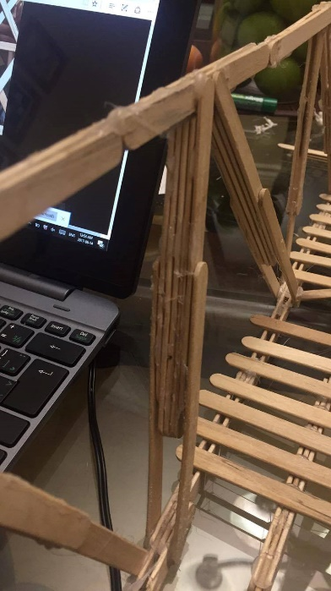
Final Product

Making The Waddell “A” Truss Bridge

- Make4 sticks, each made like the diagram shown below

- Glue each pair together at about a 90 degree angle

- Glue each pair to the support beam like below

- Glue a single stick to the arch of the bridge on each side of the bridge

- Glue two sticks together by one inch. Do this twice

- Attach this stick from the top of the arch, straight down to the beam

- Glue 2 sticks to a stick in the middle leaving about an inch uncovered. Make 4 of these.

- Glue these pieces to the bridge, attaching the end with 2 ends to the top of the single stick and glue the bottom to the bottom of the middle stick

Final Product
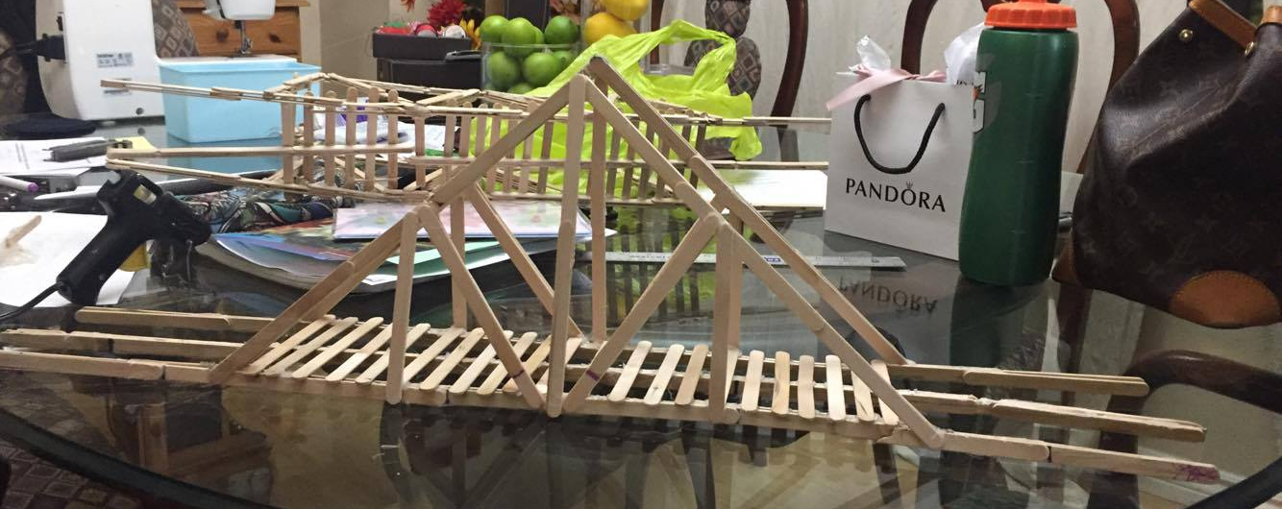

The Experiment

- Place the bridge in between two flat surfaces that are the same height
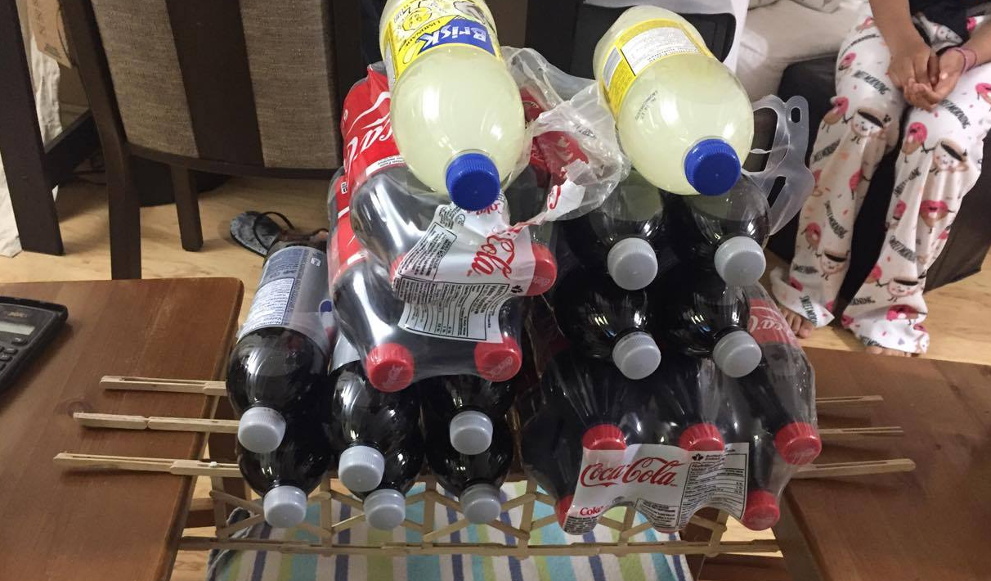
- place the flat surface 6 inches under each side of the bridge

3. start recording the weight carried on the bridge at zero
4. add five pounds to each attempt and record it
5. keep adding five pounds at a time and record each time until bridge collapses

OBSERVATIONS
While conducting this experiment it was noticed that all of the bridges did not show signs of bending or struggle until about 30 pounds of weight was placed on each bridge.

RESULTS

Deck Truss Bridge
Attempt number | Weight (lb)
1 | 0
2 | 3
3 | 5
4 | 10
5 | 15
6 | 20
7 | 25
8 | 30
9 | 35
10 | 40
11 | 45
12 | 50

Warren Bridge

Attempt number | Weight (lb)
1 | 0
2 | 3
3 | 5
4 | 10
5 | 15
6 | 20
7 | 25
8 | 30
9 | 35
10 | 40
11 | 45
12 | 50

Waddell “A” Truss Bridge

Attempt number | Weight
1 | 0
2 | 3
3 | 5
4 | 10
5 | 15
6 | 20
7 | 25
8 | 30
9 | 35
10 | 40

CONCLUSION

This experiment investigated out of 3 different bridge designs, which design could carry and withstand the most weight. In order to answer this question 3 different bridges were to be made, those being: a Deck Truss Bridge, a Warren Truss bridge, and lastly a Waddell “A” Truss Bridge. In this experiment each bridge was given the circumstances, each bridge was held up by the same flat surface, used the same materials and roughly the same amount of materials. When these bridges were being tested the first attempt was to see if the bridges could stand on their own, all of them were able to. Next, 5 pounds of weight was added to the bridge then recorded on a chart until the bridge collapsed or had a piece of the bridge break. Results showed that out of all the bridges the Waddell “A” Truss bridge could withstand the least amount of weight at 40 lbs on the 10th trial, where as both the Deck Truss bridge and the Warren Truss bridge were able to hold up to 50 lbs on the 12th trial before collapsing. Ultimately the hypothesis stated was negated. The Deck Truss bridge had the 2nd most amount of sticks being 124 but was able to withstand the same amount of weight as the Warren Truss bridge, using 144 sticks.
This information can be helpful in real world situations because when a bridge is need for transportation, depending on what the bridge is most commonly going to be used for, contractors can plan ahead on what bridges needs to be used according to how much weight is going to be pressured on the bridge.
Questions about the experiment include whether or not the type of popsicle stick used had any say over the outcome of the experiment. For example if the Waddell “A” Truss bridge were to be built with colored sticks would the bridge carry more weight? Less? Or even the same amount? Another question is the type of glue used had a major or minor effect of the experiment. Would liquid glue or wood glue work better than hot glue?
Finally, if the experiment could be repeated, the experimental design could be improved by keeping a heavy amount of weight on the bridges for a set amount of time, to test the long term strength of the bridge. By doing so the bridges would be tested similar to how a bridge would be used in real life, similar to many vehicles waiting on a bridge during traffic.

