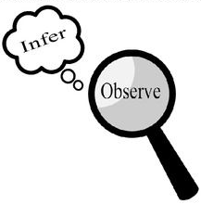
Observations and Inferences
Science 10 Name: Brooke BLK: C

OBJECT | OBSERVATIONS  Words that describe the object | INFERENCES  Ie: Where might the object come from? Possible uses? Etc. | QUESTIONS YOU HAVE ABOUT THE OBJECT
 | - Red  - Blade inside  - Small  - Metal ring attached  - You can pull it apart  - When pushed down something pointy pops out  - No scent | - There is a blade, so it must be able to cut  - Meant for small items  - The key ring is there so it can be attached to bags and be carried around  - The pointy thing is to cut envelopes | - What is it?  - What is it used for?  - What are you supposed to cut with the blade?  - Why does the pointy thing come out?  - Why do you need to use a lot of force to get the pointy thing out?  - How much force is needed to get the pointy thing out?  - How often is this supposed to be used?  - When was this invented?
 | - Blue/cyan colour  - Smells like laundry detergent  - Translucent  - Some of the substance is stuck on the side/bottom of the container  - Thick liquid  - Moves slowly  - Bubbles forming on the edge  - The scent is strong | - It is laundry detergent  - Not meant to be drank  - Cleaning supplies  - Since there are bubbles on the side it is soapy  - It is poisonous | - Why is it blue?  - Is it blue for a reason?  - What gives it it’s soapy smell?  - Why is it so thick and sticky?  - What chemicals are used to create this thing?
 | - White  - Crystal texture  - Smells a little like pepper or salt  - A lot of small pieces  - Translucent until grouped  - Light weight  - Creates a dust | - It is salt before grained  - They’re crystals  - Easy to obtain because there are a lot  - It is edible  - Type of mineral  - Comes from a bigger source (shaved off to become smaller) | - Can you buy it?  - Where do you get it from?  - What is it?  - Is it a crystal?  - How did it get crystallized?  - Can we eat it?  - How are they made?
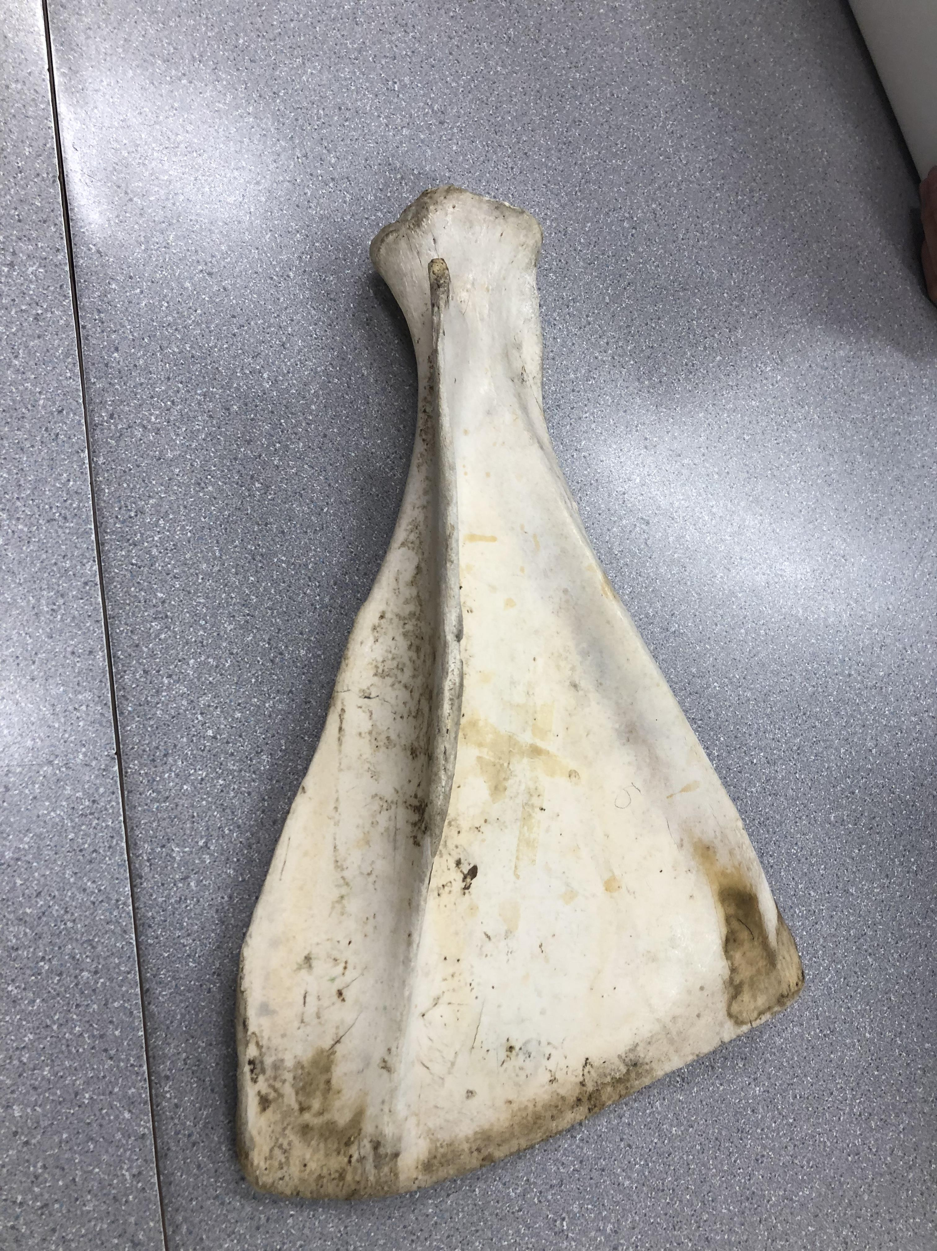 | - Hard  - Has an off white colour with yellow edges  - Flat on one side  - Curved  - Same length as Molly’s forearm  - Dry  - Cracked a little on the side  - Stained by something | - Might’ve been broken from something  - It is an animal bone  - Looks like a fin from an aquatic animal  - Belongs to a big animal | - How old is the object?  - What part of the body is it from?  - Is it extinct?  - What animal does it come from?  - Where do the stains come from?  - If it is a real bone, how is it preserved?  - What is it made of?  - Why would you want to keep this?

Observations/Inferences Assignment Assessment
Name: _____________________
Ex: Excellent VG: Very Good G: Good S: Satisfactory IN: Improvement is needed
Criteria | IN | S | G | VG | Ex
The following is included
- All 4 Images included
Observations:
- A minimum of 5 detailed observations made
Inferences:
- Thoughtful and logical inferences made
Questions:
- 2 thoughtful and logical questions made
- Spelling/grammar
- Assignment was completed on time
/10

