Name: Brad Lee BLK: C
Penny Lab
Purpose: To determine how many drops of water fit on one side of a
penny.
Hypothesis: if the liquid placed on the penny decreases the surface cohesion, then the penny will hold less drops of water because the penny dipped in the solution has less area for the water.

Materials: (List all the materials used in the experiment)
- 8 pennies
- Forceps
- Liquid solution
- Eye dropper
- water
- 5 paper towels
- 100ml Glass Beaker
- 60ml Glass Beaker
Procedure:
Part A: Perform a CONTROL test for comparison with later results.

Step 1: Rinse a penny in tap water and dry completely.
Step 2: Place the penny on paper towel.
Step 3: Use an eye dropper to place drops of WATER on the penny (one at a time) until ANY amount of water runs over the edge of the penny.
Step 4: Record the number of drops for that trial in the table.
Repeat Steps 1 - 4 three more times before calculating your average.

Number of drops  TRIAL 1 | Number of drops  TRIAL 2 | Number of drops  TRIAL 3 | Number of drops  TRIAL 4 | AVERAGE Number of drops
18 | 20 | 17 | 26 | 20

Part B: Perform tests with the TESTING LIQUID.

Step 1: Start with a “clean” penny. Rinse the penny in tap water and dry completely. Be sure to remove as much residue as possible - without using soap!
Step 2: Hold the penny with the tweezers provided, then dip it into the TESTING LIQUID. Allow extra liquid
to drip off the penny into the container before proceeding to the next step.
Step 3: Place penny on dry spot on a paper towel. Place drops of WATER on the penny (one at a time) until ANY amount of water runs over the edge of the penny.
Step 4: Record your observations and the number of drops for that trial in the table.
Repeat Steps 1 - 4 three more times before calculating the average.

TRIAL 1 | TRIAL 2 | TRIAL 3 | TRIAL 4 | AVERAGE
13 | 10 | 9 | 9 | 10
Observations:
Part One: Labelled Diagram of observations:  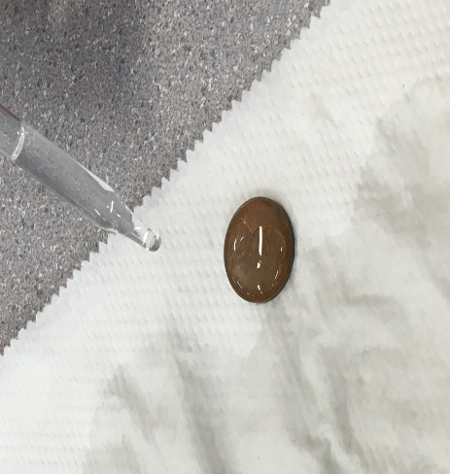 | Part Two: Labelled Diagram of observations:  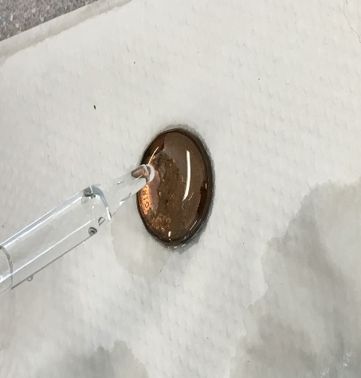
Description:  The Dry penny retained more water without spilling, it made a small water bubble in the process. | Description:  The wet penny didn’t retain much water, the water tended to leak from the top of the penny and didn’t keep its form for long either.
Results:
Group # | Average Number of water Drops on the Control Penny | Average Number of Drops on the  Penny submersed in the soap solution
Group One | 23 | 9
Group Two | 20 | 10
Group Three | 26 | 12
Group Four | 22 | 5
Group Five | 37 | 13
Group Six | 14 | 11
Class Average: | 23 | 10

Conclusion:
This experiment investigated whether liquid soap affects how much water can be put on penny.

In order to study the problem students were given pennies, water, and liquid solutions. In this experiment, students are determined to find out whether if the liquid solution either decreases or increases the amount of water put on the penny without bursting.

Results showed the penny without the liquid solution contained more water than the one with the liquid solution.

This proved that the hypothesis that if the liquid placed on the penny decreases the surface cohesion then the penny will hold less drops of water. This Hypothesis was (supported/negated) because the penny with the solution had less drops of water than the dry penny.

To extend this experiment, many other substances could be used in the experiment. For example, one substance could be rubbing alcohol, or cooking oil. These can be compared with the liquid solution and standard penny to see if it makes a difference.

Finally, if the experiment was repeated, some changes to improve the experimental design could be improved if there were more trials to see if would be a difference in any way.

****REMEMBER TO AVOID THE USE OF PERSONAL PRONOUNS****

Post 2 photos (penny with water only and penny with testing liquid) and your conclusion to your edublog site. Tag “Science10pennylab_Feb2018”

