Name: Brad Lee | Date: Jan. 6, 2018

/  How does the artifact you selected demonstrate strengths & growth in the communication competency?  In what ways might you further develop your communication competency? | Self-Reflection  Describe how the artifact you selected shows your strengths & growth in specific core competencies. The prompt questions on the left - or other self-assessment activities you may have done - may guide your reflection process.  Communications: Acquire, interpret and present information  Artifact: WWII infographic  When making this infographic, I showed that I understood the event that took place, and the small details that also took place during that event in my infographic. I’ve listed down where the event took place, how many casualties died during the event, and the consequences that both the allied and axis forces faced after this event.  I feel I have shown that am capable of presenting information clearly to others. What I would change would be maybe put more detail in what the soldiers used during the war, and what soldiers endured during this event.  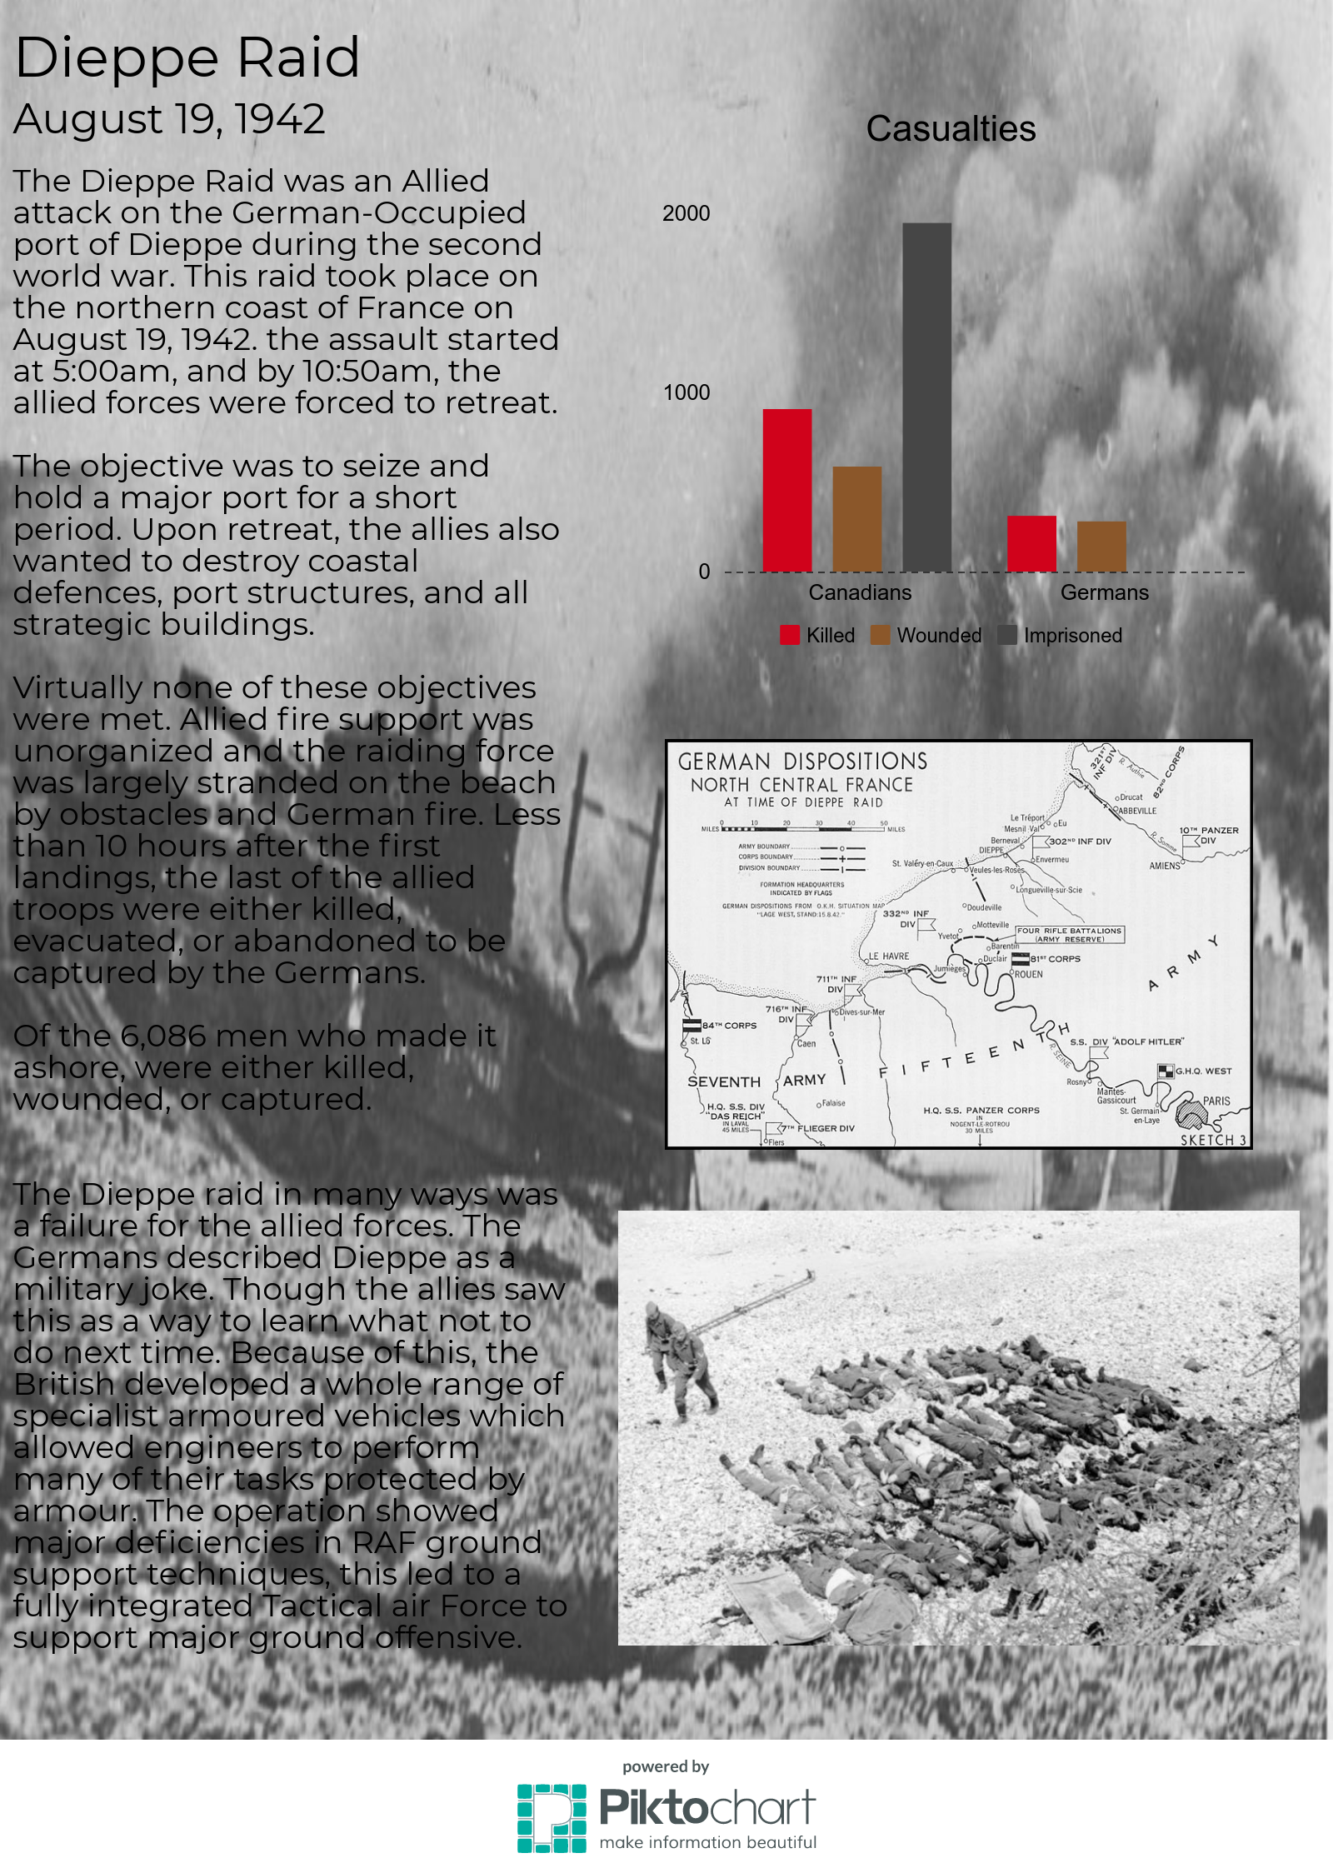  Creative thinking: Developing ideas  Artifact: WWI Letters  When making these letters, I showed that I could develop ideas for what these letters would contain. I tried to make it seem like it came from a soldier writing to his loved one or relative. I tried to put impact in each letter, making it seem like the soldier was undergoing many challenges which meant life or death.  Though I have shown that I can develop ideas, I lack a sense of when I certain event happens or what happened during the specific date. What I would improve on is understanding when certain events happen and to make sure that the letter Corresponds with that event.  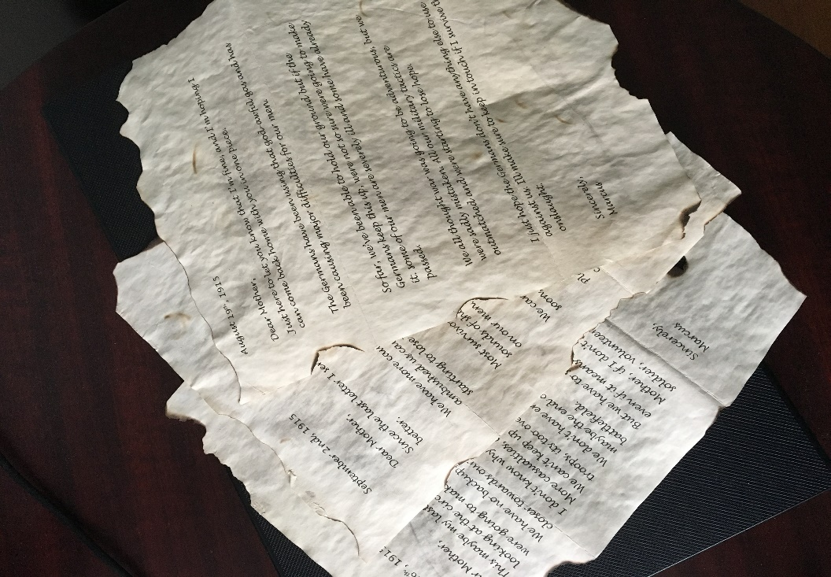
/

How does the artifact you selected demonstrate strengths & growth in the thinking competencies?

In what ways might you further develop your thinking competencies?

How does the artifact you selected demonstrate strengths & growth in the personal & social competencies?

In what ways might you further develop your personal & social competencies?

Publish Your Self Assessment
You will now attach and/or embed your self-assessment to the bottom of the blog post with the artifact you have chosen. You may choose to make this post private or public. After placing your artifact on a blog post, follow the instructions below.
- Categories - Self-Assessment
- Tags - Now tag your post using the tag that corresponds to the competency that you have written about. You can choose more than one. Please use lower case letters and be exact.
  - #creativethinkingcc
  - #communicationcc
  - #criticalthinkingcc
  - #socialresponsibilitycc
  - #personalidentitycc
  - #personalawarenesscc
- Use the Add Document button located at the top of your post page and embed your self-assessment at the bottom of your blog post.
- Publish

