Name:lake BLK:1
Penny Lab
Purpose: To determine how many drops of water fit on one side of a
penny.
Hypothesis: (Use an if-then-because statement for your hypothesis)
If the testing liquid is placed on the penny, then…. because….

Materials: (List all the materials used in the experiment) Paper towel, penny, water, blue liquid, eye dropper, and tweezer.

Procedure:
Part A: Perform a CONTROL test for comparison with later results.

Step 1: Rinse a penny in tap water and dry completely.
Step 2: Place the penny on paper towel.
Step 3: Use an eye dropper to place drops of WATER on the penny (one at a time) until ANY amount of water runs over the edge of the penny.
Step 4: Record the number of drops for that trial in the table.
Repeat Steps 1 - 4 three more times before calculating your average.

Number of drops  TRIAL 1 | Number of drops  TRIAL 2 | Number of drops  TRIAL 3 | Number of drops  TRIAL 4 | AVERAGE Number of drops
44 | 16 | 22 | 15 | 24.25

Part B: Perform tests with the TESTING LIQUID.

Step 1: Start with a “clean” penny. Rinse the penny in tap water and dry completely. Be sure to remove as much residue as possible - without using soap!
Step 2: Hold the penny with the tweezers provided, then dip it into the TESTING LIQUID. Allow extra liquid
to drip off the penny into the container before proceeding to the next step.
Step 3: Place penny on dry spot on a paper towel. Place drops of WATER on the penny (one at a time) until ANY amount of water runs over the edge of the penny.
Step 4: Record your observations and the number of drops for that trial in the table.
Repeat Steps 1 - 4 three more times before calculating the average.

TRIAL 1 | TRIAL 2 | TRIAL 3 | TRIAL 4 | AVERAGE
26 | 13 | 25 | 10
Observations:
Part One: Labelled Diagram of observations:  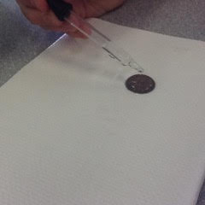 | Part Two: Labelled Diagram of observations:  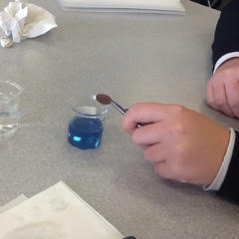
Description: | Description:

Results:
Group # | Average Number of water Drops on the Control Penny | Average Number of Drops on the  Penny submersed in the soap solution
Group One | 21 | 9
Group Two | 35 | 10
Group Three | 25 | 8
Group Four | 20 | 11
Group Five | 20 | 23
Group Six | 27 | 9
Group Seven | 27 | 17
Class Average: | 25

Conclusion:
This experiment investigated….

In order to study the problem …

Results showed…

This proved the hypothesis that if… then…was (supported/negated) because… Explain if/how cohesion and surface tension came into play for this experiment. How do your results compare to the other groups in your class? Provide at least 2 possible reasons for any similarities and differences you identified.

To extend this experiment (explain what could be done)…
Finally, if the experiment was repeated, some changes to improve the experimental design could be...

****REMEMBER TO AVOID THE USE OF PERSONAL PRONOUNS****

Post 2 photos (penny with water only and penny with testing liquid) and your conclusion to your edublog site. Tag “Science-10-penny-lab”
Penny lab Conclusion

This experiment investigated how many drops of water would fit on top of a clean, dry penny compared to how many drops of water would fit after the penny was treated with the special blue solution.

