SEXUAL HEALTH
LESSON #5

Complete this worksheet as we discuss information within the PowerPoint Presentation.

Bacterial vs Viral STIs:
- _______________ can be ____________ with antibiotics
- ____________ diseases are ______________________
- Both bacterial and viral infections can have _______________ changes to your body.

Bacterial STIs: | Viral STIs:

SYMPTOMS of STIs:
STIs can present themselves with some, all, or none of the following:
- Itching
- Hurts to pee
- Change in colour or odour of discharge (female)
- Any penile discharge
- Change in periods (painful, spotting, increased /decreased flow)
- Bumps, lumps, sores
- Rash
- Abdominal pain
- Pain with intercourse
- NO SYMPTOMS AT ALL

Some of these STIs and their symptoms can be ____________________ and can also lead to ___________________________, __________________________, ____________________, and even _____________________.

HIV & AIDS:
- HIV = _______________________________________________________________ (virus indicates that it is NOT curable)
- AIDS = ______________________________________________________________ (it is the second stage of HIV and is also non-curable)
- People do not die from AIDS. They die from _________________________________ which are other colds and viruses that their weakened immune system cannot fight.

Complete the true and false to find out how much you know about HIV and AIDS

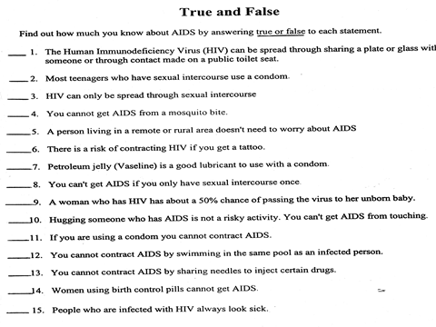

STATISTICS on TEENS, SEX, & STIs:
- New estimates show that there are about ____________________ new infections in the United States each year.
- Young people age _______________ account for 50 percent of all new STIs, although they represent just 25 percent of the sexually experienced population.
- Roughly 75 percent of all reported gonorrhea is found in people age 15 to 29, with the highest infection rates found in teen girls age 15 to 19 and 20 to 24-year-old men.
- The Centers for Disease Control and Prevention estimates that there are more than _________________STIs among men and women in the U.S. This includes both new and existing infections.
- The annual number of new infections is roughly _____________ among teen girls (51 percent) and teen guys (49 percent).
- HPV (human papillomavirus) accounts for the majority of prevalent STIs in the U.S.
- The U.S. has the ______________ rate of STIs in the industrialized world.
- 46% of American high school students have had sexual intercourse and potentially are _______________ for human immunodeficiency virus (_____) infection and other STIs.
- _____________ sexually active high school teens reported ______________________ during their most recent sexual intercourse.
- ______________________________________________________________________
- ______________________ of adults age 18 to 44 have ever been tested for an STI other than HIV/AIDS.

PREVENTION & PROTECTION:
- ______________________________
- ______________________________
- ______________________________
- ______________________________
- ______________________________

Protection from Pregnancy vs Protection from STIs:
- Birth control can help prevent ____________________ but it ____________________ protect you from STIs.
- If you plan to be sexually active, always use a __________ to help protect against STIs

EARLY DETECTION:
The early detection and treatment of STIs is critical to prevent further spread of infections

Early identification and treatment of an STI can help ____________________ the possibility of complications, both for an infected individual and their sexual partner(s).
This is especially true for women, as undetected and untreated infections can lead to:
- ______________________________
- ______________________________
- ______________________________
- ______________________________

TESTING:
When:
• Individuals who suspect they may have contracted an STI should ask for guidance about when to get tested.
• Regardless of symptoms, at-risk individuals should be ______________________________.
• Visible symptoms should not be the only reason for testing, as many infections are _____________________. If symptoms are not present or a person is infectious before symptoms appear, the infection can be unknowingly ________________________ to others.
• At the ____________of any new sexual relationship, it Is a good idea for both partners to get assessed and _____________________ for infections.
• Suspicion or diagnosis of an STI should prompt testing for ________________ if not already done.

How:
The main methods of testing/screening are:
1. _____________ from the urethra, cervix, vagina, anus or throat
2. ______________________________
3. ______________________________

IMPORTANT FACTS:
- The only way to be completely safe from STIs and pregnancy is__________________ (but even so, that would depend on what your definition of abstinence is).
- Abstaining from ______________________ is the only way to be 100% safe from STIs.
- If you choose to be sexually active, the only contraceptive that provides any protection from STI transmission is a _____________________.
- Some STIs are ____________________ and can even lead to ________________.
- Honest and open ___________________ with a partner are key components in staying safe.

