Active Health Lesson 5 – Nutrition Student Activity Sheet
AWARENESS AND EATING DISORDERS
- Being aware of your caloric ___________ and ____________ does not necessarily mean you are “on a diet”
- Awareness can have a ____________________ impact as long as it does not lead to a ______________________________________
- If a loss of control occurs, it can lead to disordered eating such as ______________________, ____________________________, or ______________.
EATING DISORDERS VIDEO CLIP
- An eating disorder is a ______________ illness characterized with an unhealthy obsession with _____________ and ________________

Anorexia:
Extreme ________ of weight gain. Distorted view of body ___________. Limit intake with excessive dieting or outright ________________. Look sickly but still see themselves as ____________.
Bulimia:
Frequent episodes of _____________followed by ________________. Forced vomiting or use of diuretics. Do not always appear excessively thin as with _____________________.
EDNOS:
Eating disorders not otherwise specified. Includes all other eating conditions. (ex Binge Eating)
Stereotypes:
Eating disorders do not just affect adult __________________. Men (5-15%), children and teens (2/100) are also commonly affected.
Damage:
Hair _____________, tooth ______________, bloating, extreme weight loss.
Stop menstruation, sometimes infertility, heart and circulatory problems, organ problems.
High percentage will die without ___________________.
Treatment:
Psychotherapy, ______________________ counseling and medical supervision

WEIGHT MAINTENANCE:
The basic concept of weight gain is:
_____________________________________________________________________________
- Eat more than need/store what is left over = weight _________
- Intake is greater than output = weight __________
- Eat less than need/use up is stored = weight ____________
- Output is greater than intake = weight ______________
- Eat same as use = ________________ weight
- Intake and output same = __________________ weight

To gain 1 pound of excess fat you must consume _____________ calories above your daily output.
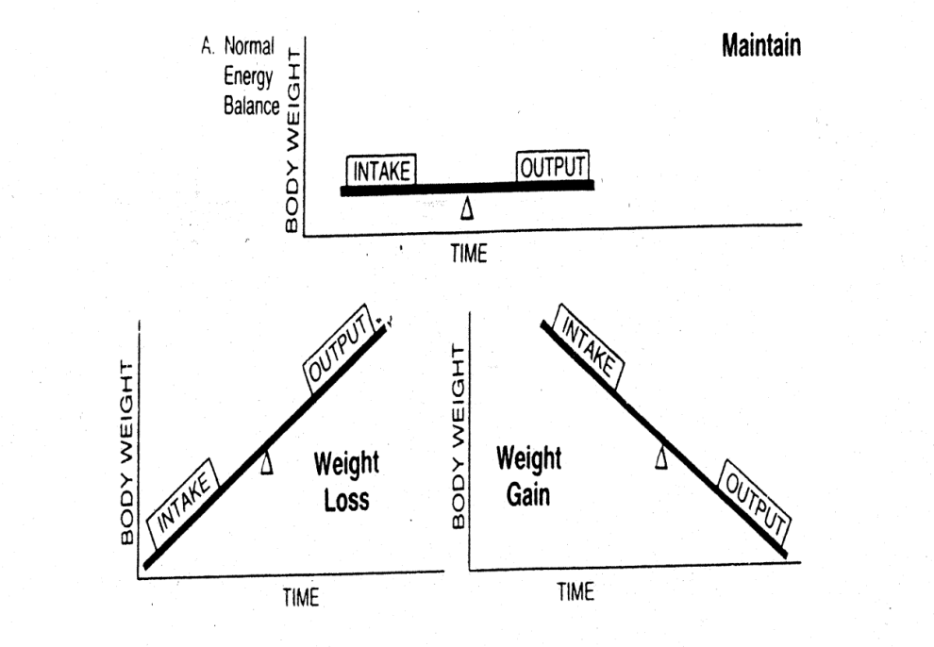

What kinds of problems are likely to be experienced by a person carrying excess body fat?
- Detracts from ______________________
- Decreases endurance and ______________________________
- Increase risk of coronary heart disease and other related problems (______________, clogged arteries, high blood pressure, __________________)

MEAL PLANNING
Using the chart below, highlight one item from each category/section to build a meal that you would enjoy:
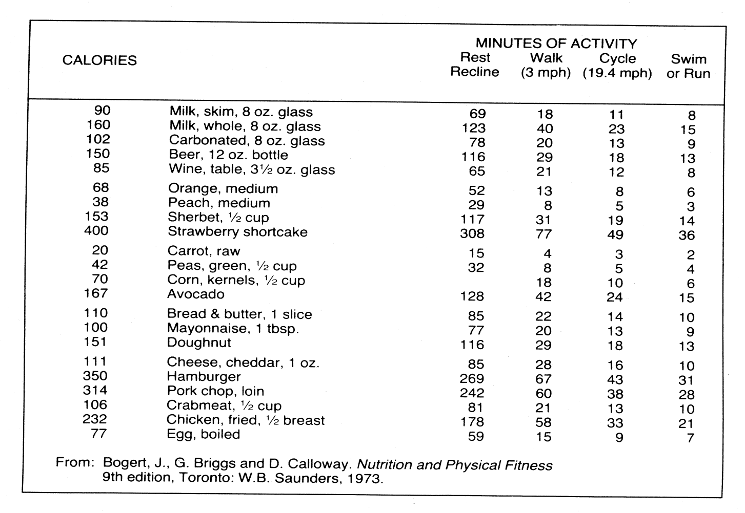

Now take your choices and calculate the number of calories you consumed in this one meal: __________
Check the right columns of the chart to determine how many minutes it would take you to burn these calories if you were:
RESTING: __________
WALKING: __________
CYCLING: __________
SWIM/RUN: __________

Do you feel as though the choices you make on a daily basis (food consumption combined with activity level) will lead to weight maintenance, weight loss, or weight gain? ___________________

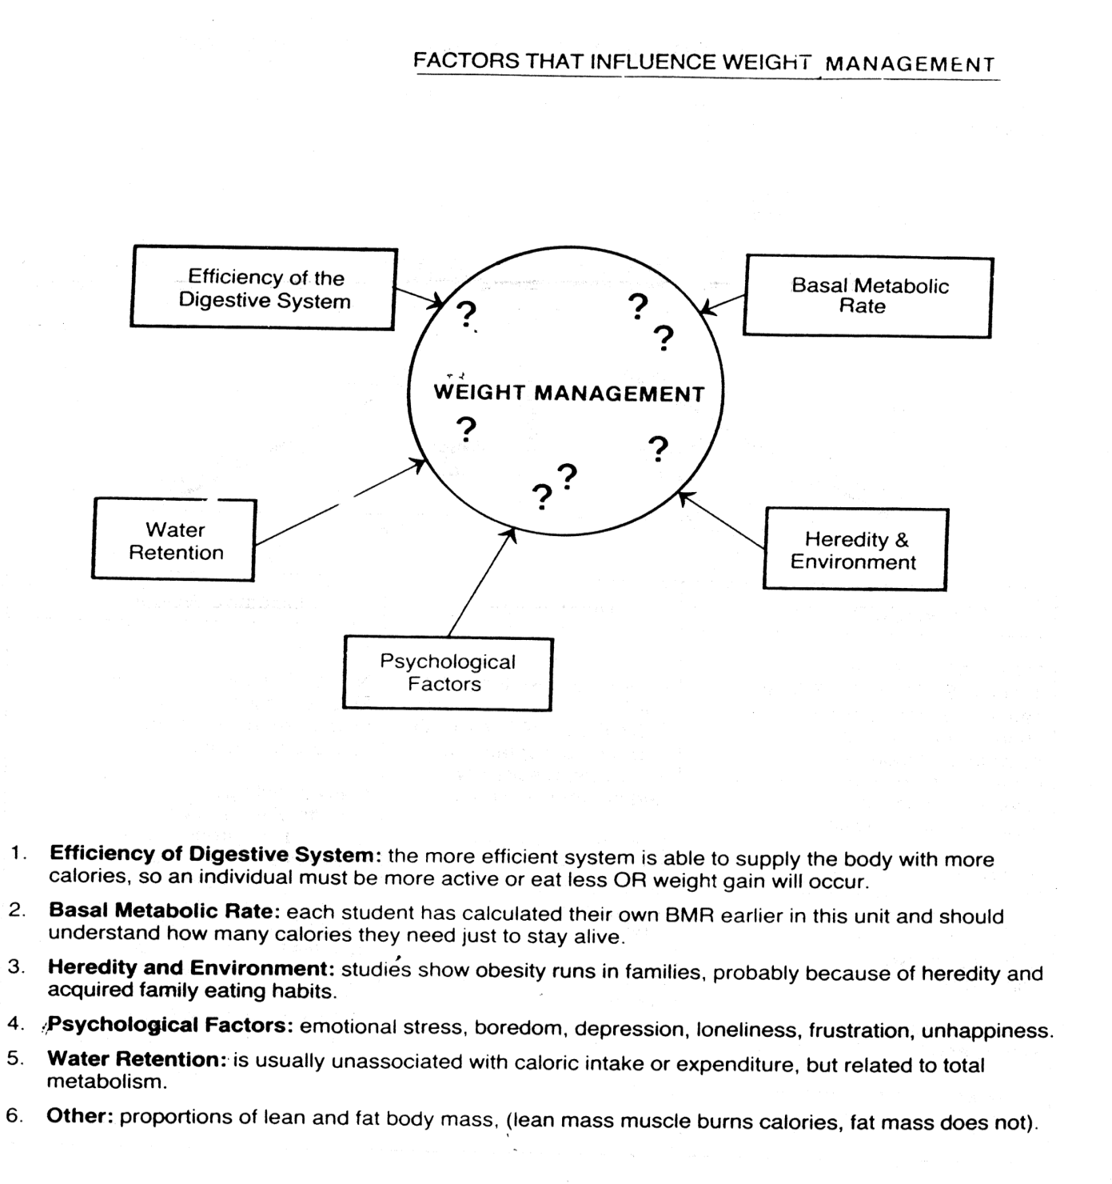

MOST DAILY WEIGHT FLUCTUATIONS ARE DUE TO WATER RETENTION

