Sweden

Geography
- Physical geography
Sweden is in Northern Europe and is on the northern peninsula. The land consists of 69% forest and woodlands. Another 8% is used a farmland. The west side of the country has many hills and mountains. The highest point is Sweden is Kebnekaise at 2,111m above sea level, the lowest point is 2.41m below sea level at Lake Hammarsjön.
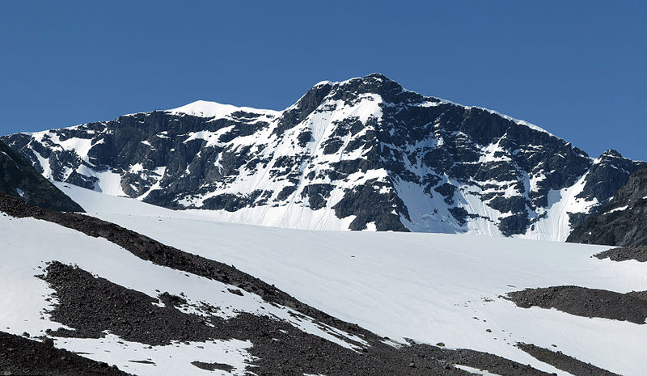 Kebnekaise, taken 29 June 2014.
- Population information
The population of Sweden is 10,034,400 when counted in 2017.
Majority of foreign born residents are from Finland and Syria as well as Iraq.
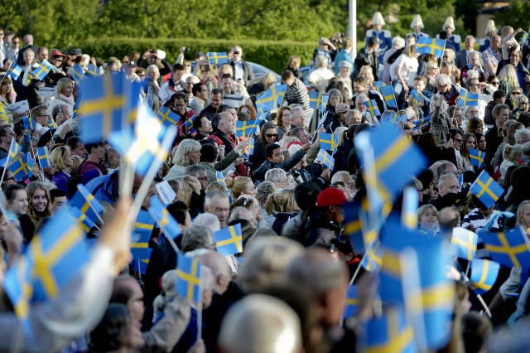
- Special attributes
Only 1% of Sweden’s garbage goes to landfills. In the summer Sweden has 56 days of daylight 24 hours a day. 95% of the power in Sweden is hydropower. There is a 91 degree difference between the highest and lowest temperature, 38°C and -53°C

People
- Language
Swedish is the official language of Sweden. It is similar to Norwegian and Danish. People that speak Norwegian and Danish can understand Swedish most of the time. Majority of Swedish people born after WWII can speak English.
- Religions
At the 3nd of 2016 61.2% of Swedish citizens went to the church of Sweden. In 1972 it was 95.2%. It is an Evangelical Lutheran national church, which means it is Christian.
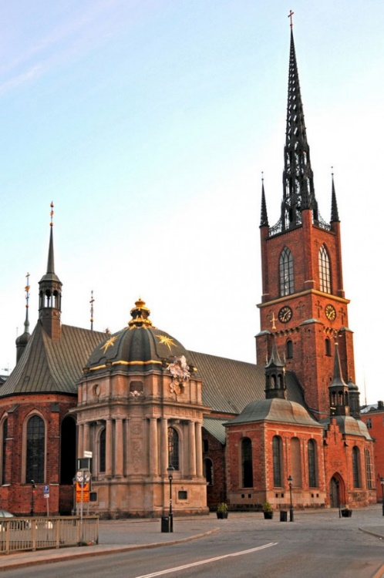
- Culture
Sweden has gotten 7 Nobel prizes, 26 Oscars. Minecraft, the second bestselling game of all time was created it Sweden. Sweden is also home to the most subscribed person on YouTube and some of the best competitive gamers around. Sweden is also home to IKEA, the biggest furniture company in the world. Lingonberry jam is very popular as well a Swedish meatballs.

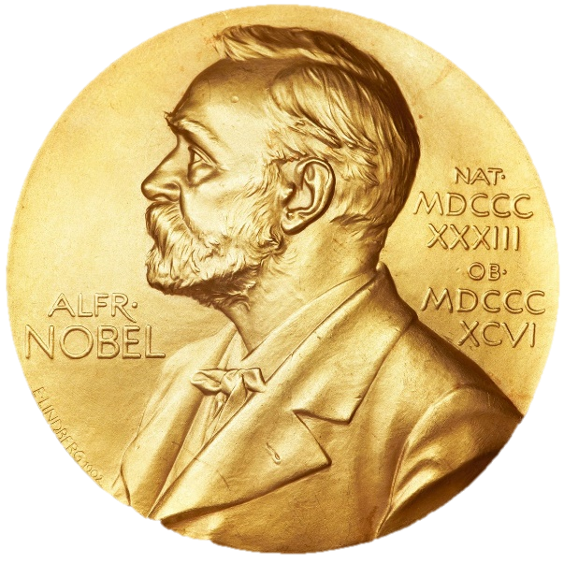
- Standard of Living
According to the OCED better life index Sweden is 6.5/10 when it comes to housing, Canada in comparison is 7.6 (or second)

Industry
- Key industries
Key industries are: motor vehicles, telecommunications, pharmaceuticals, industrial machines, precision equipment, chemical goods, home goods and appliances, forestry, iron, and steel.
- Currency exchanged
Sweden uses their own currency, the Swedish Krona or SEK. One SEK is worth 0.11USD. The Krona “11th most traded currency in the world by value” in 2013.
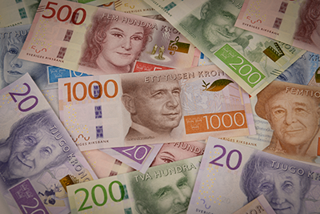

Tourism Highlights
The Vasa Museum is very popular is Sweden and houses the only almost fully intact ship from the 17th century that has been preserved.
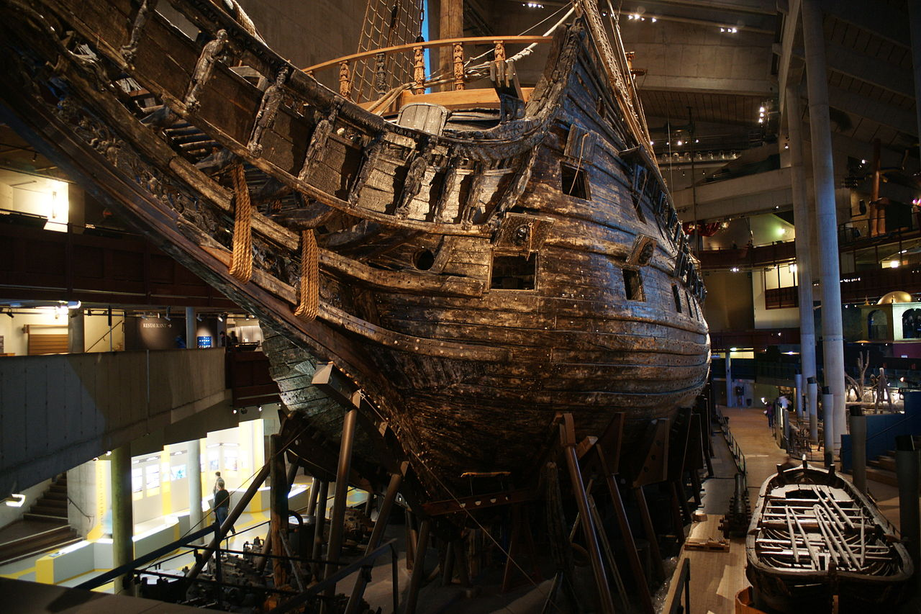
The Fairytale Drottningholm Palace because it dates back to the 17th century and was home to the royal family
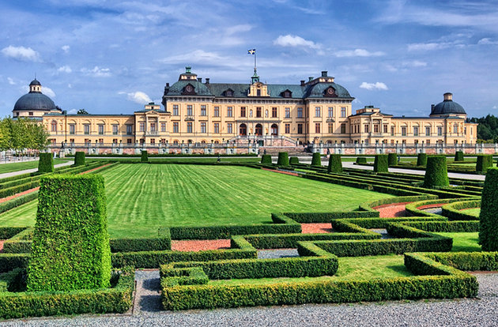
The Abisko National Park is popular attraction because the of beauty of the lakes and landscapes
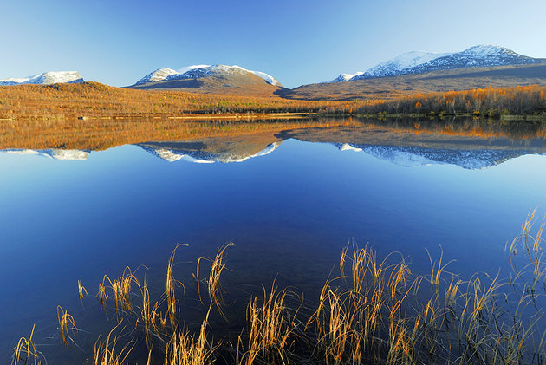

Sources
https://en.wikipedia.org/wiki/Sweden
https://sweden.se/
https://en.wikipedia.org/wiki/Swedish_krona
http://www.planetware.com/tourist-attractions/sweden-s.htm

