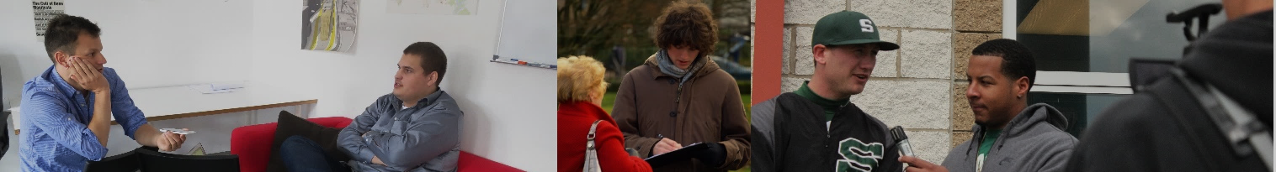
An important skill in the 21st Century is making connections with others. Connections lead to friendships, jobs, opportunities. They open the door for collaboration and cultivation of relationships. In order to establish these connections, you need to be aware of the employment or volunteer opportunities that surround you.
Community Connection Modified
Instructions
Task 1: Go to one of the following websites and select a volunteer opportunity that you could get involved with in order to gain experience or knowledge that may benefit your future.
https://ca.indeed.com/Volunteer-jobs-in-Coquitlam,-BC
http://www.volunteerconnections.net/start-volunteering!/places-to-volunteer-near-you
Task 2: Create a blog post that has 5 sentences.
Title: Community Connections
Tag: ADL17connection
Category: PE9
- Sentence 1: What is the volunteer job/position that you are interested in?
- Sentence 2: Where and when is the volunteer job/position taking place?
- Sentence 3: Why does this experience appeal to you?
- Sentence 4: How could you benefit from this experience?
- Sentence 5: How can you get involved?
Task 3: Submitting your Assignment:
- When you have completed your Edublog post, submit using either the link below or the QR code on the right
- http://bit.ly/2AKHXbY

 | Missing - 0 | Not Meeting – 1-2 | Minimal - 3 | Meeting – 4 | Exceeding - 5
Quality of Connection | Missing. | A connection was attempted but not completed | A connection was made but it lacked meaning for the student | A connection was made that was meaningful to the student | A connection was made that lead to increased opportunities
Quality of Post | Missing. | Minimal information about the interview and individual | A retelling of the interview | Effective media; clear description of interviewee and student learning | Effective media; links to the interviewees work; meaningful reflection

Marking Rubric

