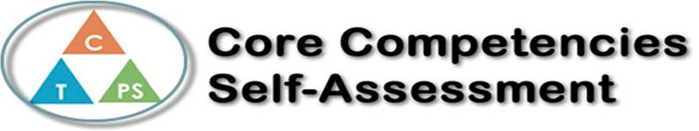
Name: Austin | Date: 2017/11/14

Self‐Reflection
Completing both a resume and cover letter helped me prepare to get a job and what I need to do to get the job I want. It made me understand more about the workforce. When preparing the answers to possible questions for my interview, I felt better prepared and more confident when speaking to the person who was interviewing me. I became a more confident speaker, I was able to give a proper firm handshake and maintain eye contact with the interviewer. I now also know what to wear and what not to wear to an interview. The experience felt so real and I felt it was very worthwhile to do.
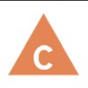
How does the artifact you selected demonstrate strengths
& growth in the communication competency?

In what ways might you further develop your communication
competency?
How does the artifact you selected demonstrate strengths
& growth in the thinking competencies?

In what ways might you further develop your thinking competencies?
How does the artifact you selected demonstrate strengths
& growth in the personal & social competencies?

In what ways might you further develop your personal & social
competencies?

Publish Your Self Assessment
You will now attach and/or embed your self‐assessment to the bottom of the blog post with the artifact you have chosen. You may choose to make this post private or public. After placing your artifact on a blog post, follow the instructions below.
- Categories ‐ Self‐Assessment
- Tags ‐ Now tag your post using the tag that corresponds to the competency that you have written about. You can choose more than one. Please use lower case letters and be exact. o #creativethinkingcc o #communicationcc o #criticalthinkingcc o #socialresponsibilitycc o #personalidentitycc o #personalawarenesscc
- Use the Add Document button located at the top of your post page and embed your self‐assessment at the bottom of your blog post. 4. Publish

