Austin St. Germain

Bridges That Can Take A Shake

Question - Which type of bridge will best survive an earthquake?
HYPOTHESIS
If bridges are subjected to different magnitudes of earthquakes, then the suspension will be the strongest because the towers dissipate the compression to the earth.
INDEPENDENT VARIABLE
Different magnitudes of earthquakes on each bridge type Suspension Bridge, Cable Stay Bridge, Truss Bridge.
DEPENDENT VARIABLE AND HOW MEASURED
Earthquakes – Hayward fault 5.0/8.2, San Andreas 7.0/9.0
They are measured through a computer simulation.
SAFETY FEATURES:
1. Bearings - Are a component of a bridge which provides a resting surface between the bridge piers and the bridge deck. The purpose of bearings are to allow controlled movement and reduce the stresses involved.
2. Ductile Materials - Are used for components that experience heavy loads. Such as steel, aluminum and also Brittle materials such as concrete, ceramics and glass are used for components that experience compressive loads.
3. Shock Absorbers - Are a hydraulic device designed to absorb damp shock impulses. It converts kinetic energy of the shock into another form of energy. Most shock absorbers are a form of dashpot. Dashpot is a device for damping shock vibration.
4. Shear Links – bridge foundations often reach down to bedrock. That solid base makes them very stable – unless the bedrock itself starts to shake! Earthquakes can tear a tower apart as the shockwaves hit each leg moments apart. Shear links are the cross-beams that connect the individual of the shaking, sacrificing themselves to save the tower legs from damage
PROCEDURE:
- Do the research and understand the basic bridge designs.
- Pick three types of bridges to test and read. I picked Suspension Bridge, Cable Stay Bridge, and Truss Bridge.
- Then Add Safety Features" to reinforce the bridge design. I added all four safety features to each bridge.
- Test each bridge with the Hayward fault earthquake starting with the lower magnitude and working up. Then test each bridge with the san Andreas fault quakes starting with the lower magnitude and working up. Record all results and take screen shots to show work.
RESULTS:
Hayward fault
Table 1 Earthquake mag.
 | 5 | 6 | 7 | 8
Suspension | Success | Success | Success | Two spans took some damage but the bridge itself did not collapse
Cable stay | Success | Success | Success | There’s structural damage on one of the spans but the bridge did not collapse
Truss | Success | Success | Success | Not a success
San Andreas fault
Table 2 Earthquake mag.
 | 5 | 6 | 7 | 8
Suspension | Success | Success | Success | Success
Cable stay | Success | Success | Success | Success
Truss | Success | Success | Success | Not a success
Hayward Fault
Suspension bridge
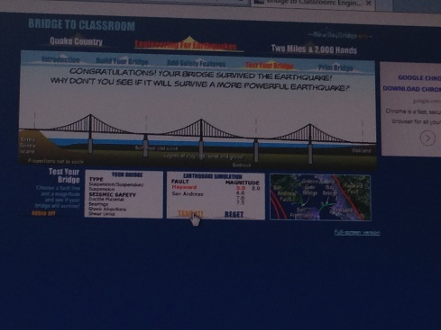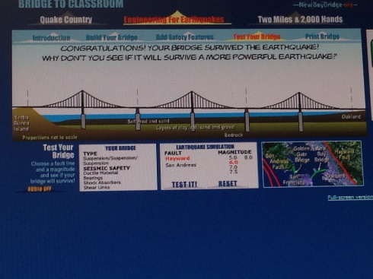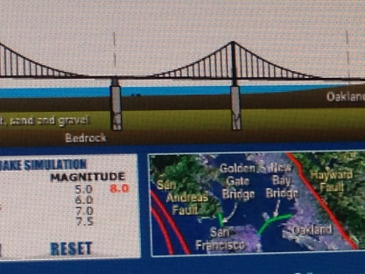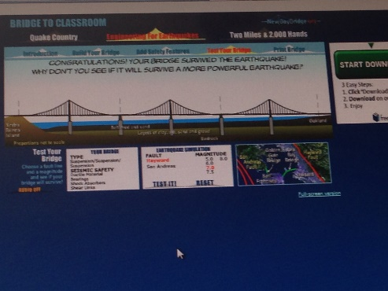
Cable Bridge
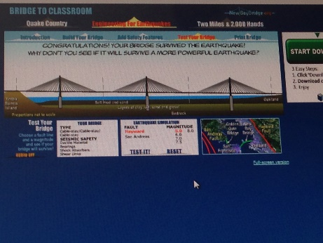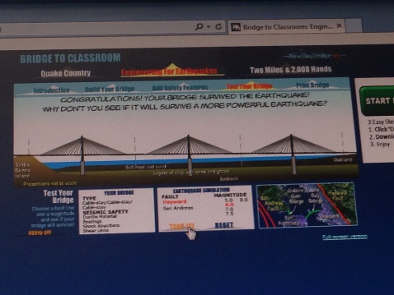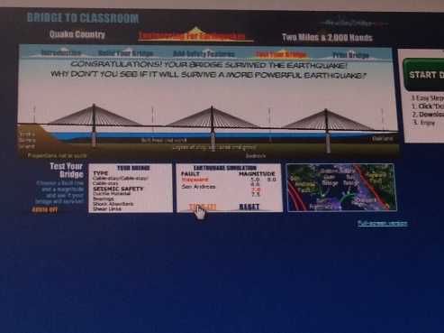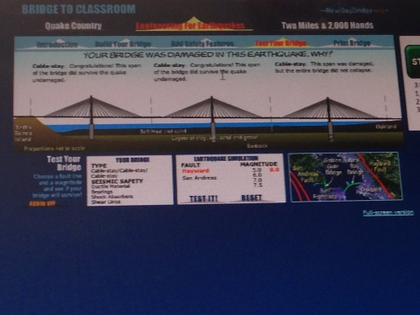

Truss bridge
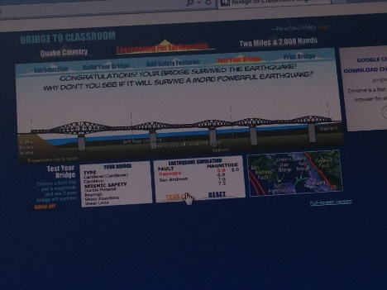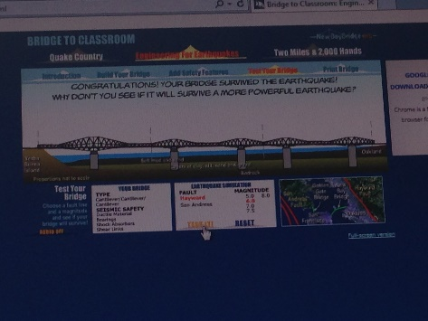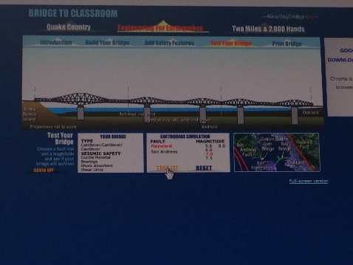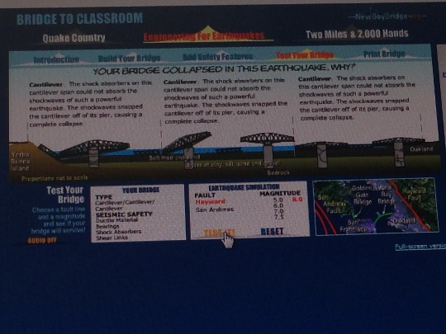

San Andreas Fault
Suspension bridge
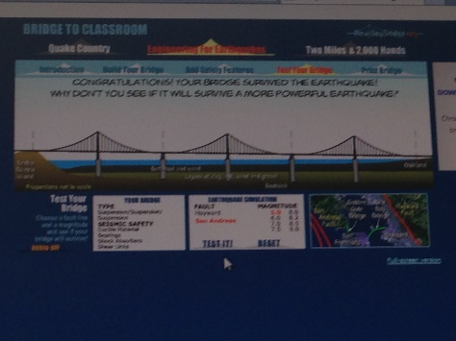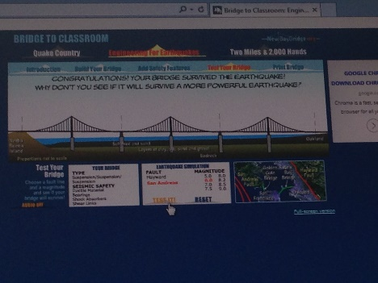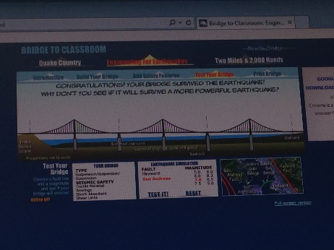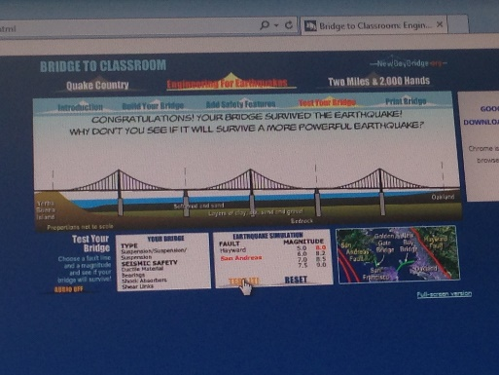

Cable bridge
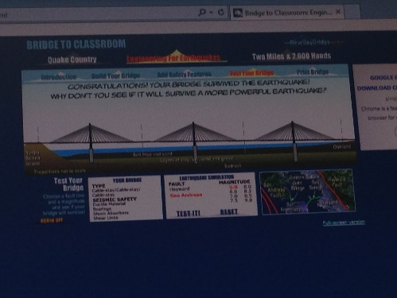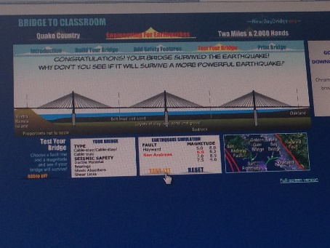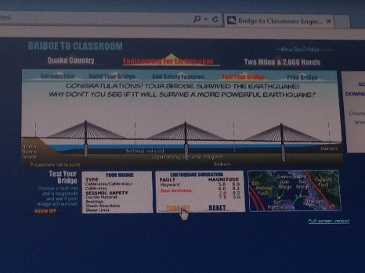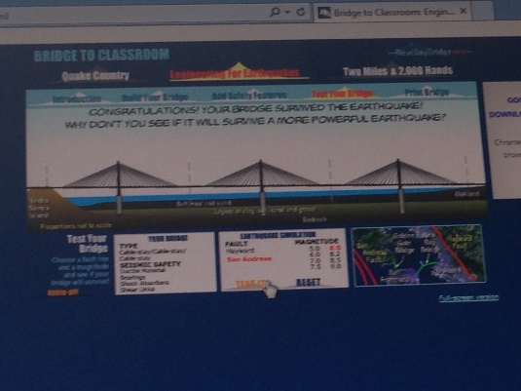

Truss bridge
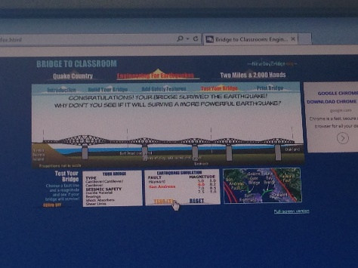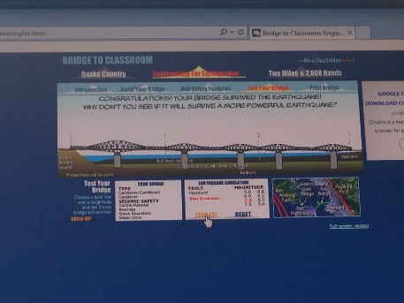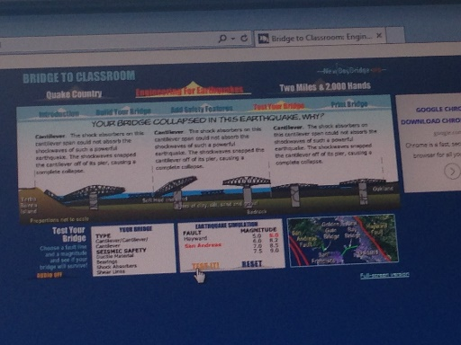

Cable Stay Bridge
Cable stay bridge is the best to withstand a earthquake because it has one or more towers and the cables support the bridge deck. The cables supporting the deck are suspended vertically from the main cable anchored at both ends of the bridge and running between the towers. The cable-stayed bridge spans are longer than cantilever bridges and shorter than suspension bridges. The tower of the cable-stayed bridge is responsible for absorbing and dealing with compressional forces. The cables extend from several points on the road to a single point at the tower. The basic design dates back to the 16th.
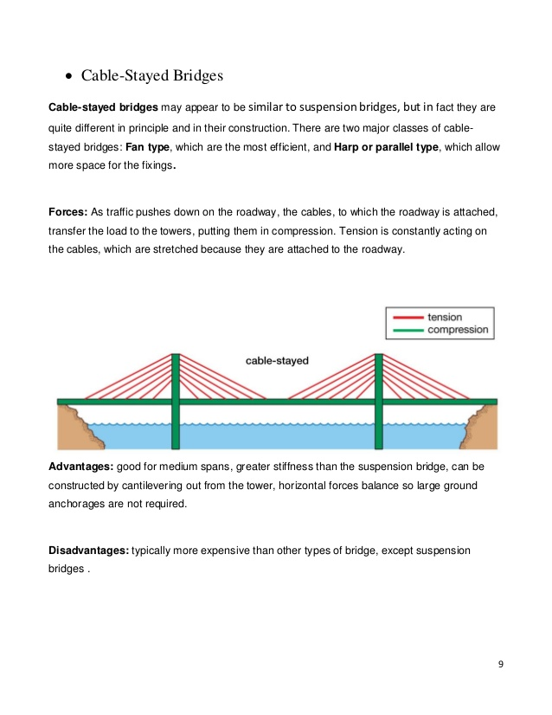
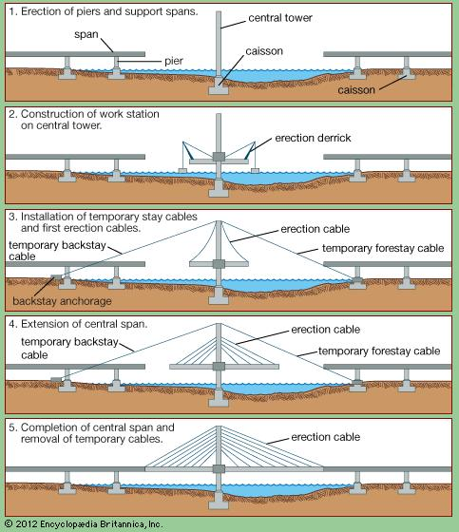

Suspension bridge
A suspension bridge has a deck which is hung below suspension cables on vertical suspenders. They were originally made from rope and wood, and then later with iron chains. Now they use a box section roadway support by high tensile strength cables. This bridge has cables suspended between two towers and vertical suspender cables that hold the weight of the deck. These suspension cables must be anchored at each end. The two towers support most of the weight of the bridge, they dissipate the compression right to the earth.
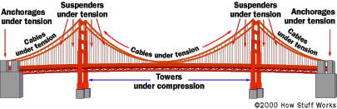

Truss bridge
A truss bridge has load-bearing superstructure that is composed of a truss. Truss bridges are one of the oldest types of modern bridges. The basic truss bridge has simple designs which could be easily analyzed by 19th- and early 20th-century engineers. Modern materials such as restressed concrete and fabrication methods, such as automated welding, and the changing price of steel relative to labor that has significantly influenced to the design of modern bridges.

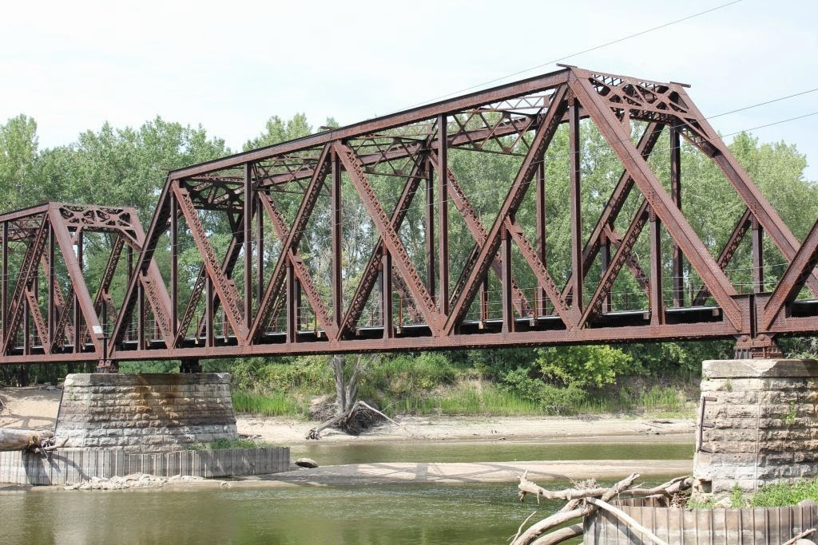
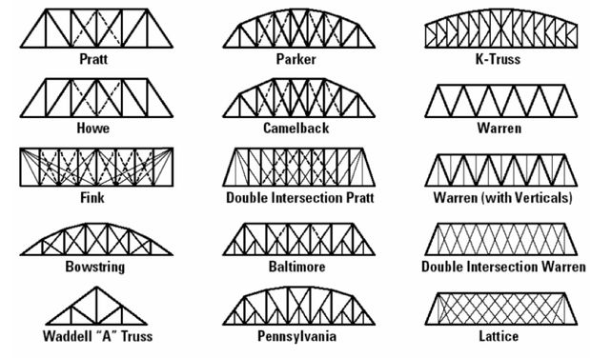
CONCLUSION/DISCUSSION:
Cable stay bridge is the best to withstand a earthquake because it has one or more towers and the cables support the bridge deck. The cable stay bridge stayed in tacked threw san Andreas fault and the Hayward fault. And the other bridges didn’t survive the different magnitudes. The suspension bridge in the Hayward fault was successful for all the magnitudes but the last magnitudes had structural damage on two spans but the san Andreas fault it was successful with all the magnitudes.

