Wolf Hirschhorn Syndrome
Hello, I’m Wolf Hirschhorn syndrome; I am a condition that can affect many parts of the body. This includes one’s facial appearance, development, slowed growth, intellectual disability, and seizures. My disorder causes and affects my host by having a broad face, flat nasal bridge, and a high forehead, they sometimes say I have a “Greek Warrior Helmet” appearance. I make the eyes spread widely apart and they could be protruding. Some other features I may have are shortened distances between the nose and upper lip (a short philtrum), a downturned mouth, a small chin (micrognathia), and small ears with small holes (pits) or flaps of skin (tags).
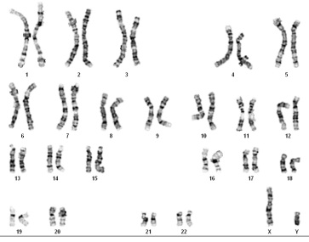
There are two ways of treating me surgical care and medical care. The medical care way is to help with feeding problems, valproic acid that helps with seizures, and benzo, communication and speech therapy as well as sign language helps the host talk, ophthalmologic abnormalities, congenital heart defects, and hearing loss this helps with their hearing. The surgical care way is Nissen-Hill fundoplication procedure; this is indicated for severe gastroesophageal reflux. Standard orthopedic surgery is suggested for foot deformities at an early age.
Watch this video to learn more about Wolf Hirschhorn syndrome. It helped me to understand more about it, and how it affects people It gives lots of great facts. https://youtu.be/ck2E387sWqc
This website by NORD. This website made it easy to find good explanations about wolf Hirschhorn syndrome. I thought this website was very educational and helped a lot with my research. http://ghr.nlm.nih.gov/condition/wolf-hirschhorn-syndrome

Wolf Hirschhorn Syndrome Questions
- Some questions I looked up to create my story were; What does wolf Hirschhorn syndrome look like and what does it do to facial appearance? What are the causes? What are the symptoms/ side effects of Wolf Hirschhorn syndrome? How do doctors help with Wolf Hirschhorn syndrome?

- I used Microsoft word, YouTube, Google, and different websites on the topic of wolf Hirschhorn syndrome.

- I first started by looking up and writing down some Information on Wolf Hirschhorn Syndrome I wrote down important facts. I than looked up YouTube videos and different websites. I linked the video and website I got most of the information from.

- To make sure all of my information is correct I double check the info on multiple websites; and make sure all of my questions are answered correctly.

- I didn’t think this project was too hard, and I didn’t mind learning about my mutation, I think that I could’ve made the story more creative if I had more time.

