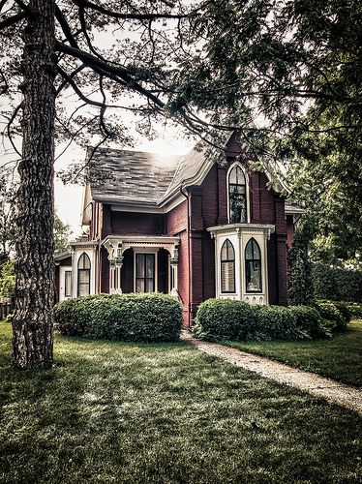

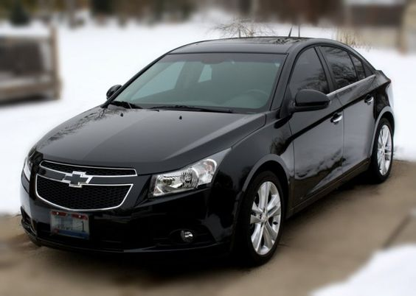

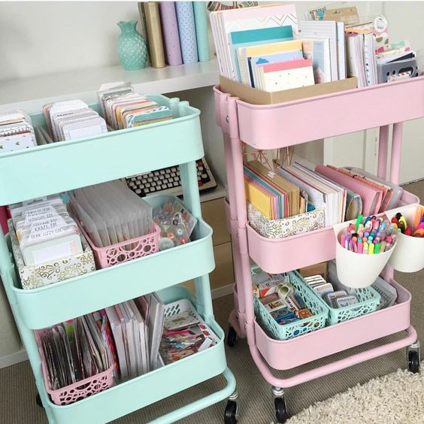
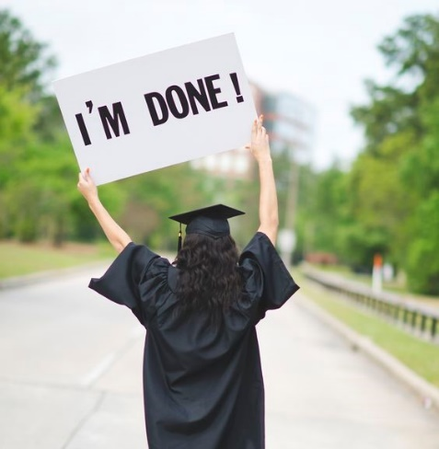

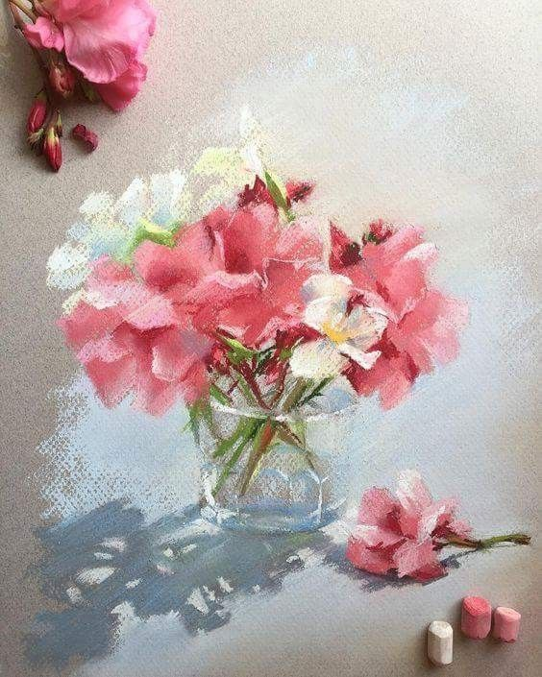

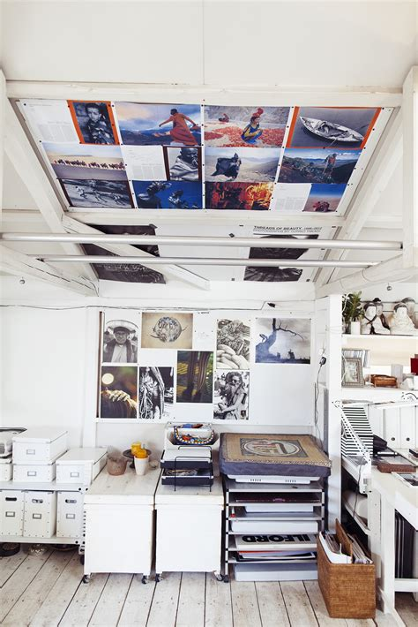

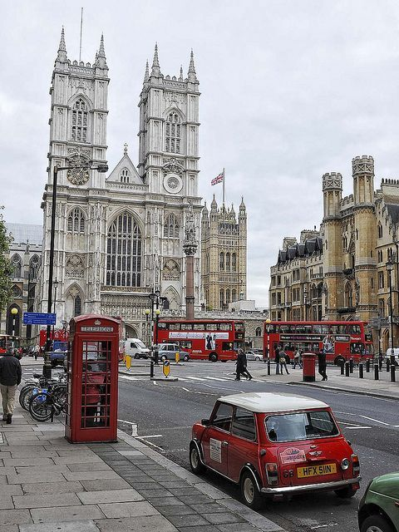

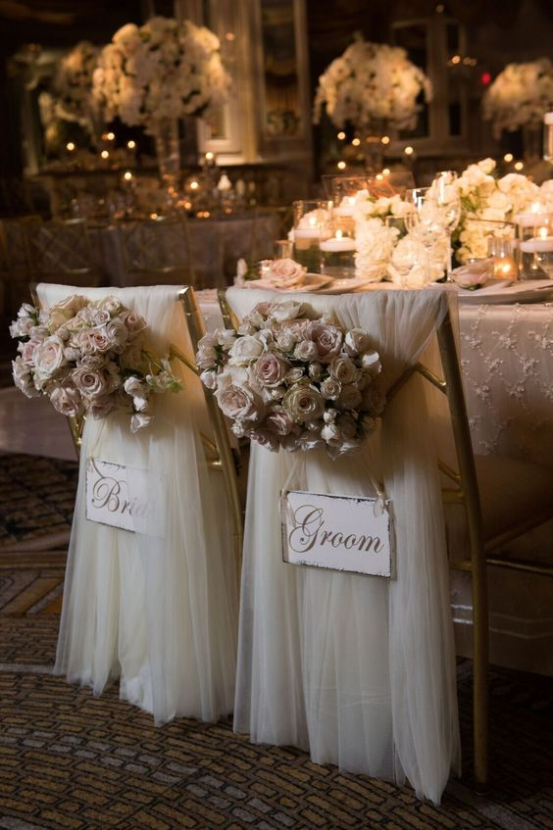

I want to live a comfortable and relaxing life. I want to go on with my art career and having a calming routine. With illustrators, they usually work at home and stay home which is the perfect for an introvert like me. I’ll probably only go out for food. I don’t like travelling that much and social gatherings so It’d be me and a partner just mostly staying at home. I don’t want pets or kids.

$75,270 per year for an illustrator.

  - Average cost of a wedding $18 150.
  - Average cost of a car $25 108.
  - Average housing cost in Canada $375 810.
  - Cost of ordering pizza everyday for a year $ 9 125.
  - Cost of all that stationary $387.
  - Cost of an art studio $1 295.
  - Cost of travelling to England $1 481 (round trip.)
  - Cost of art pastels $32.
(BE FREE OF STUDENT DEBT.)

