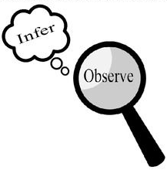
Observations and Inferences
Science 10 Name: Ashiana Sunderji BLK: D

OBJECT | OBSERVATIONS  Words that describe the object | INFERENCES  Ie: Where might the object come from? Possible uses? Etc. | QUESTIONS YOU HAVE ABOUT THE OBJECT
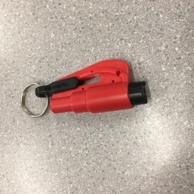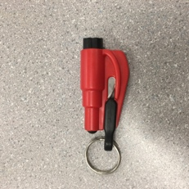  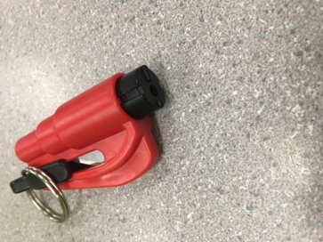 | •The object is red black and silver.  •There is a silver sharp and shiny part in the center and a silver shiny circular part attached to the black end of the object.  •When you shake the object it jingles.  •When you touch the object it is a hard solid, and there are circular edges that feel bumpy.  •One side of the object has a semicircular dip, which contains the silver sharp shiny part and a black kind of handle part that holds the object together, and the circular shiny part.  •Solid  •No smell | •The silver shiny part is a blade.  •The silver circle, is a key ring used to be put onto key chains, because of this inferences we can further infer that it can be used in a situation where you have keys in a car, and are trapped – maybe to cut a seat belt to free yourself.  •The outer black cylinder that is attached to the object, can be used like a hammer to break a window if you are in a car accident as well. | •How sharp is the blade?  •How often is this used to save lives?  •What is it made of?  •How much force is used to initiate the blade?  •How do you initiate the hammer?  •When was this invented?  •Where was it invented?
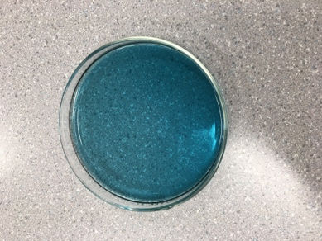  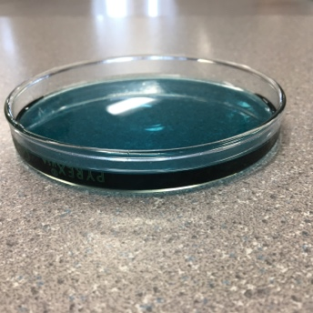 | •The color is dark blue greenish.  •It is quite transparent, when you move it around the more liquid in the area the darker the color and the opaquer it becomes.  •Feels Cold  •Is in a cylinder container  •Is a liquid  •Smells very strong of chemicals, like soap.  •Has a semi thick consistency  •Sticky. | •Some type of a soap or cleaner, probably laundry detergent because of the smell.  •When mixed with water it will probably clean very well, and bubble.  •There are probably lots of chemicals inside, because of the smell.  •The blue could be either a chemical, or it could be dye.  •Most likely poisonous if you tried to ingest it. | •What gives off the blue color?  •What chemicals are inside that give off the transparent look?  •What chemicals make it sticky?  •What makes it cold?  •What would have happened if you warmed it up?  •How was it discovered that with the mixing of chemicals you can produce a cleaner?  •Which chemical is producing the strong smell.
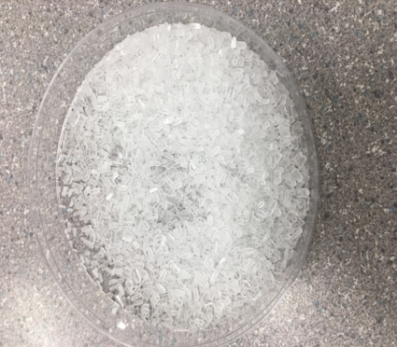 | •White  •Shiny  •Small  •Multiple  •Smells soothing  •Feels rocky  •Looks like shaved ice  •Looks like crystals  •Is held in a container.  •Transparent.  •Glass  •Clear  •Solid | •Most likely bath salts, because of the way it looks and the calming scent that.  •Helps bath smell better, more relaxing.  •It could be aspen salt used for injuries in baths.  •It is made up of some sort of chemical? | •Does it make noise (like crackling sound) in water?  •What gives that smell?  •Can it be further broken down?  •What is it made from?  •Is it decomposed of something larger?  •What gives it it’s scent?  •What type of chemical is used?  •Is it edible?
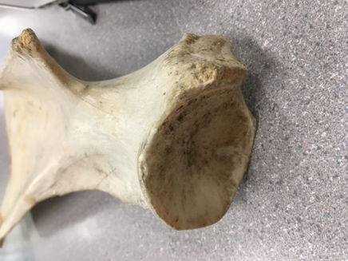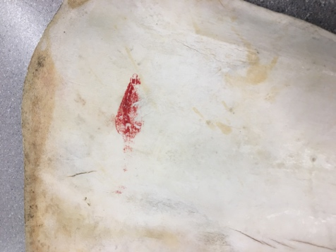  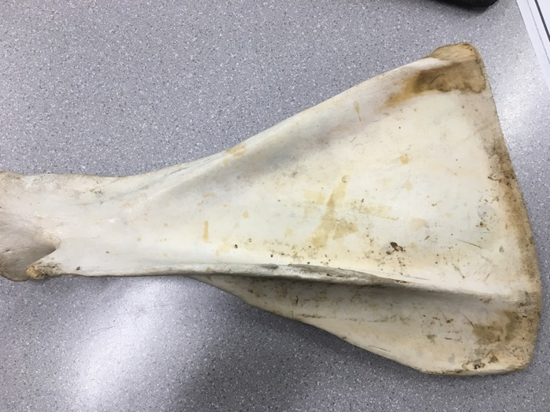 | •Appears like a bone  •Rusty  •old  •Yellowish, brown, beige  •looks to be decaying on the edges  •Feels like wood  •It looks like coral  •There is a circular joint look on one end.  •The other end is flat.  •There are 3 edges.  •Hard and solid texture  •There is a red stipe on one side  •Very destroyed, scratched up and rough.  •Doesn’t have any type of smell. | •Could be coral.  •Could also be some sort of a bone, flipper, tail or wing of an animal.  •Could be a shoulder blade or a hip bone of a larger animal.  •Because of the joint it could be a bone.  •If it’s real it must have some sort of preservative. | •What is it made of?  •How old is it?  •What made it all scratched up?  •Why is there a red stripe?  •If it is a bone, what animal is it from?  •What type of preservative was used, if used?  •What part of the animal could it be?  •What is the use of the part of the animal?  •Why would you want to keep something like this, what is the practical use?  •What would happen if you broke it down?

Observations/Inferences Assignment Assessment
Name: _____________________
Ex: Excellent VG: Very Good G: Good S: Satisfactory IN: Improvement is needed
Criteria | IN | S | G | VG | Ex
The following is included
- All 4 Images included
Observations:
- A minimum of 5 detailed observations made
Inferences:
- Thoughtful and logical inferences made
Questions:
- 2 thoughtful and logical questions made
- Spelling/grammar
- Assignment was completed on time
/10

