
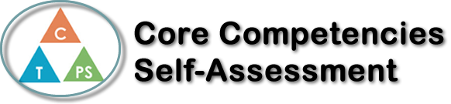
Name: Angelina Burton | Date:

  How does the artifact you selected demonstrate strengths & growth in the communication competency?  In what ways might you further develop your communication competency? | Self-Reflection  Describe how the artifact you selected shows your strengths & growth in specific core competencies. The prompt questions on the left - or other self-assessment activities you may have done - may guide your reflection process.  First off, reading this book opened my eyes to issues and controversies in this world. Although this book was written and published in 1960, there are still aspects that relate to our society today. There are still people supporting the KKK, Nazis, white supremacy, etc. These problems are putting our world in reverse, and soon we will be back to how it was in the mid-1900’s, even though we should be more advanced and more knowledgeable in issues. There are so many more activists than there were back then, but the government is turning a blind eye to what could make our world more progressive.  Second, making the project helped me have a better understanding on how to analyze books. Before, I didn’t really understand how to find all the points in the book, but having a longer book helped me, even though most people would think the opposite. I very easily located the main characters, symbol, theme, and conflict, when otherwise I would have a hard time. I had to think hard about how the book affected me in ways I would not normally think of. It showed me how kids then acted, how adults treated kids, how there was a lot more liberty to do what you wanted, but most importantly, it taught me about the racism that occurred. Although I had some knowledge of earlier on in slave trade from reading Les Larmes Noires last year in French class, but this gave me a view a little bit more recent. After reading To Kill a Mockingbird, I definitely want to read more books about racism and the like.

x

How does the artifact you selected demonstrate strengths & growth in the thinking competencies?

In what ways might you further develop your thinking competencies?


How does the artifact you selected demonstrate strengths & growth in the personal & social competencies?

In what ways might you further develop your personal & social competencies?

Publish Your Self Assessment
You will now attach and/or embed your self-assessment to the bottom of the blog post with the artifact you have chosen. You may choose to make this post private or public. After placing your artifact on a blog post, follow the instructions below.
- Categories - Self-Assessment
- Tags - Now tag your post using the tag that corresponds to the competency that you have written about. You can choose more than one. Please use lower case letters and be exact.
  - #creativethinkingcc
  - #communicationcc
  - #criticalthinkingcc
  - #socialresponsibilitycc
  - #personalidentitycc
  - #personalawarenesscc
- Use the Add Document button located at the top of your post page and embed your self-assessment at the bottom of your blog post.
- Publish

