**SMART GOAL: Personal**

(Specific, Measurable, Achievable, Realistic, Timely)

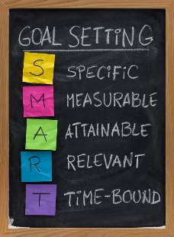 **GOAL STATEMENT:**

I will increases my stamina my running 30 minutes everyday before school.

**WHAT DO I NEED TO REACH THIS GOAL? (The steps you**

**must take in order, and the date you wish the step to be**

**completed by.)**

What I need to achieve my goal, is drive and I have that. I plan to do this until the end of provincials for track, which is in late may or early June. To make this a reality I will wake up at 5 am every morning and go for a jog.

**HOW ARE YOU GOING TO MEASURE THE PROGRESS TOWARDS**

**YOUR GOAL?**

I will my progress is how fatigue I am after doing the 30 minutes run and that I will give a basis on my measuring ,a second thing I can do to measure my goal. Is to see how my sprints times decrease.

**OBSTACLES YOU MIGHT SOLUTIONS**

**FACE**

Wear warmer clothing

Finish it in class

Go to bed early

If there is will, there is a way

Bad weather

Schoolwork

Being to tired to wake up

Traveling places

**WHO ARE YOU GOING TO SHARE YOUR GOAL WITH?**

My mother because she can pull out bed

**HOW WILL YOU CELEBRATE YOUR GOAL?**

By running a marathon

**NEVER GIVE UP!**