**SMART GOAL: Education/Career**

(Specific, Measurable, Achievable, Realistic, Timely)

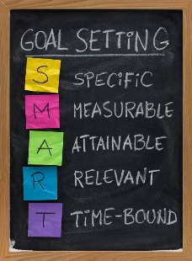 **GOAL STATEMENT:**

I will graduate and get a scholarship to division one university for volleyball.

**WHAT DO I NEED TO REACH THIS GOAL? (The steps you**

**must take in order, and the date you wish the step to be**

**completed by.)**

What I need to do in order to reach my goal is to first get my grades to an 85% or higher by studying better for test. Secondly I need to get my skills in check so in this goal I will get my passing,serving,attacking,and blocking consistent by June. To reach that goal I will review videos and practice 5 times a week for 2 hours on my own.

**HOW ARE YOU GOING TO MEASURE THE PROGRESS TOWARDS**

**YOUR GOAL?**

I will measure my goal by watching videos on myself to see my progress and to measure it.

**OBSTACLES YOU MIGHT SOLUTIONS**

**FACE**

Practice before school

Video my footwork and watch so I can correct it

Can’t really control my height

Not having enough time to practice due to my other sports

Not doing the foot work properly on my own

Being to short for playing middle in volleyball

**WHO ARE YOU GOING TO SHARE YOUR GOAL WITH?**

I will share my goals with my mother and my coaches

**HOW WILL YOU CELEBRATE YOUR GOAL?**

By taking a road trip

**NEVER GIVE UP!**