Wolf Hirschhorn syndrome part 1
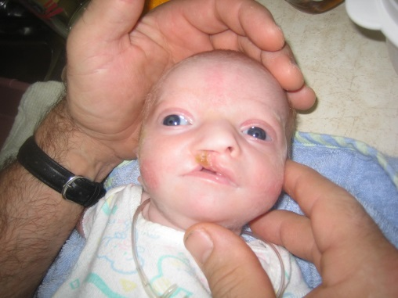
Hi I’m Wolf Hirschhorn syndrome; I am a condition that can affect many parts of the body. This includes a characteristic facial appearance, delayed growth and development, intellectual disability, and seizures. With my disorder I cause and affect my host by a broad, flat nasal bridge, and a high forehead, they call me a “Greek Warrior Helmet” appearance. I make the eyes widely spread apart and could be protruding. Some other characteristic I have are shortened distances between the nose and upper lip (a short philtrum), a downturned mouth, a small chin (micrognathia), and small ears with small holes (pits) or flaps of skin (tags).
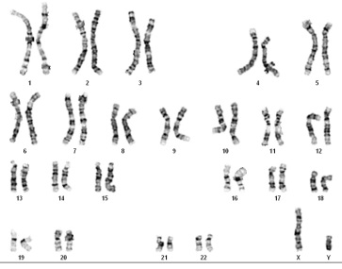
There are 2 ways of treating me medical care and surgical care. The medical care way is to help with feeding difficulties, valproic acid that helps seizures, and benzodiazepines, speech and communication therapy and sign language helps them talk, ophthalmologic abnormalities, congenital heart defects, and hearing loss this helps with their hearing. The surgical care way is Nissen-Hill fundoplication procedure this indicated for severe gastroesophageal reflux. Standard orthopedic surgery is recommended for foot deformities at an early age.
This YouTube video shows what wolf Hirschhorn syndrome looks like, what it does, and how it works. I like this video because it helped me understand a lot better and gave a lot of amazing facts about wolf Hirschhorn syndrome. https://youtu.be/Ol-UBlbpANY
This article by genetics Home Reference. This article made it easy to follow a good explanation about wolf Hirschhorn syndrome. I thought this website was very educational and helped a lot with my research. http://ghr.nlm.nih.gov/condition/wolf-hirschhorn-syndrome
This blog is a bunch of people sharing and giving information about wolf Hirschhorn syndrome. I found this blog very useful and helpful, when I was thinking of my story. http://wolfhirschhorn.org/

Wolf Hirschhorn syndrome part 2
- Questions I researched to create my mutation story where; what does my wolf Hirschhorn look like and what they do to the facial characteristics, what are the cause, what are the symptoms/ side effects of wolf Hirschhorn syndrome, how can doctors help you.
- I used word, YouTube, Google, and websites/ blogs concerning wolf Hirschhorn syndrome.
- I started my process by coming with a list of questions, once I had all the information I needed I started to write my story. At the end I looked up blogs, articles, and YouTube videos about wolf Hirschhorn syndrome and added three that I thought were interesting.
- To verify my information I check multiply websites to make sure all of my questions were answered correctly.
- I didn’t think this project was too hard, and I enjoyed learning about my mutation, but I wish I could have had more time to put toward the story because I think I could have made it more creative.

