RESEARCH

What is a Solar Oven?

A solar oven is a device that utilizes sunlight as a source of heat for cooking different types of food. Solar ovens all have different methods for cooking such as frying, baking, and grilling. It’s a practical, economical, and portable efficient tool. The solar oven can be brought on camping trips when you want to cook smores or can even be used in your own backyard to cook eggs. Solar ovens are preferred over different methods of cooking, especially since our economy is increasing in development. One main advantage used while cooking with solar oven is it’s lack of need for fuel and electricity. These methods of cooking prevent deforestation and over usage of automatic electricity.

Parabolic Cooker

A “Parabolic Solar Cooker,” is a parabolic-shaped reflector that directs sunlight in a small area so it can create heat to cook the objects (food).

Pros:
- Can hold higher temperatures than a box/panel style cooker
- Good for grilling or frying
- More reflective

Cons:
- Bad weather
- The food can easily burn
- Harder to make

Box Cooker

A “Box Solar Cooker,” cook foods at high temperatures and mostly come with pots. It usually takes two to three hours to cook multiple foods. They are the most common type of Solar cookers.

Pros:
- You can fit all the food and cook it at the same time (depends how big the box is)
- Bigger space
- Can capture more sunlight

Cons:
- The food will cook longer
- Requires lots of supplies
- More expensive to create

Panel Cooker

A “Panel Solar Cooker,” combine the box and parabolic cooker together into one. They are the simplest to make and usually inexpensive to purchase.

Pros:
- Cheapest it to make
- Easiest to create
- More durable

Cons:
- Wind could affect heat/temperature
- Might not cook as well
- Less heat going through

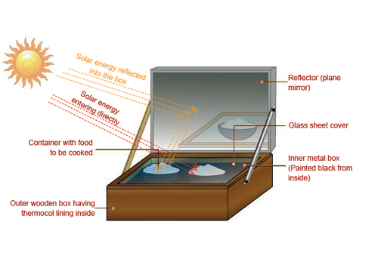

How do thermal energy transfers affect our solar oven and cooking process? (conduction, convection, and radiation)

Thermal Energy transfers affect our box solar cooker in three ways by using concentration, absorption, and retention. Concentration of sun rays are caused by reflecting panels, and surfaces that can concentrate rays of light to a certain point. These reflecting panels are made out of materials that are usually shiny and reflective, such as aluminum foil. Without an object to concentrate the sun’s rays, it could take more time to heat objects/surfaces. Most solar cookers are built with reflective panels to speed up the process of heat that come from these sun rays. The second way thermal energy affects solar ovens are by absorption. Absorption of the sun’s energy while solar cooking is most successful when the surface is dark. Dark colours absorb heat, as light colours do not. Silver is an example of a colour that reflects sun energy away. The best solar cookers are dark and thin. The colour of the solar cooker helps absorb the heat from the sun rays and the thinness allows the heat to transfer more quickly to the food. The last way that thermal energy transfers affect our solar cooker is through retention. It is the final step in solar cooking. If the cooker is not insulated properly and does not contain a cover/lid, the concentrated and absorbed heat would quickly vanish into the air. A solar cooker is required to have a “trap,” so that the concentrated heat can be captured and given time to build up high enough energy levels, so the food can be cooked properly and efficiently. These three energy transfers can also be known as conduction, convection, and radiation.

Citations:

Harper, G. D. (2015, November 06). Solar oven. Retrieved from https://www.britannica.com/technology/solar-oven.html

How does solar cooking work? (n.d.). Retrieved from http://www.solarcooker-at-cantinawest.com/solarcooking-howitworks.html

Solar Cookers: Pros and Cons of the Different Types. (n.d.). Retrieved from http://www.solarcooker-at-cantinawest.com/solarcookers-prosandcons.html

R., C., K., & S. (2017, February 24). DIY Solar oven experiment. Retrieved from https://www.thecrafttrain.com/diy-solar-oven/
How solar cookers work. (2018). Retrieved from http://solarcooking.wikia.com/wiki/How_solar_cookers_work

