Mary Lewis 1850
Here I am again, sitting here in this cold shed with no clean water, my knees are weak and my arms are heavy. My mother has gone to the village with my brother, while I take care of my baby sister. My life is constantly filled with fear and of the next beating, fear of no food and the fear of never being free. My day just consists of me feeding my masters, cleaning their house and torture.
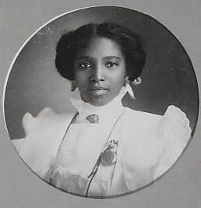
I know we’re not the only family like this and I know better than to complain to master… or my mom, but every night I dream for a new start, a new life away from Michigan. Forever. I need someone my family can trust to take us away from this terrible unhappy place.

My mom came back form the village a while a go and she told me she met a “Methodist” I ofcourse didn’t know what she ment by that, but she said this man can take us to a free state!! But why would he want to take a risk for us? My mom is willing to go and same with my brother, and I know what I said earlier, about wanting to leave and all. But we could get into trouble. I will do this for my family and I better be worth it.
While my mom fed the masters their supper, my brother and I got our bags together and fed my baby sister. My brother said we had to wait behnd the garden shed, but when the sun went down… my mom never came. We had to leave without her.
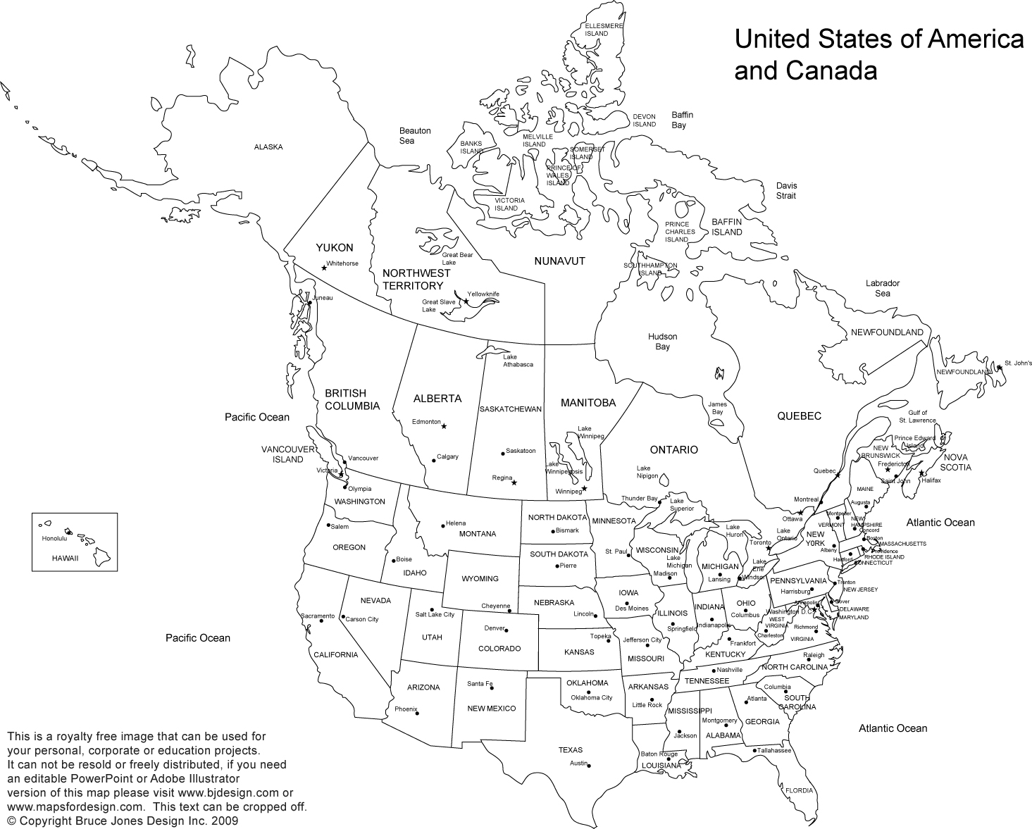
Now I am sitting here under a large amount of hay and its just as dirty as my shed, we’re at the back of a carraige waiting for freedom. We are not the ony slaves back here, there are many more who are also waiting for paradise. Earlier we had to travel through a forest and hide from our masters. All of us were drenched from the rain and mud and we’re all starving. Our destination awaits.

I will always remember what it felt like when the methodist man removed the hay from our busy heads. It was mid-day in the Ottawa and it felt so good to stand on free state soil, but if only my mom was here.
We are staying in this families home and they help us with my baby sister and take care of us everyday. They are the same colour as my masters yet they’re so wonderful to us. They have to hide us a lot though because people from the slave states would come look for us and other slaves. If we get caught that means we all have to suffer the consequences.
While bathing my baby sister one of the ladies in my new home head a knock on the door. The mysterious methodist man who brought us here had went back for my mom and travelled a long way to bring her here. We’re now reunited with my mom and I cant think him enough. Im ready for my new life with my family, the methodists and the quakers.

