The 3 Don’ts For Surviving an Island Filled With Pre-Teen Boys

Some peoples worse nightmare would be stuck on a tropical island filled with pre-pubescent boys armed with giant spears. Although, this may be seen as an unlikely occurrence, life is unpredictable and it's better to be prepared for life's misfortunes. So, here are 3 things you must never do in order to survive William Golding’s island of British boy filled terror.

- Don't: Make Enemies

When deserted on an tropical island, you would think your biggest threat would be the giant beast that hides in the depths of the sea or the unknown essence of the night. Those things are scary but, the one thing that's scarier is un-groomed boys running wild. It's survival of the fittest and you are going to need the help and support by all.

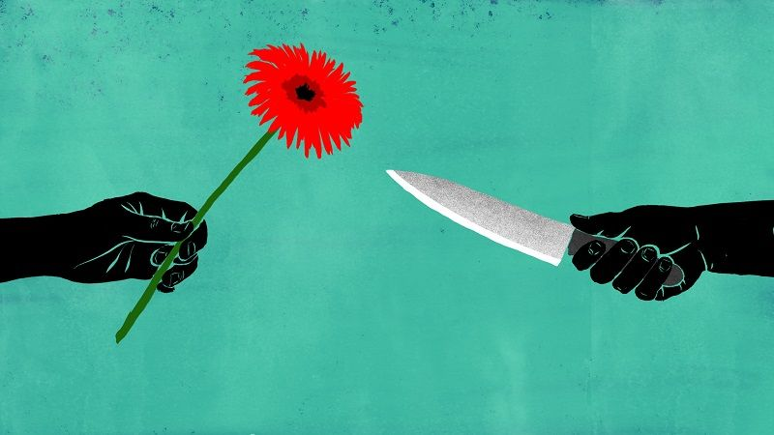
Do exactly what you are told and try to blend in but, not too much you get left behind in a raging fire. Follow the orders of the chief no matter how tedious they seem but, don't disrespect the maniacal hunter whose out for blood. Also, try not to pick on the fat kid, he may be an easy target but he has lots of good ideas that you may need in the future.

2. Don't: Be a Hero

Everyone would like the death of the dreaded beastie but, you don't want your own death either. Let the hunters do what they know best and you use your abilities do something far, far away. When you think about it, we know nothing about the beast. What does it look like? How big is it? Does it have claws? Sharp teeth? Does it breathe fire? Let's stick to the safe side and handle what we already know.

I know you feel bad for the kid getting picked on and being denied his share of the pig but remember, the one picking on him is blood thirsty and likes his meat. It may be unfair but, you don't want to go against the First don't, do you? Also, you don't have much that's considered yours on this island and to give up what little you have and possibly become a new target would be absolutely folly.

3. Don't: Let Your Savagery Take Over

Being stranded on an island far, far, away from the rest of the world, you forget about the old rules and ways. Your principles from your past life will quickly change and the old you will start to fade. So, make sure you have something that connects you to your old life. Whether it's a memory, a pair of glasses, or an old dirty tie, keep it close for when you loose your way.

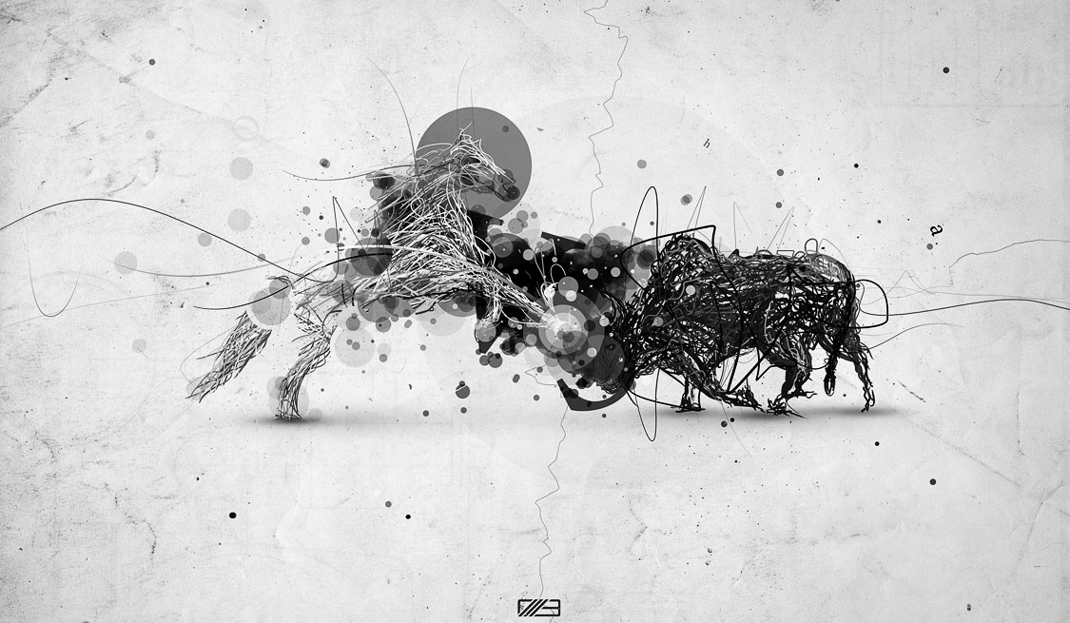
Don't fall for the savage ways of others. They may be bigger, stronger, armed, and out for blood but don't let them control you. Don't let them control your fears and actions with threats. You have bigger things to be afraid of like, the unknown beast that resides on the top of a mountain , not a 12 year old homicidal boy. Pick your leader carefully and make sure he's the one that will steer you in the right, civilized way.
I hope these 3 “Don’ts” helps you next time and who knows, maybe one of these things will be the thing that helps you survive and keep your humanity.

