Ms. Ferreira Aleana Labrador Science 15/10/16

Testing Vitamin C

I think we did this experiment to see if there would be a different chemical reaction between different substances with different amounts of vitamin C put into the same circumstances.
I learnt that the amount of vitamin C changes the kind of reaction that could happen. It’s important to know this because the amount of vitamin C can change everything. (example if your body might didn’t get enough vitamin C it may not react the same as if it were to get enough)

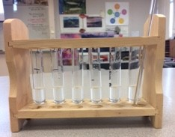
First we filled up 6 test tubes with 5mL of starch solution each.
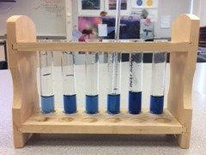
Then we filled each test tube that had the starch solution with one drop of iodine each. After dropping one drop we stirred everything together turning each test tube blue.
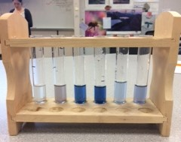
Starting on the left we first dropped 10 drops of Vitamin C in the test tube than we began to stir (turned clear.) And after we stirred each test tube we rinsed of the stirring stick. Then in the second test tube we dropped 10 drops of the strawberry banana juice then stirred (turned grey.) The third test tube had 10 drops of Gatorade added to it and then was stirred (turned into a lighter blue.) For the forth test tube we had to add 10 drops of 7up then we stirred (turned into a slightly lighter blue.) For the fourth one we put 10 drops of ice tea then stirred (it almost turned clear.) And for the last and final test tube we filled it with 10 drops of blueberry juice then stirred (turned into a light purple’ish’ blue)

