The History of MARRIAGE
The Three historical stages of marriage:
- Marriage customs have undergone many changes. There are three that marriage has progressed through.
  - Marriage by ________________________
  - Marriage by ________________________
  - Marriage for ________________________

MARRIAGE BY CAPTURE:
- This was the ___________________ type of marriage. Men were responsible for ____________________ a wife. They were looking for a woman that would be a good _____________ and a good ________________.
- Occasionally the man would send a “gift” to the father of their bride, to thank them.

MARRIAGE BY PURCHASE:
- During this stage girls were considered to be under the care of their ______________.
- The prospective husband (or family of the groom) had to ask the ________________ for his ________________________.
- The father would ask for ___________________in exchange for his daughter.
- This exchange of goods is known as a _______________where the groom must ‘pay’ for his bride.
- ___________________________ was when the groom made an exchange with the father in public.
- Following the consent of the father and exchange of goods, the couple would go to eat together and then go to the groom’s home.
- _________________________________ between families sometimes took place ____________ before the marriage.
- _____________is the money, goods, or estate that a woman __________________ in marriage.
- Originally, the purpose of dowry was to ____________ a husband to feed and protect his family, and to give his wife and children some ___________________ if he were to die.
- _____________________ a customary, or agreed-upon, dowry could _____________________.
MARRIAGE FOR LOVE:
- This is the stage of marriage that we see today.
- These types of marriages began in the _______ century.
- However, at this time many marriages were still __________________.
- Today there are families and cultures who still _________________ marriages.

INTERESTING FACTS:
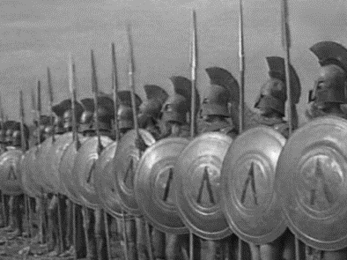
Seventh Century B.C.
- ________________________was very important to Spartans.

- It was important to produce______________________, so much so, that if a man was ____________________________, or couldn’t father _______________ he would allow a stronger man to _____________________________ his wife.

Ancient Greece
- Women suffered ______________________ if they lied about their virginal state.

- To stop any rumors the husband would ____________________________, stained with blood, from the window the day after the wedding.

