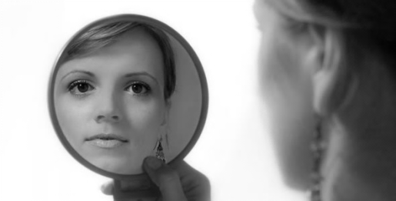
PART 1: LOOKING AT YOURSELF
DIRECTIONS: Below is a list of statements that describe personal
qualities. Read each statement and decide whether or not it
describes you. In the blank to the left of each statement, write
the number that represents your feelings about the statement.

1 = strongly disagree; 2 = disagree, 3 = no opinion;
- = agree; 5 = strongly agree

______ 1.I can be depended upon to do what I say I will do
______ 2.I give in to others easily and often
______ 3.I feel at ease and comfortable when I’m with others
______ 4.I usually have to be told what to do at school or work
______ 5.i try not to laugh at the mistake of others
______ 6.I organize my work so it’s done on time
______ 7.I often get discouraged at school
______ 8.I can control my temper when I get angry
______ 9.I have trouble making friends with others
______ 10.I worry that friends might not like me if they knew what I was really like
______ 11.When I make up my mind, I stick to it
______ 12.It takes me a long time to adjust to change and anything new
______ 13.I usually feel happy and cheerful
______ 14.I often don’t finish what I start
______ 15.I like to demonstrate how much I know to others
______ 16.I often feel inferior to my classmates and co-workers
______ 17.I like to talk a lot and often dominate conversations
______ 18.I try not to be critical of other people
______ 19.Most other people think I am an interesting person
______ 20.I am good at solving problems
______ 21.I have good athletics skills
______ 22.I usually take action on the basis of what I am feeling
______ 23.I try to be helpful and supportive to others
______ 24.I don’t like the way I look
______ 25.I handle most of my problems pretty well
______ 26.I am a good thinker
______ 27.I try to be fair to others
______ 28.I don’t let criticism bother me if I know I have to done my best
______ 29.I don’t have a lot of confidence in myself
______ 30.I want to be admired by others
______ 31.I have a good imagination
______ 32.I don’t care what happens to me
______ 33.I am not good at speaking in front of a group
______ 34.Most of my teachers don’t like me
______ 35.I have good ideas
______ 36.I don’t like to meet new people
______ 37.I am good at making or fixing things with my hands
______ 38.I try to achieve to the very best of my ability
______ 39.I find it easy to get along with people
______ 40.I worry a lot

PART II:
DIRECTIONS: Look back over this list. Put a + beside any response that you believe shows high self-esteem. Put a – beside any response that shows low self-esteem. Compare the number of marked items on the list. What conclusions can you draw about your self-esteem?

____________________________________________________________________________________________________________________________________________________________________________________________________________________________________________________________________________________________________________________________________________________________________________________________________________________________________________________________
