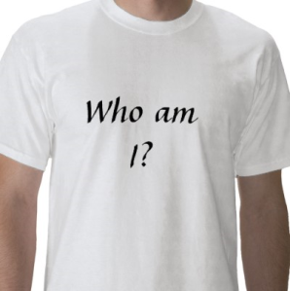
DISCOVERING WHO YOU ARE
Your emotions can have an influence on how you feel about yourself. Listed below are a number of feelings which people frequently have. Think of how you react when you have the feelings. How do these feelings influence your self-concept? If the emotion helps you feel good about yourself, place a check in the column “Positive Self-Concept”. If the emotion causes you to feel badly about yourself, check in the column labelled “Negative Self-Concept”.

FEELING | POSITIVE SELF-CONCEPT | NEGATIVE SELF-CONCEPT
Acceptance
Anger
Anxiety
Competence
Distress
Fear
Frustration
Hate
Incompetence
Jealousy
Joy
Love
Pleasure

1. Look back over the chart at those feelings which led to a positive self-concept. List three situations where you have felt at least one of these emotions.
______________________________________________________________________________
______________________________________________________________________________
______________________________________________________________________________
______________________________________________________________________________
______________________________________________________________________________
______________________________________________________________________________
______________________________________________________________________________

2. Suggest some ways in which you could work to increase the feelings that help you have a positive self-concept.
________________________________________________________________________________________________________________________________________________________________________________________________________________________________________________________________________________________________________________________

3. Look back over the chart at those feelings which led to a negative self-concept. List three situations where you have felt these emotions.
______________________________________________________________________________
______________________________________________________________________________
______________________________________________________________________________
______________________________________________________________________________
______________________________________________________________________________
______________________________________________________________________________
______________________________________________________________________________

4. What could you do to decrease the feelings which cause you to have a negative self-concept?
________________________________________________________________________________________________________________________________________________________________________________________________________________________________________________________________________________________________________________________

