WE’VE COME A LONG WAY BABY
Use the chart on page 271 in the Married and Single Life textbook to compare traditional marriage customs with those of today. Please be sure to compare with reference to the text info but also add information about your own thoughts on the current custom.
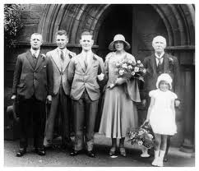
PRIOR TO THE 1900’s | TODAY
Parental approval before dating was allowed
Dating only used for serious appraisal of a potential marriage partner
Dating was mainly done in groups

Parents chose mates for their children

Parents chose mates based on social & economical considerations
Courtship happened within the girl’s home
Engagements lasted for two or more years
Marriage was an arrangement between the families
Parental consent was required for marriage
Dowries were paid

Poor transportation limited options for perspective partners
Marriage was considered an obligation

Widows and widowers were expected to re-marry quickly
Weddings were small private home ceremonies
Formal invitations were not sent out

Music was seldom used

Formal attire was not necessary

No receptions

Simple ceremony

Most brides did not wear a ring

Public notice of intent to marry was necessary
Common marriage age was between 16-19
Large number of children were expected
Breach of promise contracts were required due to economic arrangement
Divorce was infrequent due to the stigma attached

