INFANT CARE PRESENTATIONS

Many newborn babies spend most of each day sleeping. When they are awake, they need to be fed, changed, bathed, talked to, rocked and held. All of these routine activities can be turned into quality time by focusing on the baby and by doing your best to understand and respond to the baby’s signal.

Working in pairs, students are to research the latest information on a selected “baby care” topic. This information will be shared with the class in a:

Short, but well organized, and informative presentation.
Use of props is extremely encouraged.

OVERALL REQUIREMENTS:

Equitable sharing of responsibilities
Paperwork and presentation outline submitted on time (including list of resources – min 4)
Presentation (equally divided, prepared, good use of props, speaks clearly, well-organized, well-rehearsed, informative)

STEPS:

- Select a partner
- Select a topic from the list (there cannot be two groups covering the same topic)
- Use the text to find basic information and a starting point
- Divide into key topics and split the responsibilities
- Using the attached Infant Care Presentation Outline to plan and organize all aspects of the presentation and demonstration. This should include:
  - Introduction/importance/overview (and partner responsible for presenting)
  - Topic breakdown including key points and props required (and partner responsible for presenting)
  - Conclusion that highlights the key points of the presentation and importance of the topic (and partner responsible for presenting)
  - Resources list (minimum of 4 different resources)
- You must have your props and infant care presentation ready for our class on

_______________________________________________________________________
- You are welcome to supplement your presentation with a PowerPoint/poster/display board or other but please note that the demonstration aspect should come from you.

EVALUATION PART 1

Presentation Details:
- equally divided, prepared, good use of props, speaks clearly, well-organized, well-rehearsed, informative

Introduction
- Your introduction should capture the audience’s attention and spark their interest
- What is the reason the class should listen? Why is this topic important?
- You may wish to include an overview of what information will be covered within your presentation.

Organization
- Divide your presentation into easily identifiable sections/topics
- Topics should follow a logical sequence that connects to timing and/or procedural steps.

Demonstration (you will be provided 3-4 minutes between presentations for prop set up)
- Assemble props in the order that you will need them
- Identify each prop, providing relative information and important features
- Demonstrate in a step by step fashion. Provide instructions as you go. Make sure your audience is able to see.
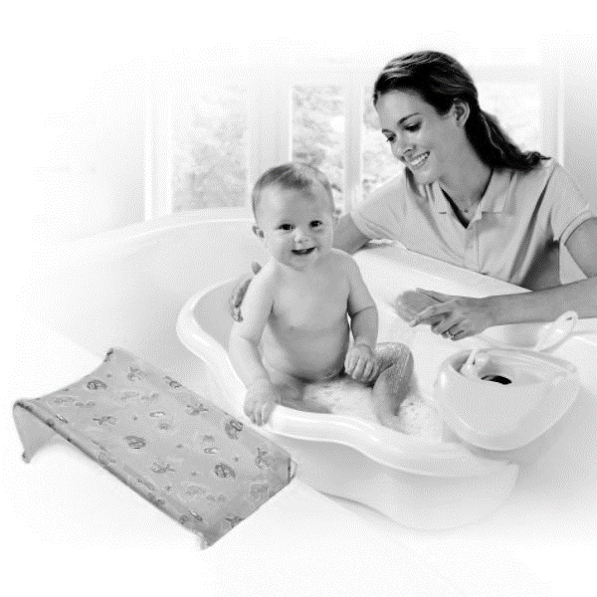
- Practice! Practice! Practice!

Conclusion
- A conclusion is important to end your presentation.
- It should be a brief review of the information covered and stress the importance of the topic.
- The presentation should end with a strong message.

DOES NOT MEET EXPECTATIONS/  CRITERIA established for this assignment | MINIMALLY MEETS  EXPECTATIONS/  CRITERIA  established for this assignment | PARTIALLY MEETS EXPECTATIONS/  CRITERIA  established for this assignment | FULLY MEETS EXPECTATIONS/  CRITERIA  established for this assignment | EXCEEDS  EXPECTATIONS/  CRITERIA  established for this assignment
NHI I  0-45% | C- C  55% 60% | C+ B-  70% 73% | B B+ A-  78% 82% 86% | A A+  92% 100%

