How to Get Married (and divorced ) In British Columbia

Are you eligible to marry in BC?

- You do not have to be a _________________________ resident to be married in the province.
- You are required to get a ______________________________, require by the Marriage Act.
- The license is valid for a term of ____________ months and only in _____________________.

Applying for a Marriage License

- Only _____________ member of the couple needs to apply in person for a marriage license.
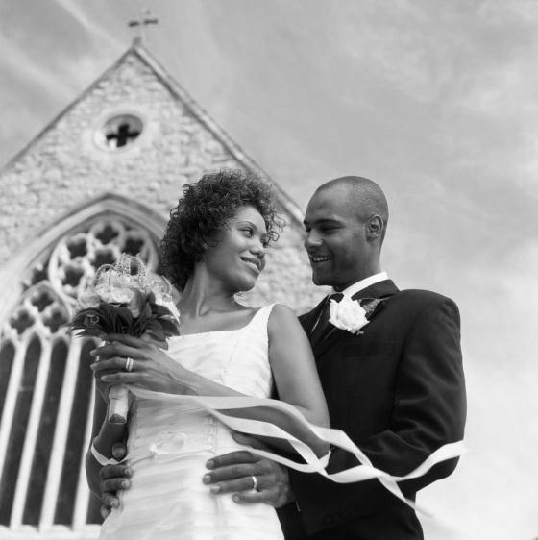
- The current fee for a Marriage License is ________ and must be paid at the time of application.
- The marriage license is
  - issued __________________ of application
  - ______________________________
  - valid for _______________________
  - may not be _____________________

Documentation

- Applicants must provide identification for both parties in the form of:
  - ______________________
  - ______________________
  - ____________________________ or _______________________ card which confirms 1) full legal names 2) birth date 3) place of birth

- Without the above primary identification, the following documents can be substituted (in order of preference):
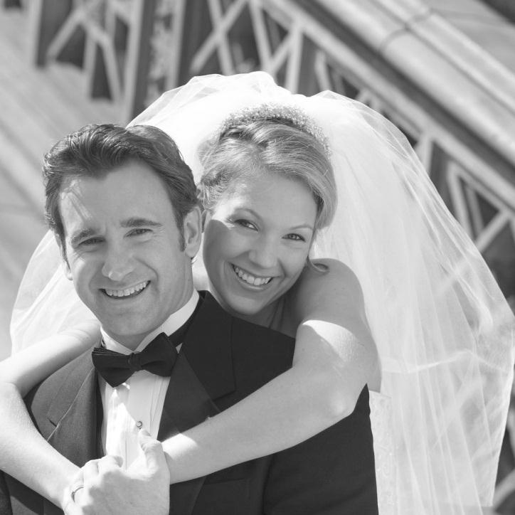
  - ______________________
  - ______________________
  - ______________________
  - ______________________
  - You will also be asked to provide information on:
    - current ____________________
    - _____________________

Restrictions

- Anyone over ________ years of age is eligible to apply for a marriage license in BC.
- Anyone under 19 years of age must first obtain the consent of _________________________.
  - No one under _____ years can be married without the consent of the _________________________________.
- If one or both individuals were recently ________________ proof must be provided.
  - No license can be issued until the courts ________________ a divorce, normally ____________________________the divorce is issued by the Courts.

Arranging the Marriage Ceremony

- In British Columbia, couples can choose to have a ______________ or __________ceremony, both of which must be ___________________ by two people.
- A religious ceremony requires a _________________________________ who must be ____________________________ with the Vital Statistics Agency, under the Marriage Act.
- In BC, a __________________________ is performed by a ___________________________, who must also be registered with Vital Statistics.
Registering the Marriage

- The marriage commissioner or religious representative who will perform the wedding ceremony will help complete the ___________________________________.
- Within _______________ of the wedding ceremony, the form will be sent to the Vital Statistics Agency, where the marriage will be registered and a _______________________ will be kept.
Proof of Marriage

- At the time of the ceremony, your marriage commissioner or religious representative may provide a ___________________________, which can be used temporarily as ___________ of marriage. However, it is not a legal document.
- You will receive a legal __________________________from the Vital Statistics Agency after the registration of the marriage.

CHANGING YOUR NAME

- After marriage, you _________________________ to use your spouse's surname or you can continue to use your own surname.
- Changing to your spouse’s surname does not require a ______________________________ (example: the name on your birth certificate would remain the same) or any _____________________________ to your identification records (you must submit a copy of your Marriage Certificate to have your current documents changed)
- If you choose to use a __________________________, a legal change of name is ________.
DIVORCE

THE DIVORCE ACT

Under the Divorce Act, _____________________________ is the only admissible ground for divorce.

By law, a marriage has broken down if:
- you and your spouse have lived apart for _______ and have decided your marriage has ended
- your spouse has committed ___________(sexual intercourse with someone other than you); or
- your spouse has been ______________ and/or _________________ cruel to you

If your situation qualifies as marriage breakdown, and either you or your spouse has resided in British Columbia for the past _______________, you may apply for a divorce in this province.

TWO TYPES OF DIVORCE

Joint Action (Both parties _______________)

- If you and your spouse agree to divorce, you may file for a ____________________________.
- To file, both spouses must be in ____________________ on all details including __________, __________ and ____________, and both spouses must sign a Writ of Summons and Statement of Claim.

Sole Action (Only _____________________ is requesting the divorce)
- Undefended Sole Action Divorce
- An undefended divorce is where one spouse is asking the other spouse for a divorce and the defendant _______________________any of the details of the divorce, such as custody, access, or support.
- Defended Sole Action Divorce
- A defended divorce is where one spouse is asking the other spouse for a divorce and the defendant has _________________ either the ________________ of the divorce or the ___________________________________.
DO IT YOURSELF DIVORCE
- The Divorce Act makes it possible for many married couples in Canada to handle divorce proceedings ________________________, without hiring lawyers to act on their behalf.
- If you are doing your own divorce and your spouse __________________ the details, you should consider seeking ____________________________

PROCESSING TIME
- Processing time of a divorce application depends on the _______________________ of the case as well as when clearance is received from the _________________________________________________ in Ottawa.
- Processing can take __________________________ from start to finish, but may take longer.
- If the judge determines that parties are _________________ to a divorce, she or he will grant a _____________________________.
- The divorce is automatically finalized ____________ days after the divorce order is granted if no __________________________ is filed.
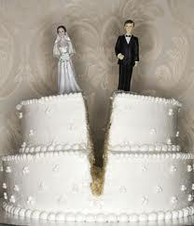
LEGALITY

- By law, without the existence of a __________________________ agreement, all asset and debt growth within the relationship are considered to belong to both parties.
- This includes:
  - ______________
  - ______________
  - ______________
  - ______________
  - ______________
  - and more

COMMON LAW

- The term COMMON LAW recognized unions created by _________________________________________ and ___________________, not by a civil or religious ceremony or official ________________
- To be considered common law, you have to prove you have been living with your partner for at least ______________________________ in a relationship like a marriage.
- Although a couple is considered to be common law after only 12 months of living together, most laws relating to division of assets and/or debts do not apply until having lived common law for ____________________
- The existence of _______________________causes an _________________________ to the two year rule.

