SOCIAL DEVELOPMENT

- Social development deals with ________________________
- Babies progress from complete _____________________________________ to the adult ability to live and work with others
- Babies develop socially to satisfy their _________________ and ________________ needs

SOCIAL DEVELOPMENT: refer to pg. 277 of your text and make note of the developmental milestone for each age group listed below:

1 month: ________________________________________________________________________________________________________________________________________________________________

2-3 months:
________________________________________________________________________________________________________________________________________________________________

4-6 months:
________________________________________________________________________________________________________________________________________________________________

7-8 months:
________________________________________________________________________________________________________________________________________________________________

9-10 months:
________________________________________________________________________________________________________________________________________________________________

11-12 months:
________________________________________________________________________________________________________________________________________________________________

Attachment:

- Attachment is a strong emotional ________________ between two people.
- At six months a baby ____________________ he is a _________________ person and works to develop a strong special ___________________ to parents/caregivers.
- This is the child’s first___________ relationship and the success of this relationship helps to shape all _______________ relationships.
- For attachment to occur the baby needs lots of physical _____________ and __________________
- Failure to develop ________________ can result in;
- Failure to _______________to people or object
- Cries will weaken, smiles fade, child turns _________________
- Lack of the ability to ____________normal social relationships in the future
- In severe cases, _________________ occurs (between 6-12 months, babies stop eating, death results)
- Often seen with _____________ care but can occur in families

Stranger Anxiety:

- By approximately 8 months a baby’s ______________ has improved so he now knows who he knows and who he doesn’t
- He will associate_______________ and _____________with his parents and other caregivers.
- Strangers cause him to be ______________ resulting in crying.
- This is a normal healthy response

Strategies to cope with stranger anxiety:

- Strangers should ________________ slowly, allowing the child to become used to them
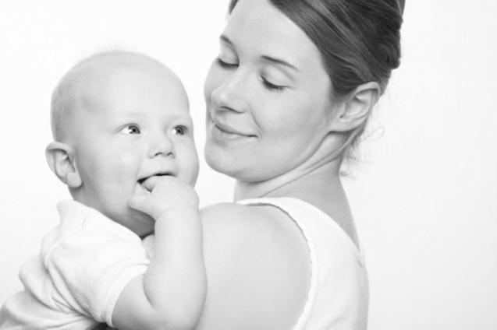
- Do not ______________ the child to go to a stranger
- ______________ are very important at this time

