AM I A ‘PEOPLE PERSON’?
People who pursue socially driven careers (whether with young children, teens, or families) typically have certain characteristics in common. Many of these characteristics are listed below. For each of the characteristics, rate yourself as (S) strong, (A) average, or (W) weak. Then have a friend or family member complete the same ratings on the back of this form & use both sides to answer the questions that follow.
___ Active  ___ Affectionate  ___ Alert  ___ Ambitious  ___ Artistic  ___ Broad-Minded  ___ Calm  ___ Capable  ___ Careful  ___ Committed  ___ Competent  ___ Considerate  ___ Cooperative  ___ Creative  ___ Dedicated  ___ Dependable  ___ Eager  ___ Efficient  ___ Energetic  ___ Enthusiastic  ___ Fast Learner  ___ Firm  ___ Flexible  ___ Friendly  ___ Healthy  ___ Honest | ___ Humorous  ___ Intelligent  ___ Kind  ___ Level-Headed  ___ Likable  ___ Loving  ___ Loyal  ___ Mature  ___ Organized  ___ Patient  ___ Practical  ___ Realistic  ___ Resourceful  ___ Responsible  ___ Self-Confident  ___ Self-Controlled  ___ Selfless  ___ Sensible  ___ Serious  ___ Sincere  ___ Stable  ___ Thorough  ___ Tolerant  ___ Understanding  ___ Warm  ___ Well-Groomed  ___ Wholesome

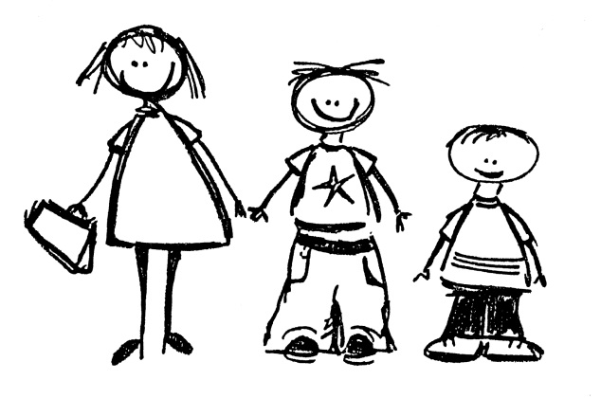
Record additional characteristics that you feel should describe someone who works closely with people. Also rate yourself as (S), (A), or (W) for each.
___ _____________________________
___ _____________________________
___ _____________________________
For each of the characteristics below, Have a family member or friend rate you as (S) strong, (A) average, or (W) weak.
___ Active  ___ Affectionate  ___ Alert  ___ Ambitious  ___ Artistic  ___ Broad-Minded  ___ Calm  ___ Capable  ___ Careful  ___ Committed  ___ Competent  ___ Considerate  ___ Cooperative  ___ Creative  ___ Dedicated  ___ Dependable  ___ Eager  ___ Efficient  ___ Energetic  ___ Enthusiastic  ___ Fast Learner  ___ Firm  ___ Flexible  ___ Friendly  ___ Healthy  ___ Honest | ___ Humorous  ___ Intelligent  ___ Kind  ___ Level-Headed  ___ Likable  ___ Loving  ___ Loyal  ___ Mature  ___ Organized  ___ Patient  ___ Practical  ___ Realistic  ___ Resourceful  ___ Responsible  ___ Self-Confident  ___ Self-Controlled  ___ Selfless  ___ Sensible  ___ Serious  ___ Sincere  ___ Stable  ___ Thorough  ___ Tolerant  ___ Understanding  ___ Warm  ___ Well-Groomed  ___ Wholesome

How would the characteristics in which you are strong benefit you in a career working with people?
________________________________________________________________________________________________________________________________________________________________________________________________________________________________________________________________________________________
Are there specific careers you can think of that your specific skill set would lend itself to?
____________________________________________________________________________________________________________________________________________

