SOCIAL SELF
The masks we wear…
Presenting a certain face to the world is something that most people are very familiar with. The different __________________ that people wear in the course of a day act as a social ___________________ and help them to get through a variety of situations.
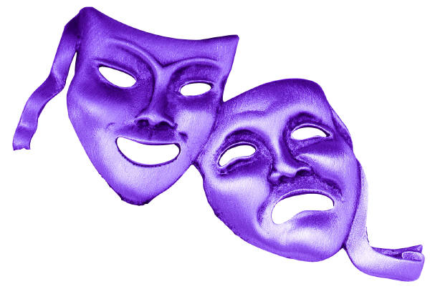
- The reasons behind the different masks that people wear vary considerably, and can be both _________________ and __________________.
BRAINSTORM:
With your group, use the space below to list of as many reasons as you can think of, as to why someone would present themselves differently in various social situations. Be prepared to share some of these reasons with the class.

We all wear masks at some time in our lives—it’s part of ________________________. The problem comes when masks become the norm and we ____________ ourselves in the process of trying to please others. It is important to have _____________________ ________________________ about the different masks we wear and the reasons behind it-- ________________________ the masks we wear is one way to make sure that they do not gain control of our true “self.”
THINK ABOUT A PARTY OR OTHER EVENT YOU HAVE ATTENDED RECENTLY:
Imagine you are telling your friends about it. What kinds of things would you share? JOT THEM DOWN. (No one will look at them, so be honest.)
________________________________________________________________________________________________________________________________________________________________________________________________________________________________________________
If you were telling your parents about this event, what information would you give them? JOT THIS DOWN. How does this information differ from the info you gave your friends?
________________________________________________________________________________________________________________________________________________________________________________________________________________________________________________
How does this information differ from the info you gave your friends?
________________________________________________________________________________
Think about a third group of people, for example your grandparents or you three year-old brother/nephew…. What information would you share with them? JOT THIS DOWN.
________________________________________________________________________________________________________________________________________________________________________________________________________________________________________________
How does this information differ from the info you gave the last two groups?
________________________________________________________________________________

ACTIVITY: the masks we wear (SCRAPBOOK DOUBLE DIP OPPORTUNITY)
NOTE *** If you choose to use this assignment as a double dip opportunity, please plan accordingly and be aware that your mask should not be double sided if you plan to have it in your scrapbook. You will need to complete two separate masks so that both are visible on your page.

Create a mask that shows the different “faces” you present to society.
- On the outside of the mask, put the faces you show your friends, family, teachers, for example. You can show these behaviours any way you like—with pictures, poetry, colours, words/slogans/ phrases, etc. (minimum 10)
- On the inside of the mask, show who you really are. On the outside of the mask you may have pieces of yourself, but you may also have misrepresentations. For example, you may behave in an outgoing manner at a party with your friends, but you may actually feel somewhat shy. You may be nice to others—sweet and innocent to your parents or grandparents, but swear when you are with your friends. On the inside of the mask, show your true self. Again, you may illustrate your true self any way you like—with pictures, poetry, colours, words/slogans/phrases, etc. (minimum 10)
When you are finished, write a paragraph or more to explain the significance of the images/words/phrase you chose.
________________________________________________________________________________________________________________________________________________________________________________________________________________________________________________________________________________________________________________________________________________________________________________________________________________________________________________________________________________________________________________________________________________________________________________________________________________________________________________________________________________________________________________________________________________________________________________________________________________________________

In addition to the above criteria, your mask should be colourful, well-planned with good use of space, include images and words, and most importantly, be reflective of your true masks. The written component should be used to explain and help the reader understand why the masks are reflective of you.

DOES NOT MEET EXPECTATIONS/  CRITERIA established for this assignment | MINIMALLY MEETS  EXPECTATIONS/  CRITERIA  established for this assignment | PARTIALLY MEETS EXPECTATIONS/  CRITERIA  established for this assignment | FULLY MEETS EXPECTATIONS/  CRITERIA  established for this assignment | EXCEEDS  EXPECTATIONS/  CRITERIA  established for this assignment
NHI I  0-45% | C- C  55% 60% | C+ B-  70% 73% | B B+ A-  78% 82% 86% | A A+  92% 100%

