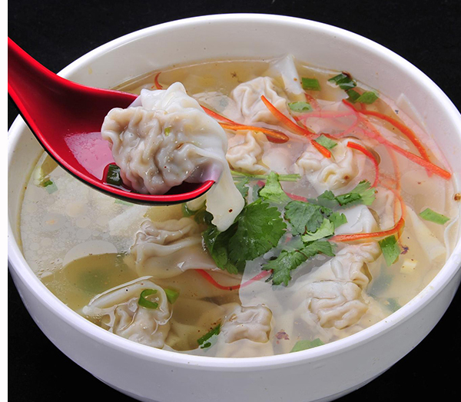
Ravioli-[hun dun]soft, juicy, small
Meet- tasty, soft, fragrant, pink
Shrimp- fresh, brittle, orange,
Soup-sweet, slightly salty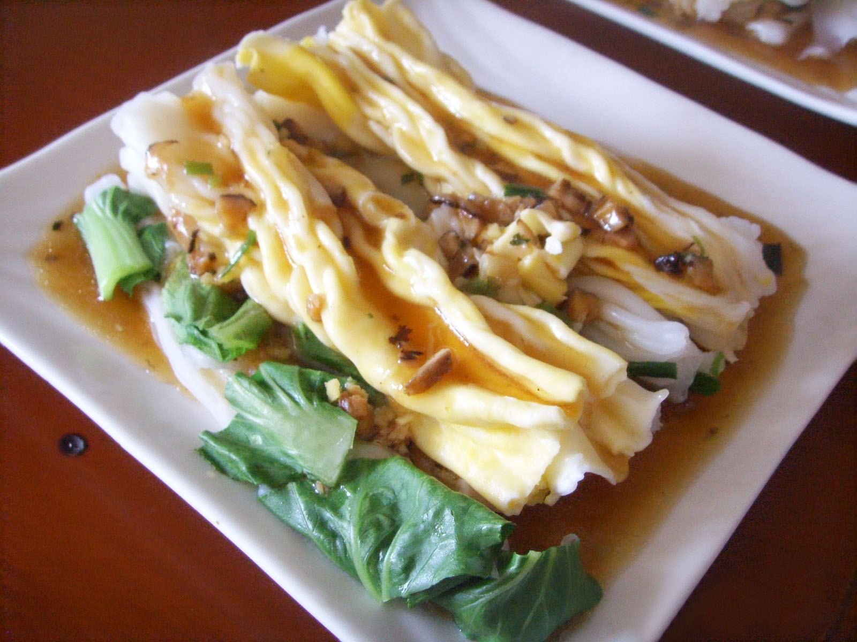
steam
Rice rolls[chang fen]-soft, salty, thin, silp
Meet- soft, fragrant
Egg- soft
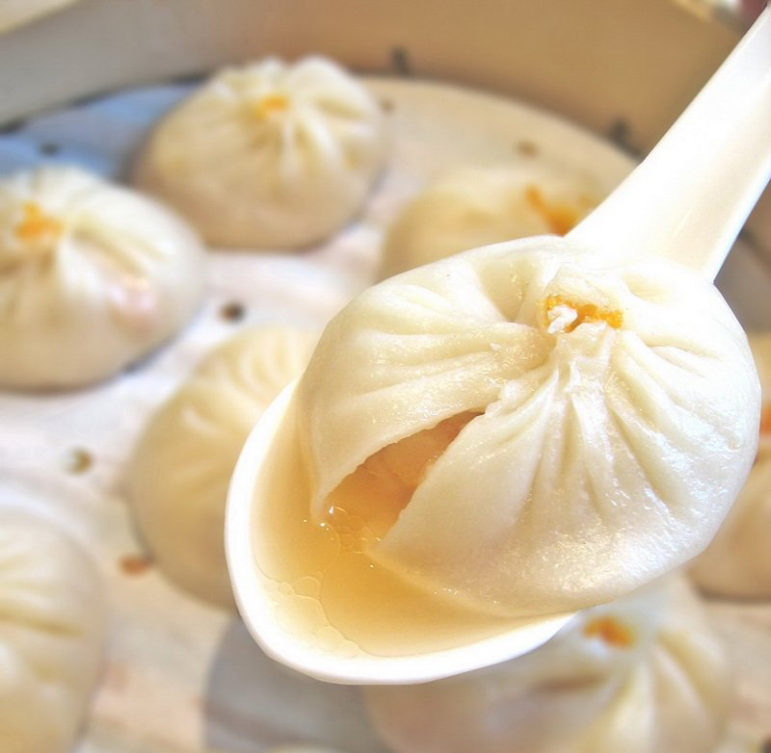
steam
Guantang Bun[guantang bao]-soft, juice, sweet, soup
Meet-soft, juice, sweet
Shrimp- Q, fresh, orange
Soup-sweet, yellow

